Mixed end of the season for the Bäckman’s
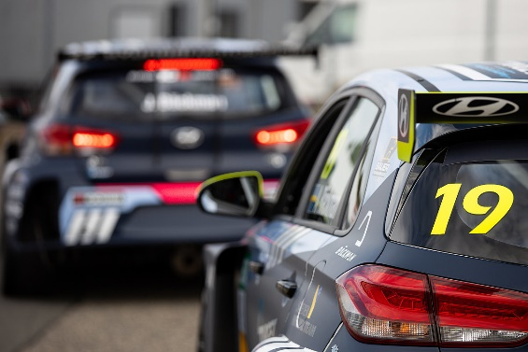
Andreas and Jessica Bäckman drove the season finale of TCR Europe in Spain last weekend.
Photo: ADAC TCR Germany (Free rights to use the image)
Last weekend it was time for the season finale of TCR Europe at the Jarama track in Spain. It was the Sweden National Team drivers Andreas and Jessica Bäckman’s last competition of the year. For Andreas, it was a consistent weekend with a strong effort in both the Qualifying and the Race’s. While Jessica had tougher Race’s with an incident in Race 1 and a last-minute repair of the car for Race 2.
Last weekend, November 6th-7th, the sixth and final round of the TCR Europe Championship was held at Circuito del Jarama, located near Madrid in Spain. The Swedish siblings Jessica and Andreas Bäckman was excited, ready and was looking forward to competing on this track, which is new on the calendar for this year’s season.
The weekend started well for the Target Competition drivers, with good speed during Free Practice’s and the Qualifying. Andreas qualified as 6th and Jessica as 8th in the Qualifying, which meant they got the starting positions 6 and 8 for Race 1 on Saturday.
Challenging conditions in both Race 1 and Race 2
The first Race on Saturday was a challenging race, as the track was drying up after a heavy rain shower from the previous night, which created difficult conditions for the drivers to master. Jessica had an incident with another car already on the first lap of the race, which unfortunately resulted in that she had to retire from the race with major damage to the car. Andreas managed to keep his 6th position over the finish line after a strong race.
The serious damage on Jessica’s car after Race 1 and the short break between Race 1 and Race 2 meant that the mechanics had a tough task to get her car ready for Race 2. The time pressure and a late change of the race start time, meant that she did not make the starting grid and had to start from the pitlane, after an impressive repair from her Target Competition mechanics’.
Race 2 was also a challenging race for the drivers, as there was a heavy downpour of rain just after the first race, which meant that the conditions once again was drying for the second race and it turned out that the tire choices would be an important factor.
Andreas had a good start and was up to 4th position after the first corner and had a lot of good battles during the race. However, the speed was not enough towards the final stage of the race, so he dropped down to 6th position in the end. This weekend’s results also gave him a nice advancement in the Drivers’ Championship up to 6th position:
- This weekend was a big challenge, as I got a quite big compensation weight gain in my car from the last race at Spa. With this in mind, I think it was a successful weekend, especially in the Qualifying when I qualified 6th. Race 1 and Race 2 turned out to be challenging with changing conditions, but two 6th places I think shows that it’s in the top where I belong, regardless of the track conditions. Finishing 6th in the Drivers’ Championship, even though I missed 4 of 12 races due to crashes and my hand injury, was a positive surprise and nothing that I had expected, Andreas Bäckman says.
Jessica’s race in Race 2 unfortunately also became another disappointment for her. Starting from the pitlane, there was no time to make a correct tire choice. Then she also suffered a problem already on the first lap, which meant that she had to enter the pits and therefore ended up one lap behind the others.
- The weekend started positively, and I showed good speed already from the first Free Practice. The Qualifying was also positive, we made an adjustment in the car from Q1 to Q2, which turned out to be worse and therefore I didn’t manage to get as good result in Q2. The two Race’s ended up worse, as I was involved in an incident already on the first lap, which meant that we barely had time to start Race 2. A disappointing end to a disappointing season, but I’m still happy with speed development during the year. Big thanks to the entire team Target Competition and Hyundai Motorsport Customer Racing for the support the whole year, Jessica Bäckman says.

Andreas’ results:
Free Practice 1: 11th
Free Practice 2: 16th
Q1 (Qualifying 1): 8th
Q2 (Qualifying 2): 6th
Race 1: 6th
Race 2: 6th

Jessica’s results:
Free Practice 1: 7th
Free Practice 2: 6th
Q1 (Qualifying 1): 4th
Q2 (Qualifying 2): 8th
Race 1: Retired
Race 2: 19th
Free rights to use the images.

