*Press release from Schoeller Arca Systems AB*

*Perstorp, Sweden, 25th January 2012*

**The Norwegian pooling company Rentpack AS buys 300 000 plastic pallets from Schoeller Arca Systems AB in Sweden**

The Scandinavian business unit of the world leading plastic packaging manufacturer Schoeller Arca Systems has signed an agreement with the Norwegian pooling company Rentpack AS to supply more than 300 000 plastic pallets to their pallet pool in Norway.

Rentpack AS is a Norwegian company that owns a pool of standardized returnable packaging such as plastic pallets, trays, crates and bottles for breweries and the beverage industry in Norway. Rentpack AS started a few years ago to search for a half pallet with the measurements 800 mm x 600 mm to upgrade their pallet. The pallet had to meet some specific requirements such as it had to be made of plastic, it had to be lightweight, it had to have an attractive design but mostly the pallet had to withstand excessive handling packed with hundreds of kilos of filled beverage bottles over many trips between production and stores in Norway.

**"We are pleased to be able to supply our customers with the upgraded pallet. The upgraded pallet have hand grip, fresher look, has a combined RFID and barcode tag and comes with antislip material. The hand grip makes the pallet very easier for manual handling. But most of all it is stronger than the previous version and has a top deck which is designed for the future of transport packaging. As we are returning the previous version and producing new pallets of old pallets we also provide a good environmental solution. We are confident that the pallet will be appreciated and hope that the new and innovative properties of the pallet will suit the future needs of our customers" - Morten Sundell CEO Rentpack AS**

Schoeller Arca Systems has a long history of supplying plastic half pallets to breweries and the beverage industry in Norway. The solution was based on the famous plastic half pallet 6100 that already has a long history on the Scandinavian market. Our R&D department adapted the plastic pallet after the requirements and demands of Rentpack AS. After excessive testing of different pallets and long discussions with Rentpack AS they announced that they were ready to sign an agreement with Schoeller Arca Systems. The production of the pallet started in the early fall of 2011 and up until now Schoeller Arca Systems in Perstorp, Sweden has delivered more than 60 000 plastic half pallets to Rentpack AS. The total quantity is estimated to reach over 300 000 pallets.

A plastic pallet is a more efficient returnable packaging than a wooden pallet. Returnable means that a packaging is used over and over again in trips i.e. between production and selling point, such as a grocery store. A plastic pallet doesn’t collect dirt and dust and therefore can be used in sensitive industries such as breweries and beverage industries. However if the plastic pallet gets dirty it can easily be washed without the weight of the pallet changes due to the fact it getting wet. Low weight pallet means less fuel consumption in transports and in the end both a more cost efficient solution and a solution better for the environment than a wooden pallet.

The Rentpack plastic half pallet weighs only 7,3 kg but can withstand more than 600 kg in load. The plastic half pallet is also fitted with barcode and RFID tag which means that Rentpack AS has 100 % possibility to offer control and tractability to their customers.

Schoeller Arca Systems always offers the best solution from both a cost efficient perspective but also from a sustainability point of view. The plastic half pallet is made of recycled HDPE which means that no “virgin” plastic has been used. When the plastic half pallet is ready to be scrapped it can be recycled and the plastic material can be used in new plastic products.

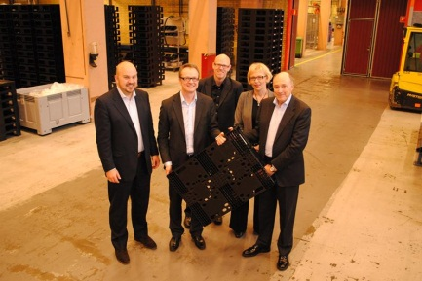 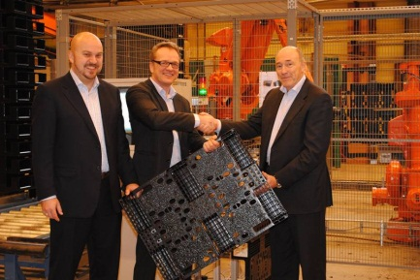 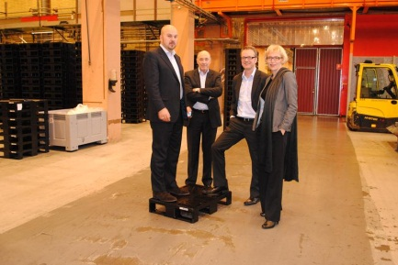

Pic 1, from left:

Stig Hellerud – Logistic Manager, Rentpack AS

Morten Sundell – CEO, Rentpack AS

Peter Hartwall – Product Development, Schoeller Arca Systems AB

Katriina Sajalinna - Marketing & Sales Director NEE, Schoeller Arca Systems AB

Idar Storsten – Area Sales Manager Norway, Schoeller Arca Systems

**For more information please contact:**

Idar Storsten Morten Sundell

Area Sales Manager Norway CEO

Schoeller Arca Systems Rentpack AS

[idar.storsten@schoellerarca.com](mailto:idar.storsten@schoellerarca.com) [morten.sundell@rentpack.no](mailto:morten.sundell@rentpack.no)

+47 92 26 5058 +47 95 92 81 55

Katriina Sajalinna

Marketing & Sales Director North East Europe

Schoeller Arca Systems

[katriina.sajalinna@schoellerarca.com](mailto:katriina.sajalinna@schoellerarca.com)

+358 50 346 22 52

**External communication Schoeller Arca Systems AB:**

Gabriel Persson

[gabriel.persson@schoellerarca.com](mailto:gabriel.persson@schoellerarca.com)

+46 (0)70 509 99 01

For more press releases and high resolution pictures please visit Schoeller Arca Systems AB at Mynewsdesk.

<http://www.mynewsdesk.com/se/pressroom/schoeller-arca-systems-ab>

***Rentpack AS is a Norwegian pooling company of standardized returnable packaging for breweries and the beverage industry in Norway. The pool consists of plastic pallets, trays, crates and bottles that brewery and beverage producer’s rents from Rentpack AS. Rentpack AS is owned by the Norwegian brewery and beverage organization, “Bryggeri- og Drikkevareforeningen”.***

[***www.rentpack.no***](http://www.rentpack.no)

***Schoeller Arca Systems with head office in Zwolle, the Netherlands, is the world leading producer of returnable plastic packaging. The group employ 1000 people and the turnover 2010 was 470 million €. The sales office and production for Scandinavia is located to Perstorp, Sweden.***

[***www.schoellerarcasystems.se***](http://www.schoellerarcasystems.se)