MEDIA RELEASE

Father’s Day Specials at Pan Pacific Manila
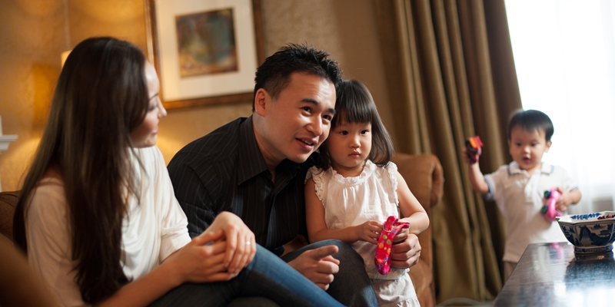

30 May 2019, Manila – On Father’s Day, treat Dad and the entire family at Pan Pacific Manila. Good food, as the saying goes, is the key to a man’s heart. With that in mind, our team of culinary experts at Pacific Lounge has come up with a special Grill and Barbeque dinner buffet on June 15, 2019 starting at 6:00 pm featuring unlimited serving of aromatic succulent meat, ribs, steak, chicken, and pre-dinner cocktails best complimented with choice of local beer, house wine, standard drinks and impeccable service. Dinner Buffet is at Php 1,200 net per person.

For a truly leisurely celebration, book a room or a suite for the weekend. Take advantage of the hotel’s Date with Dad Room Package from June 1 to 30, 2019. An overnight stay in a Superior Room starts at Php 7,000 net inclusive of buffet breakfast, welcome drink upon arrival, complimentary Internet access, complimentary local calls, use of swimming pool and fitness centre facilities, Sunset Lounge & Bar “Street Grill Combo” paired with pint of beer, and special gift for Dad.

Pacific Lounge is located on the 21st floor, Pan Pacific Manila, M. Adriatico cor. Gen Malvar Sts. Malate. For reservations, please contact (02) 318 0788 or email dining.ppmnl@panpacific.com. Price is subject to change without prior notice.

For more information on Pan Pacific Manila, please visit:
https://www.panpacific.com/en/hotels-resorts/philippines/manila

ENDS

Media Contact
Stephanie Cabrejas
Assistant Marketing Manager
Pan Pacific Manila
Email: stephanie.cabrejas@panpacific.com
Tel: +63 2 917 595 1479/ +63 2 318 0788

About Pan Pacific Manila
The first and finest Butler hotel in the Philippines – ranked among the recommended hotel at the 2017, 2018 and 2019 Forbes Travel Guide, named one of the best places to stay in the TripAdvisor Travellers Choice Award, and also recognised among the Philippines’ Leading Business Hotels at the World Travel Awards, is conveniently located at the heart of the historical and cultural district of Malate in the Manila Bay area. Pan Pacific Manila is a short drive to the city’s convention, exhibition and business centres and a walk away from shopping, food and entertainment establishments. A business hotel, designed to offer a comfortable abode to business and leisure travellers with its excellent facilities and service, the hotel has 236 all-executive rooms and suites and 7 spacious function rooms.

About Pan Pacific Hotels and Resorts
With hotels, resorts and serviced suites across Asia, Oceania and North America, Pan Pacific provides a safe harbour in an ever-changing world. Places with less to worry about because, when you stay with us, rest assured that all will be taken care of. For this is where you will find your balance.
About Pan Pacific Hotels Group
Pan Pacific Hotels Group is a wholly-owned hotel subsidiary of Singapore-listed UOL Group Limited, one of Asia’s most established hotel and property companies with an outstanding portfolio of investment and development properties.

Based in Singapore, Pan Pacific Hotels Group owns and/or managers more than 40 hotels, resorts and serviced suites including those under development in 24 cities across Asia, Oceania, North America and Europe.

Voted “Best Regional Hotel Chain” by readers in Asia in 2017 and 2018, Pan Pacific Hotels Group comprises two acclaimed brands: its signature brand, Pan Pacific and its deluxe brand, PARKROYAL.

Sincerity is the hallmark of Pan Pacific Hotels Group. The Group is known to its guest’s partners, associates and owners for its sincerity in people and the sense of confidence which alleviates the stresses of today’s complex world.

