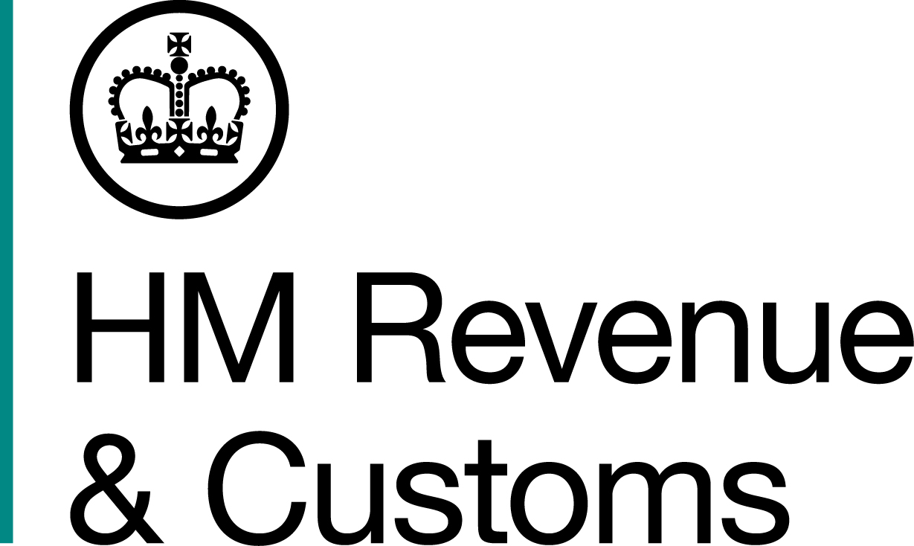
News Release

 | For the attention of News Desks |  | No. of pages:2
 | Date: | 18 August 2017 | Ref: | WA 03 2017

Brief scam revealed as tax fraud

A call centre worker from Swansea, who set up a company to sell men’s designer underwear as a front to steal more than £50,000 from taxpayers through a VAT fraud, has been jailed.

Daniel King, 37, set up his company, D-briefed, in October 2013 and told HM Revenue and Customs (HMRC) investigators he intended to import the underwear from China to re-sell over the internet. However, he couldn’t produce any documentation to support his claim that he intended to trade. The business was simply a fiction designed to conceal his tax fraud.

King told investigators he attended a VAT seminar before setting up his company, to give him a better understanding of how the tax system works. He later admitted making up the figures for ten fraudulent VAT claims between December 2013 and March 2016, totalling £57,563.35.

Colin Spinks, Assistant Director, Fraud Investigation Service, HMRC, said:

“King blatantly abused the tax system by setting up a company for the sole purpose of stealing money that should have funded public services. Now he has a criminal record and we are working to recover the money he stole.

“If you believe someone is benefitting from tax fraud please call our Fraud Hotline on 0800 788 887”.

On sentencing, Mr Recorder P Griffiths QC said:

“I am satisfied that you went into this with your eyes wide open and that you knew full well you were acting fraudulently. You have gained financially, dishonestly and deliberately and it would be an affront to the public if you were not immediately deprived of your liberty”.

Notes for Editors

- Daniel King (DOB 24/10/1979) of Russell Street, Swansea, pleaded guilty to making a false representation intending to make a gain for himself, namely VAT repayments, contrary to sections 1 and 2 of the Fraud Act 2006 at Swansea Crown Court on 17 August 2017. He was sentenced to two years and three months in prison. He was ordered to pay £670 as well as a victim surcharge of £120.

- The HMRC Fraud Hotline - on 0800 788 887 - is available between 8am to 8pm, seven days a week, 365 days a year. You can also report online using our digital form available on GOV.UK.

- HMRC’s flickr site www.flickr.com/hmrcgovuk

- Follow HMRC’s press office on Twitter @HMRCpressoffice

Issued by HM Revenue & Customs Press Office

Press enquiries only please contact:

Natalie Brown
Tel: 03000 519123
Email: Natalie.brown@hmrc.gsi.gov.uk

or
Nikki Sanders
Tel: 03000 524936
Email: Nikki.sanders@hmrc.gsi.gov.uk

Out of hours
Tel: 07860 359544
Website: www.gov.uk/hmrc

