**Astrid Lindgren now translated into 100 languages!**

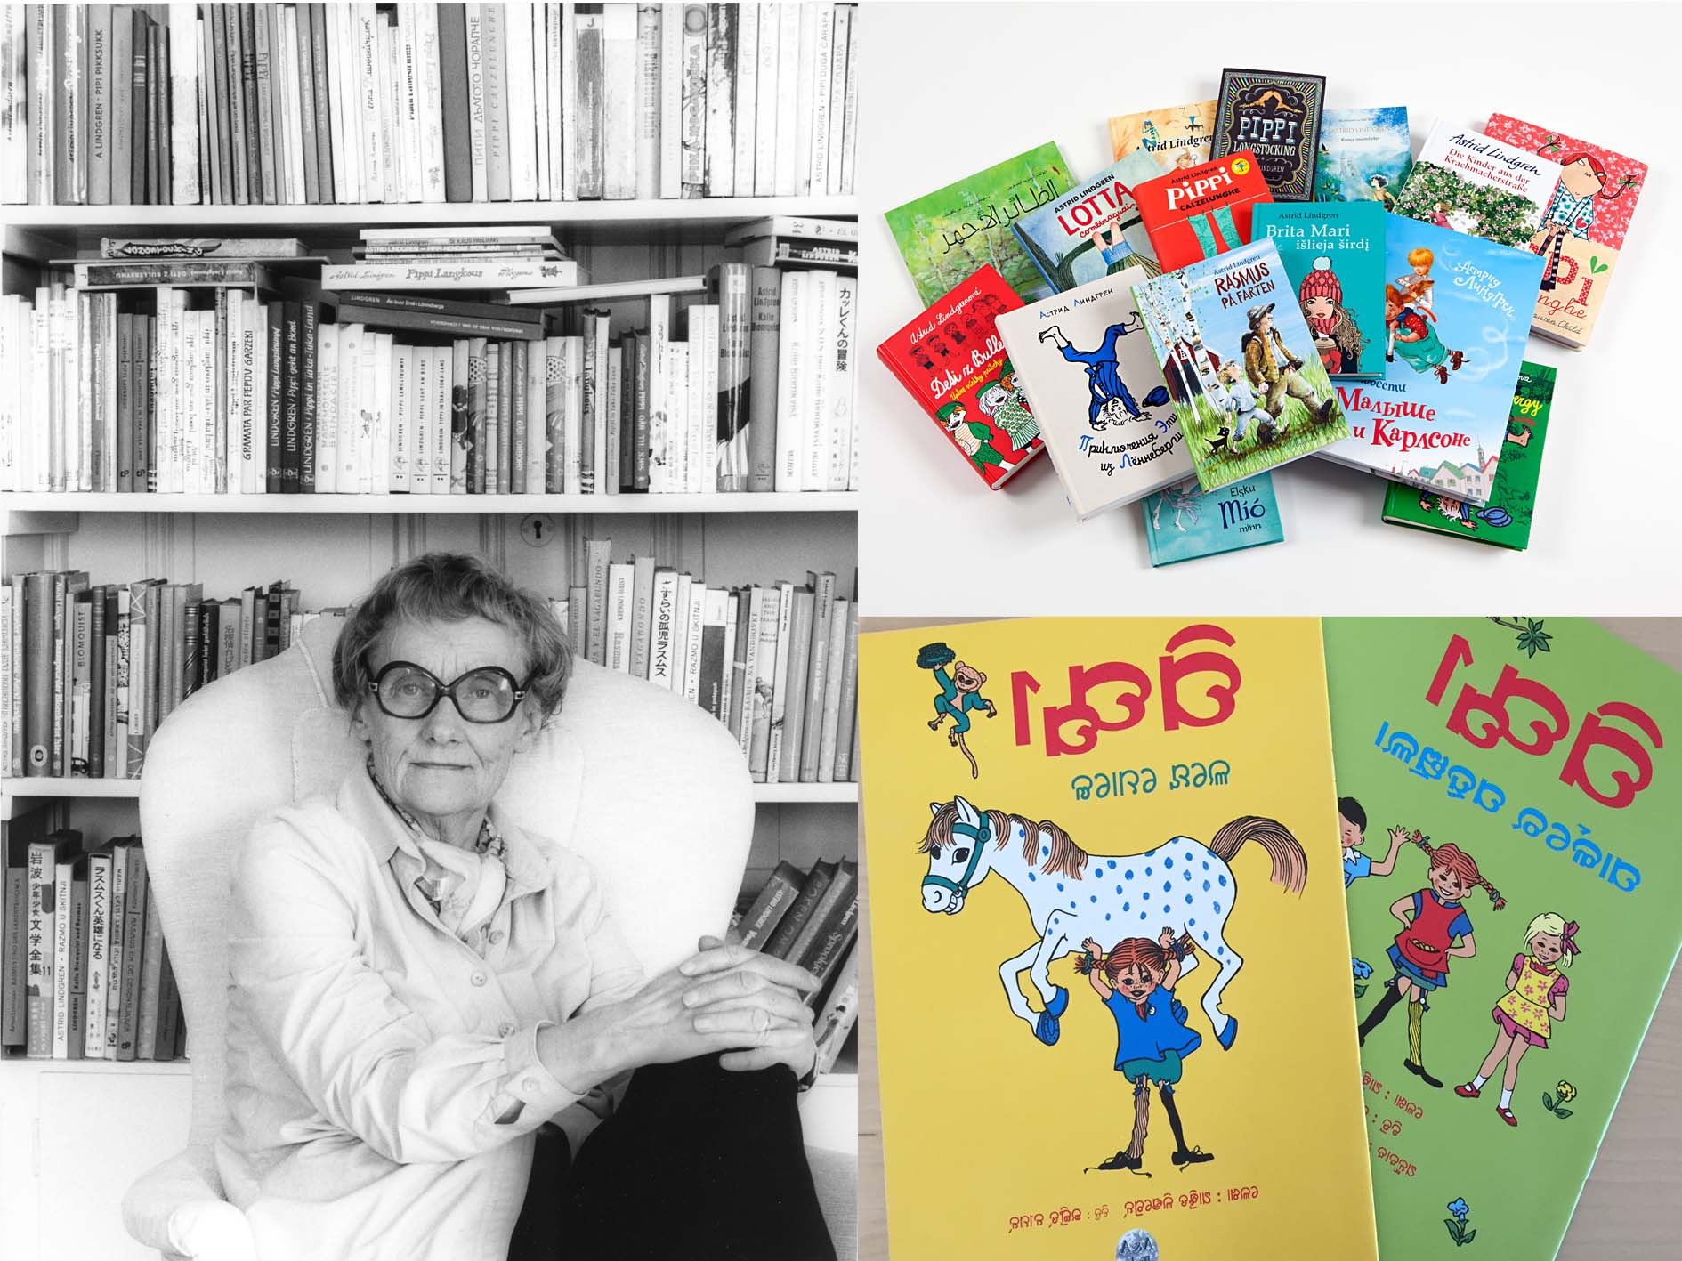

**During the spring of 2017 Astrid Lindgren’s books reached the 100 languages mark. The books *Do you know Pippi Longstocking* and *Pippi Longstocking in the Park* were then released in Oriya, which is the mother tongue of 35 million people in the Indian province of Orissa. The hundredth translation will be celebrated at Skansen, in Stockholm 20-21 May.**

“We’ve been looking forward to this moment”, says Lina Talgre, Senior Foreign Rights Manager at Saltkråkan AB. In recent years there have been 1-2 new language translations added annually, so slowly but surely we’ve been moving towards this magic milestone.”

As early as in 1946, Astrid signed her first contract outside of Sweden. It was a Norwegian company that wanted to publish Pippi Longstocking. Not long after that, contracts were signed with publishers in Finland and Denmark. And when Friedrich Oetinger from Hamburg approached Astrid in 1949, wishing to publish Pippi Longstocking, it made the way for the worldwide successes that followed.

“Pippi Longstocking is the most widely known of Astrid Lindgren’s characters. The books about her have been translated into over 70 languages”, says Annika Lindgren, chief of publishing at Saltkråkan. “After Pippi, come the Brothers Lionheart, followed by Emil in Lönneberga and the Bullerby Children. Altogether, there have been more than 160 million copies of Astrid Lindgren’s books sold. This literary success is unique”.

And there are more languages in the pipeline. Some of the requests are extremely exciting. One of the latest ones is the language of Anii which is spoken in Benin, East Togo and Ghana. Here, until recently, they did not have a written language, so the translation of Emil in Lönneberga would be their first book ever, and would play a part in the development of that ethnic group’s own written language.

“Some requests are totally irresistible”, says Lina Talgre. “My own favourite – which I really hope will become a reality – is the translation of Pippi Longstocking into Udmurt, the language spoken in the Republic of Udmurtia in Russia. It’s a region known for its many redheaded inhabitants.”

.

But first we are going to celebrate the hundredth language and everyone is welcome. 20-21 May it’s time again for the annual Astrid Lindgren weekend at Skansen in Stockholm. Astrid Lindgren’s World will make an appearance in the capital and all visitors get to meet Pippi Longstocking, Miss Prysselius, Kling & Klang and Emil in Lönneberga, together with the whole Svensson family from Katthult. More information about the program is available at: www.skansen.se/sv/tjolahopp-tjolahej

**For more info, contact:**

Cilla Nergårdh, PR & Marketing Manager Saltkråkan AB, +46 (0)70-938 46 52, [cilla.nergardh@saltkrakan.se](mailto:cilla.nergardh@saltkrakan.se)

**Persian**

**Plattdeutsch (Low German),**

**Polish**

**Portuguese (both Brazilian and Portuguese)**

**Putèr**

**Romanian**

**Romany**

**Rumantsch Grischun**

**Russian**

**Serbian**

**Seselwa (Seychelles Creole)**

**Singhalese**

**Slovakian**

**Slovenian**

**Somali**

**Sorani (a Kurdish language)**

**Soreth**

**Southern Sami**

**Spanish**

**Sursilvan**

**Swahili**

**Sylt-Frisian**

**Tamil**

**Tartar**

**Thai**

**Tigrinya**

**Turkish**

**Turkmen**

**Ukrainian**

**Urdu**

**Uzbek**

**Vallader**

**Vietnamese**

**Zulu**

**Zulu**

**Icelandic**

**Indonesian**

**Interlingua**

**Irish (Gaelic)**

**Italian**

**Japanese**

**Kazak**

**Khmer**

**Kildin Sami (a Sami language)**

**Korean**

**Kurmanji (a Kurdish language)**

**Kyrgyz**

**Ladin**

**Latvian**

**Lithuanian**

**Lule-Saamic (one of the languages of the Sami people)**

**Luxembourgish**

**Macedonian**

**Marathi**

**Meänkieli (a northern Finnish dialect)**

**Modern Greek**

**Moldavian**

**Mongolian**

**Montenegrin**

**Mooring-Frisian (northern dialect)**

**Nepalese**

**New Norwegian**

**North Saamic**

**Norwegian Bokmål**

**Oriya**

**Pashto**

**Afrikaans**

**Albanian**

**Arabic**

**Armenian**

**Azerbaijani**

**Basque**

**Belarusian**

**Bengali**

**Bosnian**

**Bulgarian**

**Cakavian (Croatian dialect)**

**Catalan**

**Chinese (Simplified)**

**Chinese (Traditional)**

**Croatian**

**Cymraeg (Welsh)**

**Czech**

**Danish**

**Dutch and Flemish**

**Elfdalian (a dialect of Dalarna)**

**English**

**Esperanto**

**Estonian**

**Faroese**

**Fering-Frisian**

**Finnish**

**French**

**Galician**

**Georgian**

**German**

**Greenlandic**

**Hebrew**

**Hill Mari**

**Hindi**

**Hungarian**

**The 100 translations of the works of Astrid Lindgren:**