Ring Knutstorp next up for Andreas Bäckman
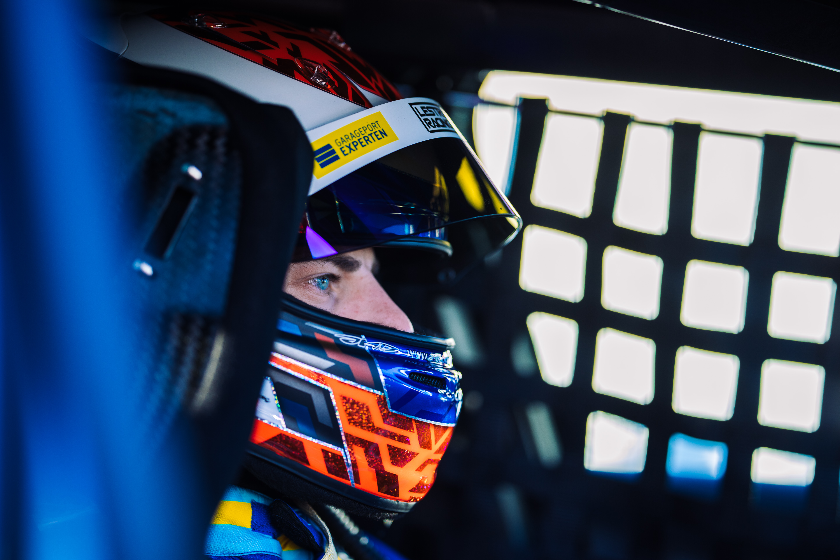
Andreas Bäckman is competing this weekend with his Audi RS 3 LMS TCR car for Lestrup Racing Team in the STCC Newsrace at Ring Knutstorp, located near Helsingborg, Sweden.
Photo: Martin Öberg (Free rights to use the image)
This weekend, July 21st-23rd, Andreas Bäckman competes at Ring Knutstorp when it’s time for the third STCC event of the season. Last time he competed in Skellefteå he got the pole position and also the track record in the qualifying but did not get as good results in the races as he had hoped.
– I feel hungry for more and look forward to competing again after the long break, Andreas Bäckman says.
STCC (Scandinavian Touring Car Championship) is Sweden's most prestigious motorsport championship and is today the leading class for Touring Car Racing in Sweden. The cars are built according to the global TCR regulations, which means that the cars used in STCC are the same as those in the other TCR series around the world. The series consists of six races that are run on different Swedish tracks and this weekend, July 21st-23rd, the third round of the championship, STCC Newsrace, are being held at Ring Knutstorp. Ring Knutstorp is a challenging track dating from the 1950s outside Kågeröd, Sweden. Ring Knutstorp is located at the foot of the scenic Söderåsen, which is also one of southern Sweden's largest excursion destinations. The track has a lot of elevation changes, mixes fast and slow corners and puts great demands on the drivers.
Andreas competes together with Lestrup Racing Team in an Audi RS 3 LMS TCR car in this year's STCC season and is in sixth place in the driver's championship after the first two races at Ljungbyheds Motorbana and Drivecenter Arena in the beginning of June.
- The speed was there at the last race weekend in Skellefteå and we showed it by taking pole position and grabbing the track record as well. Unfortunately, the race did not give the results that both I and the team had hoped for, but I feel hungry for more and I’m looking forward to competing again this weekend at Ring Knutstorp after a break of five weeks since the last competition. Ring Knutstorp is a very technical track, with large elevation differences and is a track that will require a lot of both driver and car, Andreas Bäckman says.
- The last time I drove on Ring Knutstorp was four years ago, so I do not have a lot of laps on the track, but it will be interesting to see how we are standing against the other teams, Andreas Bäckman says.
The structure of the race weekend
Already on Thursday morning, the practice begins with one official test session, which are three hours long. Then on Friday morning, the race weekend continues with two more practice sessions, which are followed by two timed qualifying sessions in the afternoon. The timed qualifying consists of two qualifying segments, Q1 (20 minutes) and Q2 (10 minutes), where it is important to drive as fast as possible and the lap times are counted. The eight fastest drivers in Q1 will continue to drive in Q2. The result from Q1 determines the starting position for Race 1 and the Q2 starting position for Race 2 for the top eight drivers.
Saturday is the race-day and consists of three races; Race 1, Race 2 and Race 3. The starting position for Race 3 is based on the result from Race 2 but with the reverse starting order for the eight top drivers from that race.
Points are awarded to the top five in the Qualifying and the top 15 in each race.
The event are broadcasted LIVE at STCC+
The STCC weekend at Ring Knutstorp are broadcasted LIVE at: plus.stcc.se
Live-timing:
raceresults.se
livetiming.getraceresults.com
More information about STCC can be found here: stcc.se
Information about the STCC Newsrace:
stcc.se/race/knutstorp/
stcc.se/2022/07/15/fullspackat-showschema-under-stcc-newsrace-pa-knutstorp/

Timetable for this weekend (STCC round 3 - Knutstorp):
(all times are in CEST/Swedish time)
Thursday July 21st:
09:00 Official test
Friday July 22nd:
09:30 Free Practice 1
13:15 Free Practice 2
16:25 Qualifying (Q1 and Q2)
Saturday July 23rd:
11:20 Race 1 (Broadcasted LIVE on plus.stcc.se)
14:00 Race 2 (Broadcasted LIVE on plus.stcc.se)
15:55 Race 3 (Broadcasted LIVE on plus.stcc.se)
About the track (Ring Knutstorp):
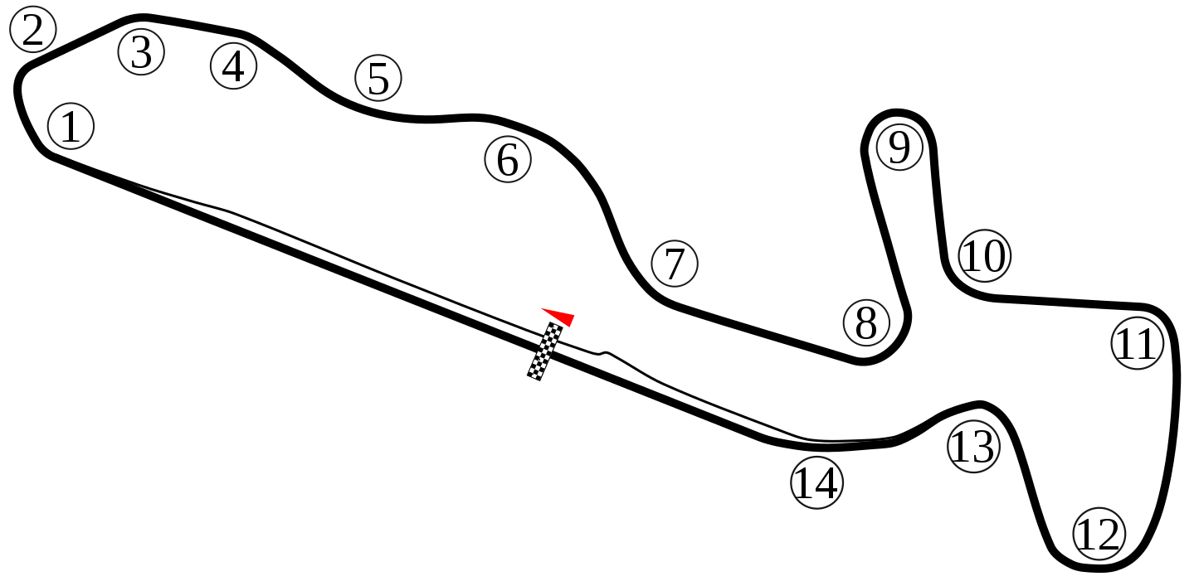
Located in: Kågeröd, Sweden
Length: 2,070 km
Corners: 14
Race duration: 16 laps (18 minutes + 1 lap)
Lap record (TCR): 59.291s

STCC Championship Standings before round 3 of 6:
STCC – TCR Scandinavia – Drivers’ Championship Standings – Overall (Top 3)
STCC 2022 (After 2 of 6 race weekends)
1: Robert Dahlgren (SWE), 71 p.
2: Hugo Nerman (SWE), 66 p.
3: Oliver Söderström (SWE), 64 p.
–
6: Andreas Bäckman (SWE), 45 p.
See the full standings here
STCC – TCR Scandinavia – Teams’ Championship Standings – Overall (Top 3)
STCC 2022 (After 2 of 6 race weekends)
1: Brink Motorsport, 125 p.
2: CUPRA Dealer Team - PWR Racing, 110 p.
3: Lestrup Racing Team, 109 p.
See the full standings here

Did you miss the previous STCC race at Drivecenter Arena?
Click here to see the replay at STCC+
Click here to see the replay from Race 1
Click here to see the replay from Race 2
Click here to see the replay from Race 3

Follow the STCC season:
Live-stream: plus.stcc.se
Other information: stcc.se
Facebook: facebook.com/STCCOfficial/
Twitter: twitter.com/stcc_official
Instagram: instagram.com/stcc_official/
YouTube: youtube.com/c/STCCTV

Free rights to use the images.

Download press-photos here:
http://bit.ly/jabaeckman-photos
https://www.mynewsdesk.com/se/ja-backman/images

