For Immediate Release

NEWS RELEASE

TAKING THE WORLD’S LEADING GREEN CITY HOTEL TO NEW HEIGHTS

PARKROYAL on Pickering’s hotel-in-a-garden concept evolves into
PARKROYAL COLLECTION, a new brand from Pan Pacific Hotels Group

Singapore, 7 January 2020 – UOL Group Limited (UOL) and hotel subsidiary Pan Pacific Hotels Group Limited (PPHG) are taking sustainable hospitality to the next level with the launch of PPHG’s new brand, PARKROYAL COLLECTION Hotels & Resorts.

The new brand, PARKROYAL COLLECTION, carries a strong sense of responsibility towards the environment and self with eco-friendliness, sustainability and care for overall well-being as its brand ethos. The brand also celebrates icons of architecture and design.

PARKROYAL on Pickering, Singapore’s first hotel-in-a-garden and the World’s Leading Green City Hotel, has been renamed PARKROYAL COLLECTION Pickering. The iconic design, signature eco-friendliness and sustainability practices of the hotel make it a natural fit for the PARKROYAL COLLECTION brand.

Joining this well-loved hotel is the former Marina Mandarin by UOL subsidiary United Industrial Corporation Limited. The Group will be transforming this classic into an indoor oasis of a garden-in-a-hotel as it is rebranded to PARKROYAL COLLECTION Marina Bay. Seamlessly integrating design and nature, PARKROYAL COLLECTION Marina Bay will bear the new brand’s iconic design, eco-friendly practices, and focus on well-being.

“As a developer, we are keenly aware of the environmental challenges and we believe everyone can do their part to contribute to sustainability and our environment. The launch of PARKROYAL COLLECTION brand marks an important milestone in our PPHG’s journey. This launch is exciting and timely because we are building on what PARKROYAL COLLECTION Pickering has achieved. We are now taking another step forward with PARKROYAL COLLECTION Marina Bay to further capitalise on sustainability into a growth opportunity,” said Mr Liam Wee Sin, Group Chief Executive, UOL.

“PARKROYAL COLLECTION is created for those with a sense of purpose and responsibility at heart. It demonstrates that sustainability and modern lifestyle can co-exist through conscious design and efforts. The brand adopts a long-term view of care and guardianship towards our environment and community,” said Mr Choe Peng Sum, Chief Executive Officer, PPHG.

PARKROYAL COLLECTION Pickering
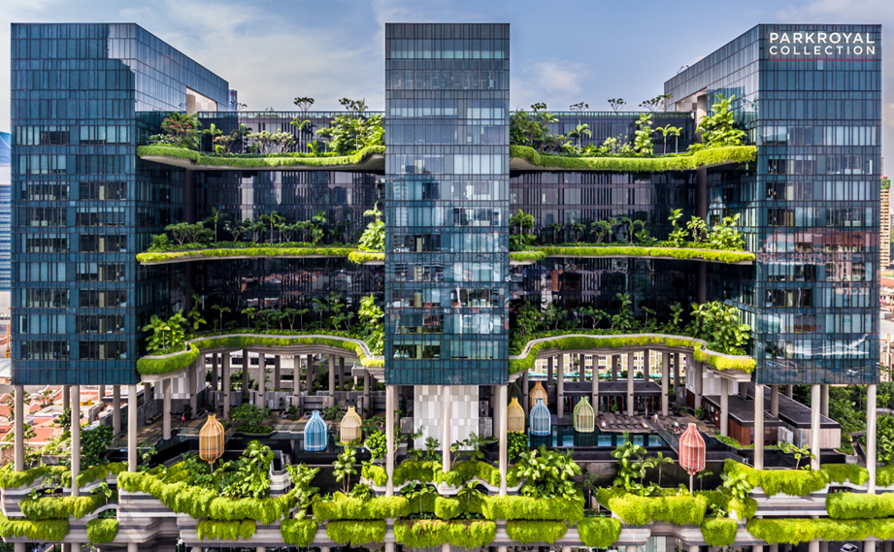
Designed by renowned architect WOHA, PARKROYAL COLLECTION Pickering pioneered a unique hotel-in-a-garden concept with over 15,000 square metres of greenery, blending visually compelling vertical gardens with an awe-inspiring green-blue façade. It is a remarkable architectural icon in the heart of Singapore’s Central Business District, with numerous awards in its bag including being named one of 50 Most Influential Tall Buildings of the Last 50 Years by The Council on Tall Buildings and Urban Habitat (CTBUH).
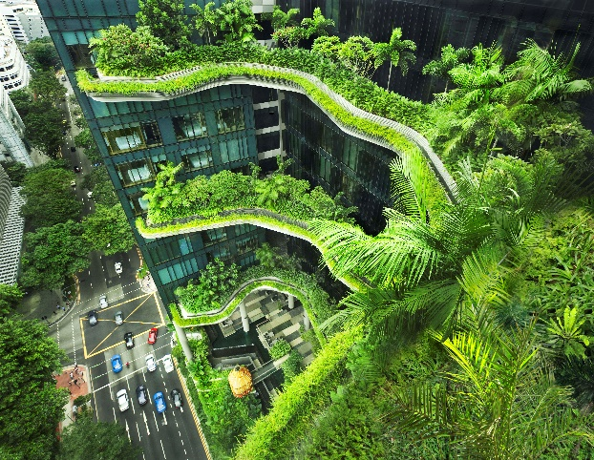
PARKROYAL COLLECTION Pickering is the first hotel with zero-energy skygardens. These are powered by a gravity-driven irrigation from a rainwater harvesting system and solar energy. Light and motion sensors in the rooms help conserve energy. The hotel continues to be a leader in sustainable hospitality, consistently named the “World’s Leading Green City Hotel” and “Asia’s Leading Green City Hotel” at the World Travel Awards.

Modern life can be stressful, and more are adopting a philosophy of well-being, not only towards the environment but also as part of their lifestyle. All year-round, the hotel offers guests a dedicated wellness experience, from locally-sourced and organic plant-based dining options, its own herb garden, to green meetings and weddings.

As a brand, PARKROYAL COLLECTION’s integration of iconic spaces with sustainable elements delivers an elevated sense of well-being— creating an enhanced guest experience that is exclusive to the brand.

PARKROYAL COLLECTION Marina Bay (formerly Marina Mandarin)
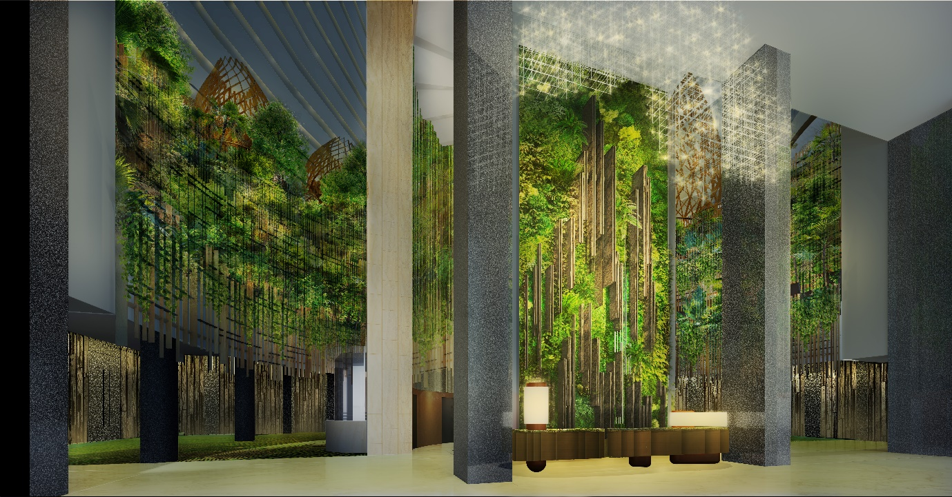
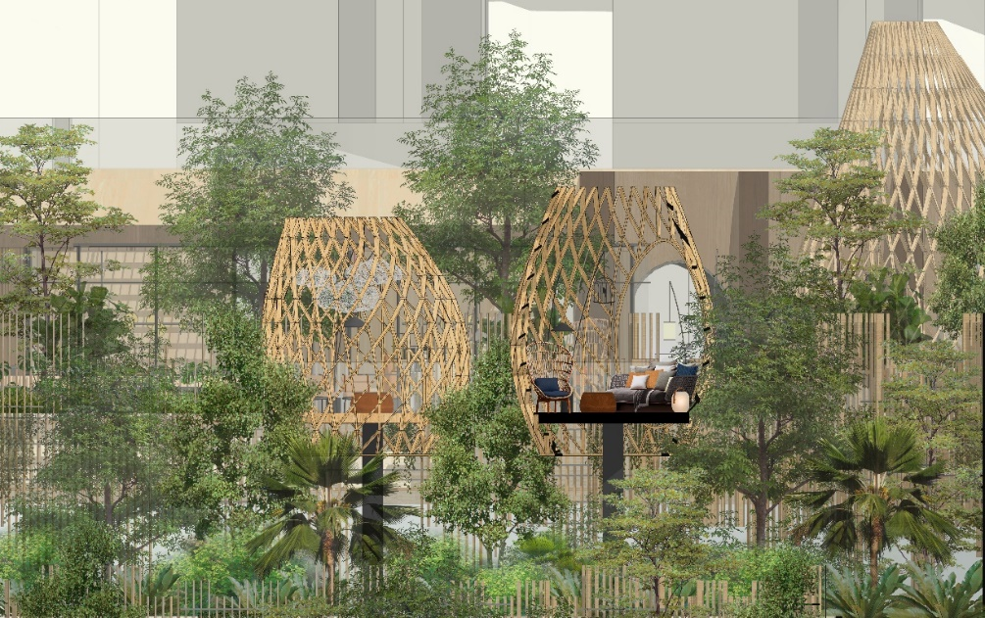
The 575-room PARKROYAL COLLECTION Marina Bay will undergo a SGD45 million renovation which will see the remaking of this classic into a “garden in a hotel”. Retaining its iconic 21-storey John Portman-designed atrium, which is one of the largest in Southeast Asia, the hotel has already unveiled a soaring 13-metre high green landscaped wall, greeting guests at its entrance. The transformation will also see sculptural pavilions shaped like bird cages nestled within lush, meticulously curated greenery throughout the hotel. Illuminated by thoughtful lighting touches, these exude a magical rainforest ambience at night.

“PARKROYAL COLLECTION Pickering has been recognised as the “World’s Leading Green City Hotel” for two consecutive years. In addition, the newly minted PARKROYAL COLLECTION Marina Bay, rebranded from Marina Mandarin, will see our efforts to transform it into another statement - garden in a hotel - in the months to come,” said Mr Choe.

Mr Liam added: “At the heart of the PARKROYAL COLLECTION brand is the belief that it’s not about people spending time in our hotels. It’s about their time well spent at our hotels. Time well spent because they can identify with our sustainability and eco-friendly causes, in the midst of the inspiring spaces that we have created.”

Renovations are expected to be carried out in phases and completed in the first quarter of 2021. This will include the transformation of AquaMarine into a new halal concept restaurant, “Peppermint”, featuring open kitchens and greenhouse-inspired private dining areas; and the renovation of 20,000-square feet of function spaces, including the Pool Garden Pavilion area with an unbeatable view of Marina Bay. The 25-metre outdoor mineral water pool has already been fitted with 1,380 fibre optic lights at its base, giving the feel of swimming amongst “twinkling stars” at night. All 575 guestrooms in the hotel will also be beautifully renovated.

The introduction of PARKROYAL COLLECTION Hotels & Resorts complements PPHG’s other two brands, “Pan Pacific” and PARKROYAL, and further diversifies the group’s offerings while strengthening its position as a trusted, global hospitality company. Over the next five years, PPHG plans to add suitable new properties to the PARKROYAL COLLECTION Hotels & Resorts brand across the region as it expands its footprint into key global cities.

Mr Choe said: “In terms of growth, our portfolio is nearly 50 properties across 29 cities, from Singapore to Beijing, Sydney, Kuala Lumpur, Tokyo and Toronto. 2020 will also be a landmark year with key openings in the key cities of London, Bangkok, Hanoi, Jakarta, and China’s first PARKROYAL hotel in the city of Dalian.”

– End –
About UOL Group Limited
UOL Group Limited (UOL) is one of Singapore’s leading public-listed property companies with total assets of about $20 billion. The Company has a diversified portfolio of development and investment properties, hotels and serviced suites in Asia, Oceania and North America. With a track record of over 50 years, UOL strongly believes in delivering product excellence and quality service in all its business ventures. UOL, through its hotel subsidiary Pan Pacific Hotels Group Limited, owns three acclaimed brands namely “Pan Pacific”, PARKROYAL COLLECTION and PARKROYAL. The Company’s Singapore-listed property subsidiary, United Industrial Corporation Limited, owns an extensive portfolio of prime commercial assets and hotels in Singapore.

About Pan Pacific Hotels Group Limited
Pan Pacific Hotels Group Limited is a member of Singapore-listed UOL Group Limited, one of Asia’s most established hotel and property companies with an outstanding portfolio of investment and development properties. Based in Singapore, Pan Pacific Hotels Group owns and/or manages nearly 50 hotels, resorts and serviced suites including those under development in 29 cities across Asia, Oceania, North America and Europe. Voted “Best Regional Hotel Chain” by readers in Asia from 2017 to 2019, Pan Pacific Hotels Group comprises three brands: “Pan Pacific”, PARKROYAL COLLECTION and PARKROYAL. Sincerity is the hallmark of Pan Pacific Hotels Group. The Group is known to its guests, partners, associates and owners for its sincerity in people and the sense of confidence which alleviates the stresses of today’s complex world. Visit www.panpacific.com.
About PARKROYAL COLLECTION Hotels & Resorts
PARKROYAL COLLECTION hotels are icons of design with a sense of responsibility and care towards the environment and self. Each hotel is one of a kind and not one in a line. It goes beyond bricks and mortar to refresh body and soul. It breathes style with a contemporary vibe, inspiring everyone who steps through its doors to live life.

For media queries, please contact:
UOL Group Limited
Sarah Ng  Head, Corporate Communications & Investor Relations  DID: +65 6350 5175  Email: ng.sarah@uol.com.sg | Aveline Tan  Assistant Manager, Corporate Communications & Investor Relations  DID: +65 6354 9611  Email: tan.aveline@uol.com.sg
Pan Pacific Hotels Group Limited
Cuili Ng  Director, Brand & Corporate Communications  Mobile: +65 9634 4425  Email: ng.cuili@pphg.com | Kit Pui Lee  Vice-President, Brand Marketing & Communications  Mobile: +65 9437 5973  Email: lee.kitpui@pphg.com
Ruder Finn Asia
Christine Lim  Mobile: +65 92704086  Email: limc@ruderfinnasia.com | Eugene Chuang  Mobile: +65 82221741  Email: chuange@ruderfinnasia.com

