Expanded waterfront for Oi18 creates more vessel and dockside demos for visitors

This year’s live demonstrations will provide visitors with a variety of interactive experiences from some of the industry’s leading ocean technology manufacturers

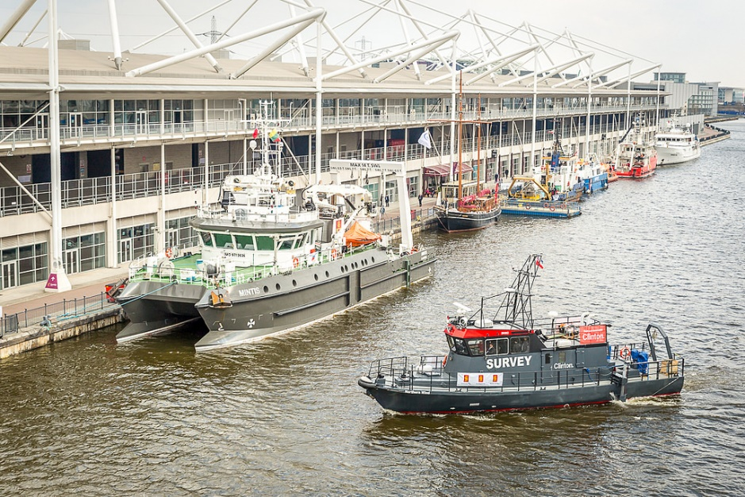

Photo from Oceanology International 2016, showing the Dockside Exhibition Area

London, 12 February 2018 – Visitors to Oceanology International 2018 (Oi18) at ExCel, London (13th-15th March 2018), will once again be able to participate in a series of live product demonstrations from the event’s waterside exhibitor area on the Royal Victoria Dock.
As one of the most popular attractions for Oceanology International visitors, this year’s dockside and on-water demo programme has been expanded and will now comprise daily demonstrations to offer an even more valuable experience for those attending, whilst allowing exhibitors to share their product’s effectiveness in a marine environment.
Exhibitors taking part in demonstrations for the dockside area of Oi18 have been confirmed as Braveheart, Briggs Marine & Environmental Services, CMS-Geotech Ltd, Deep Trekker, iXblue, Nord Slovakia, Norbit, R2Sonic, RTsys, Seafloor Systems, Sonardyne, Sound Metrics Corporation and Teledyne Marine.
Dockside Demonstrations
The following dockside demonstrations will take place from a covered dockside cabin, daily throughout the event:
09:30 – 10:30 – RTsys
10:45 – 11:45 – Teledyne Marine
12:00 – 13:00 – Nord Slovakia
13:15 – 14:15 – Maritime Robotics
14:30 – 15:30 – Deep Trekker
15:45 – 16:45 – Seafloor Systems

Sonardyne will also run daily demonstrations of its portable underwater positioning systems throughout each day of the exhibition, separate to the main programme.
Seafloor Systems will exhibit the ground breaking EchoBoat ASV 1.8m Unmanned Surface Vehicle, featuring the company’s innovative hot-swappable sensor module capability. Users can quickly swap sensor modules from multibeam/IMU, single-beam echosounder, ADCP, sub-bottom profiler, and side-scan sonar sensor packages. With Seafloor Systems’ externally mounted attachment assembly, multiple sensors can be deployed from the vehicle simultaneously and with its AutoNav auto pilot module, users can quickly and easily pre-plan a survey, upload it to the vehicle and autonomously carry out the survey plan, returning to home when completed.
Norway-based Maritime Robotics is a leading provider of innovative unmanned solutions for maritime operations in harsh environments and has developed its air and subsea technology in close collaboration with civilian, governmental and military partners. Daily demonstrations will take place dockside of the company’s portable OTTER™ Unmanned Surface Vehicle (USV), which is a turn-key and easily deployable system for seabed mapping and monitoring of sheltered waters.
RTsys, a specialist in underwater acoustics and drones, manufactures a range of underwater acoustics systems, such as hydrophone recorders and remote buoys supplying mainly research institutes, offshore renewables and oil & gas companies. The company will run a daily programme to include demonstrations of new products including the SYPod buoy (real-time data online) and MULTHY its new 16-channel acquisition system. RTsys will also highlight its web interface RAISONNANCE, which enables users to check underwater measurements such as oxygen, turbidity, temperature, pressure and acoustics in real-time. The company will also demonstrate how its underwater acoustic communication technology is used across its portfolio.
On-water Demonstrations
On-water demonstrations will take place throughout the three-day Oi18 on several participating exhibitor vessels. Exhibitors taking part in these include Braveheart, Briggs Marine, iXblue, MS-Geotech Ltd, Norbit and R2Sonic.

R2Sonic LLC, a pioneer in re-inventing multibeam sonar technology, will run daily live on-water demos to highlight the capabilities of its innovative solutions. Ultra-High Density (UHD) increases the sampling rate and accelerates the process of data as it relies on additional independent bottom samples; Ultra High Resolution (UHR) provides ultra-high resolution for target investigations and micro bathymetry; Multimode provides full coverage multifrequency surveys in a single operation and with a single system; The Pipeline Mode, specifically developed for surveying pipes or cables, combines the UHR and the Multimode with two frequencies; The Multispectral Mode provides full coverage with two or more frequencies and ensures highly accurate data by matching aspect angles of the backscatter data of all frequencies and TruePix™, which is an exclusive format that enables real time process of water column imagery thanks to its highly compressed data (1% of traditional water column files) and bottom backscatter in seamless format.

For more information on individual exhibitor demonstrations and to register for Oi18, visit http://www.oceanologyinternational.com/register
Ends

For further information, please contact:
Sara Andrade Jules Riegal/Karen Bartlett
Marketing Manager, Energy & Marine Group Saltwater Stone
Reed Exhibitions Tel: +44 (0)1202 669244
Tel: +44 (0)20 8439 5226 j.riegal@saltwater-stone.com
sara.andrade@reedexpo.co.uk k.bartlett@saltwater-stone.com

About the Oceanology International Portfolio
The Oceanology International portfolio of events offer a global forum where industry, academia and government share knowledge and connect with the marine technology and ocean science community, improving their strategies for measuring, exploiting, protecting and operating in the world’s oceans. First established in 1969, the flagship event in London features the world’s largest exhibition for marine science and technology, multiple agenda-setting technical conferences, and a visiting vessels and waterside demonstration program.

The Oceanology International portfolio includes:

- Oceanology International China: Developed with government and industry associations, Oceanology International China provides organizations with the opportunity to capitalize on China’s rapidly growing offshore energy and marine industries. With 215 exhibitors from 20 different countries, more than 5000 domestic and overseas professional attendees from 32 different countries and regions were attracted to Oi China 2015. Oi China 2017 (1-3 November) is excited to announce a move to Qingdao. Qingdao is the largest city in eastern Shandong Province on the east coast of China, the wealthiest city in Shandong Province, a demonstration area for marine ecology protection and a pilot city for marine technology and has key economic links with Ontario & British Columbia, Canada. www.oichina.com.cn/en

- Oceanology International: Oceanology International is the leading conference and exhibition dedicated to serving all professionals working in the global ocean science and marine technology sector. The first Oceanology International was held in Brighton, in 1970. Today, its home is at ExCeL London. The Oi16 exhibition was the largest ever in the show’s 47-year history with over 8,500m2 occupied by 520 exhibiting companies from 33 countries. www.oceanologyinternational.com

- Catch the Next Wave conference: Now in its fifth edition, Catch the Next Wave is an exclusive conference taking place alongside or as part of the Oceanology International events globally. The most recent program in London took place at the prestigious Royal Institution, and the North American edition will form part of the OiA conference program on February 27th, 2019. The event takes a longer-term view of the capabilities that will shape our future ability to explore, understand, exploit and protect the oceans. Catch the Next Wave 2018 is taking place alongside Oceanology International 2018.This one-day programme (Thursday 15 March) will explore the future of disruptive exploratory technology and consider opportunities for technology transfer from outside the marine industry and is run in association with The Explorers Club. www.ctnwconference.com

- Oceanology International Americas (February 25-27, 2019, San Diego Convention Center, USA): The successful launch event of the biennial series took place in 2017. www.oceanologyinternationalnorthamerica.com
About Reed Exhibitions
Reed Exhibitions is the world’s leading event organizer, with over 500 events in 30 countries. In 2015, Reed brought together over seven million event participants from around the world generating billions of dollars in business. Today, Reed events are held throughout the Americas, Europe, the Middle East, Asia Pacific and Africa and organized by 40 fully staffed offices. Reed Exhibitions serves 43 industry sectors with trade and consumer events. It is part of the RELX Group plc, a world-leading provider of information solutions for professional customers across industries. www.reedexpo.com

