NSML becomes first customer for JAWS application
on KONGSBERG’s K-IMS platform
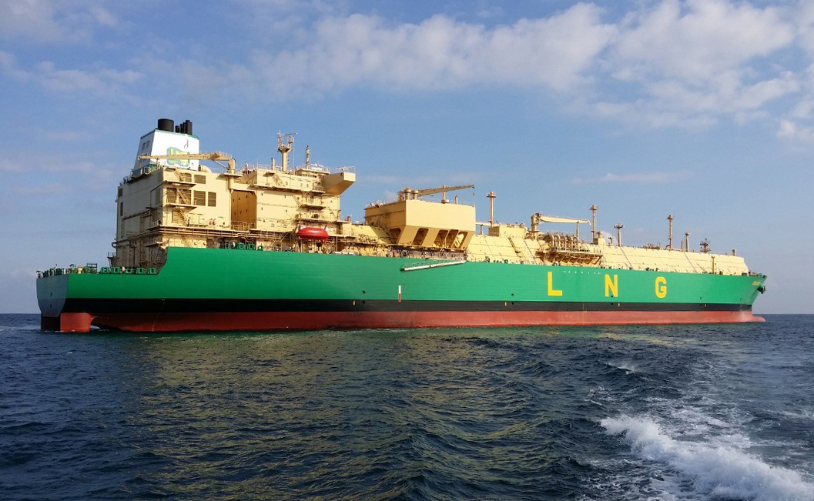
Kongsberg Maritime is to deliver Shell’s JAWS software to the entire NSML LNGC fleet via the K-IMS platform
Kongsberg, Norway, 21st June 2021 – NLNG Ship Management Limited (NSML) has just signed a contract with Kongsberg Maritime (KM) to deliver Shell’s patented JAWS (Just Add Water System) draught and trim optimisation software across the entire NSML fleet of 11 LNG carriers (LNGC). JAWS will be distributed using Kongsberg Maritime’s K-IMS digital solution – a portfolio of specialised applications to support complex operations – making K-IMS and JAWS a core element of NSML’s digitalisation and cyber security strategies.
The JAWS software uses historic, high-frequency vessel data to determine optimal operating conditions, as recorded from previous voyages. This enables the system to advise on how best to enhance a vessel’s draught and trim at any given speed as a means of reducing fuel consumption and lowering emissions. JAWS also monitor and reports live fuel and emissions savings back to managers, giving a real-time insight into the benefits of deploying this technology across a fleet.
By uniting all data-logging and communication channels into one secure system, the collaborative K-IMS solution presents a comprehensive information flow which provides a common, user-friendly solution for fleet owners, charterers and third parties alike. To date, close to 300 K-IMS contracts have been signed within the LNG sector. “K-IMS is also establishing an appreciable market footprint in the offshore segment,” says Vegar Løver, Sales Manager, LNG, Kongsberg Maritime.
“By working together with Shell on JAWS, we have added a new layer of trust and strengthened customer relations relating to KM’s regular product portfolio,” Løver concludes, “and our K-IMS solution has created a great foundation for rolling out JAWS. We’re very pleased that the solution has provided the basis for NSML to move forward with both digitalisation and cyber security.”
About K-IMS
The KONGSBERG Information Management System (K-IMS) is a suite of specialised applications hosted on the Kognifai open digital ecosystem. K-IMS is designed to allow continuous access to data, both on board and on shore, in an interactive, web-based solution, and to provide an efficient information flow. Applications, dashboards and tailor-made fleet and process automated viewing tools can subsequently be added to the K-IMS solution in each owner’s or third-party’s data replication and advisory cloud environment.
Ends

For further information, please contact:
Gunvor Hatling Midtbø, VP Communication
Kongsberg Maritime
Tel: +47 9921 4209
gunvor.hatling.midtbo@km.kongsberg.com
David Pugh
Saltwater Stone
Tel: +44 (0)1202 669244
d.pugh@saltwater-stone.com

About Kongsberg Maritime
Kongsberg Maritime is a global marine technology company providing innovative and reliable ‘Full Picture’ technology solutions for all marine industry sectors including merchant, offshore, cruise, subsea and naval. Headquartered in Kongsberg, Norway, Kongsberg Maritime has manufacturing, sales and service facilities in 34 countries.
Kongsberg Maritime solutions cover all aspects of marine automation, safety, manoeuvring, navigation, and dynamic positioning as well as energy management, deck handling and propulsion systems, and ship design services. Subsea solutions include single and multibeam echo sounders, sonars, AUV and USV, underwater navigation and communication systems.
Training courses at locations globally, LNG solutions, information management, position reference systems and technology for seismic and drilling operations are also part of the company’s diverse technology portfolio. Additionally, Kongsberg Maritime provides services within EIT (Electro, Instrument & Telecom) engineering and system integration, on an EPC (Engineering, Procurement & Construction) basis.
Kongsberg Maritime is part of Kongsberg Gruppen (KONGSBERG), an international, knowledge-based group that celebrated 200 years in business during 2014. KONGSBERG supplies high-technology systems and solutions to customers in the oil and gas industry, the merchant marine, and the defence and aerospace industries.
Web: Kongsberg Gruppen | Kongsberg Maritime
Social media: LinkedIn | Twitter | Facebook

About NLNG Ship Management Limited (NSML)
NLNG Ship Management Limited (NSML), a subsidiary of Nigeria LNG Limited (NLNG), is an international maritime services company responsible for the technical management of 11 BGT vessels (7 steam & 4 DFDE), chartered to NLNG for its operations. It also provides other top-notch maritime services (maritime training, maritime consultancy, crew administration and terminal management services) to its customers.
Web: NSML

