Stockholm, February 2013

The Absolut Company introduces
MALIBU IN A NEW DESIGN –
We’ve taken something great and made it even better.

GET READY TO EVOLVE, AS WE REDESIGN THE MALIBU BOTTLE. The new bottle keeps all the fun and energy that characterizes MALIBU but adds more of a contemporary, modern feel. And the new clear window around the bottom of the bottle maximizes shelf-appeal by highlighting the fresh, clear spirit.
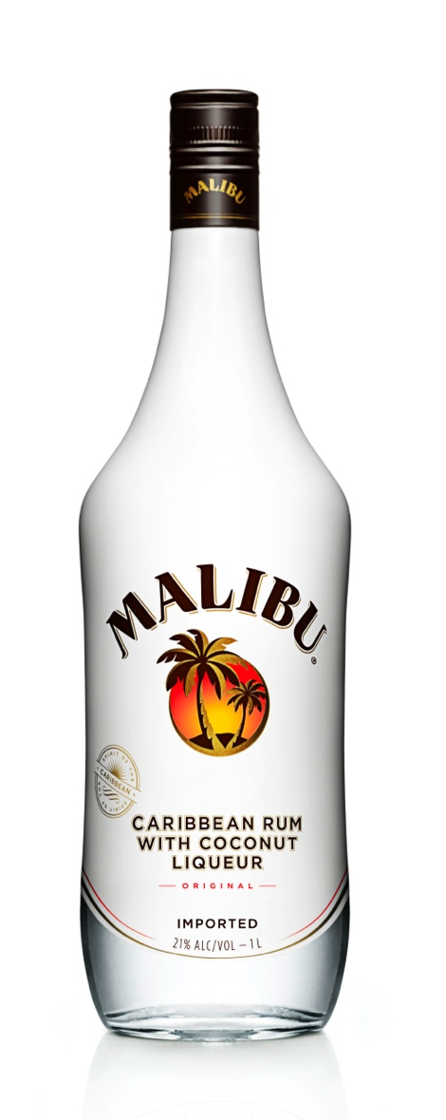
“MALIBU is the original coconut-flavoured rum with a vibrant Caribbean mindset – and our iconic white bottle is well-known worldwide. But even something great can evolve. And that’s just what we’ve done with the new design,” says Katarina Nielsen, Global Brand Director at MALIBU.

“We’ve refined everything – the logo, symbol and the typography – and the bottle shape itself. The new bottle is more slender with high shoulders, giving it a distinctive, modern feel that appeals to everyone – and emphasizes the unique MALIBU character. It brings to life the energy and warmth of the Caribbean, in a highly contemporary way” says Anna Kamjou, Global Director Design Strategy at The Absolut Company.

The new logo is clean and modern and evokes the free and easy spirit of MALIBU. It captures the inspiring moment when the setting sun meets the beach, and the day opens up into an even better time.

The new bottle is designed to celebrate our spirit. MALIBU is all about spreading the summer feeling, of being carefree and open to good times all the time. Those lucky consumers who have had a sneak-peek at the new bottle say it’s a knockout – more fun, energetic, trendy and contemporary.

So say hello to MALIBU, evolved. The same fresh and clear spirit in a beautiful new bottle promising more shelf-impact, quality and style.

The new bottle will begin shipping in early 2013.

For more information, please contact:

Björn von Matérn, VP Corporate Communications,
The Absolut Company, +46 (0)70 586 72 50
bjorn.vonmatern@pernod-ricard.com

Elin Wibell, Senior Manager Corporate Communications,
The Absolut Company, +46 (0)70 190 10 41
elin.wibell@pernod-ricard.com

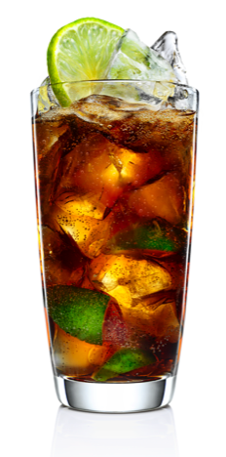
Classic drink recipes from MALIBU:
Coco-Cooler
•50ml (1 part) MALIBU
•100ml (2 parts) cola
•1 dash Angostura bitters
•1/2 fresh lime (chopped)

Method
Muddle the fresh lime with the bitters and
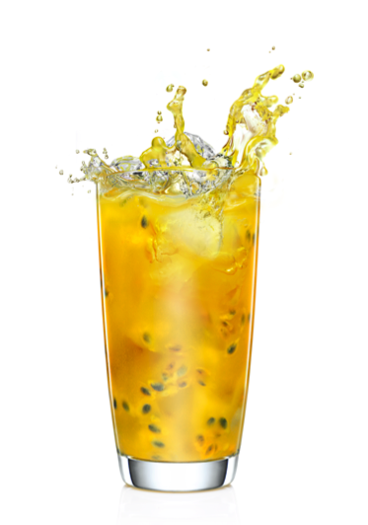
MALIBU in a highball glass. Then fill with
ice cubes and top with cola.

Lick of Sunshine
•50ml (1 part) MALIBU
•100ml (1 part) pressed pineapple juice
•1 whole pressed passion fruit or half lime
Method
Stir MALIBU and pineapple on ice in a highball glass.
Squeeze the passion fruit into the glass and stir to mix. Garnish with half passion fruit and a wedge of pineapple.

About The Absolut Company
The Absolut Company has the worldwide responsibility for the production and marketing of ABSOLUT VODKA, MALIBU, KAHLÚA, Wyborowa, Luksusowa and Frïs. ABSOLUT VODKA is the world’s fourth largest premium spirits brand. Every bottle of ABSOLUT VODKA is produced in Åhus in southern Sweden. MALIBU is the number one coconut-flavoured rum in the world, sold in more than 150 countries. As of July 2008, The Absolut Company is a company within the Pernod Ricard group, which holds one of the most prestigious brand portfolios in the sector. The head office is located in Stockholm, Sweden.

