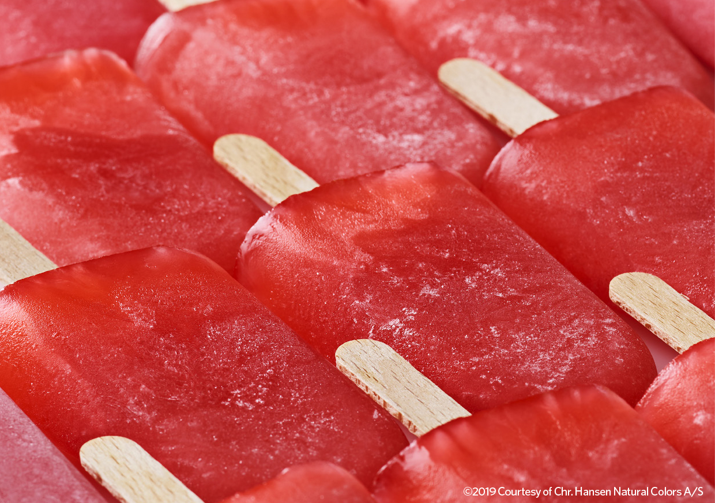

CHR-Hansen-FruitMax-red-ice-Courtesy-Pic-Press

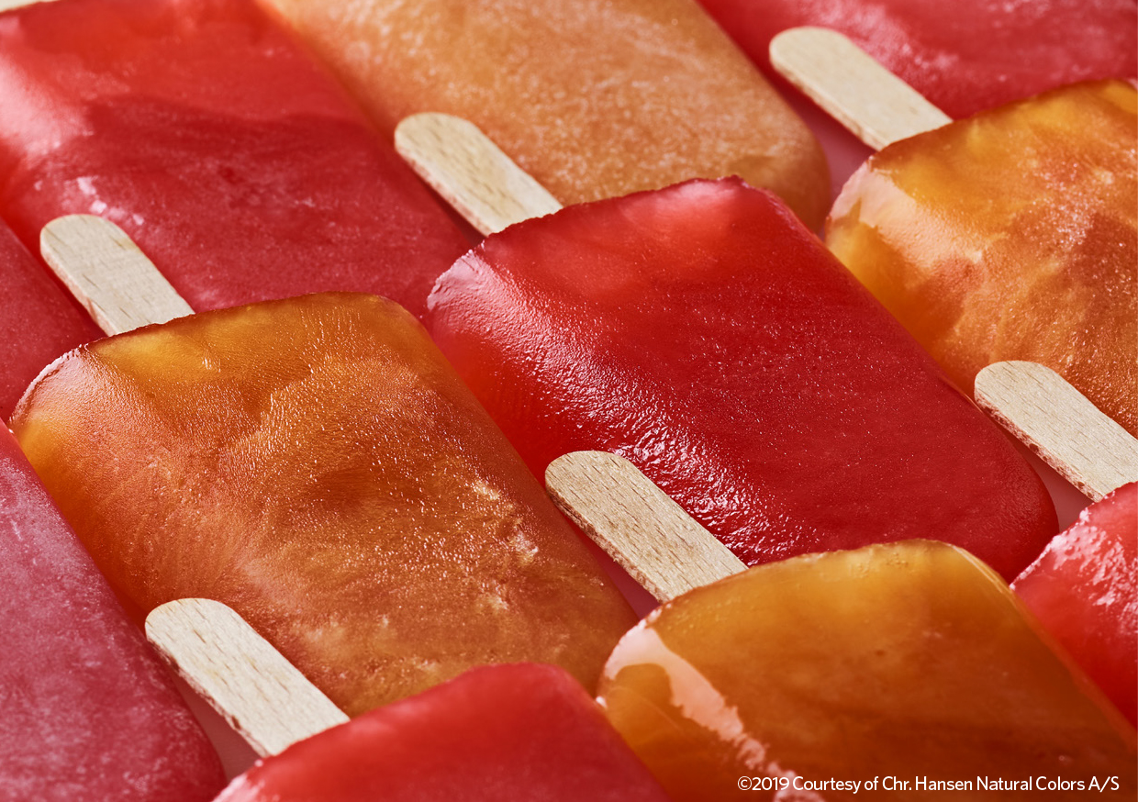

CHR-Hansen-FruitMax-red-orange-ice-Courtesy-Pic-Press

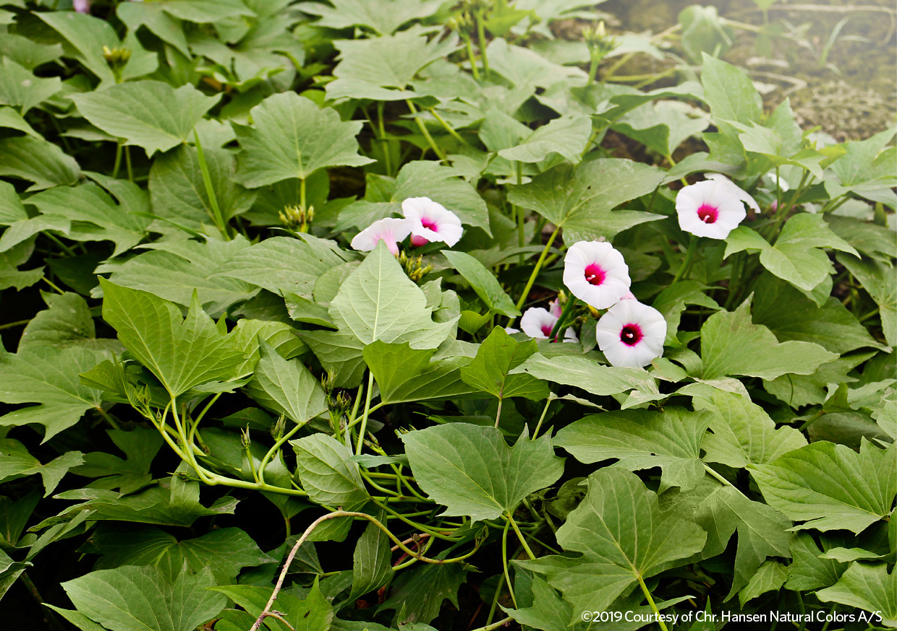

CHR-Hansen-sweet-potato-blossom-Courtesy-Pic-Press

