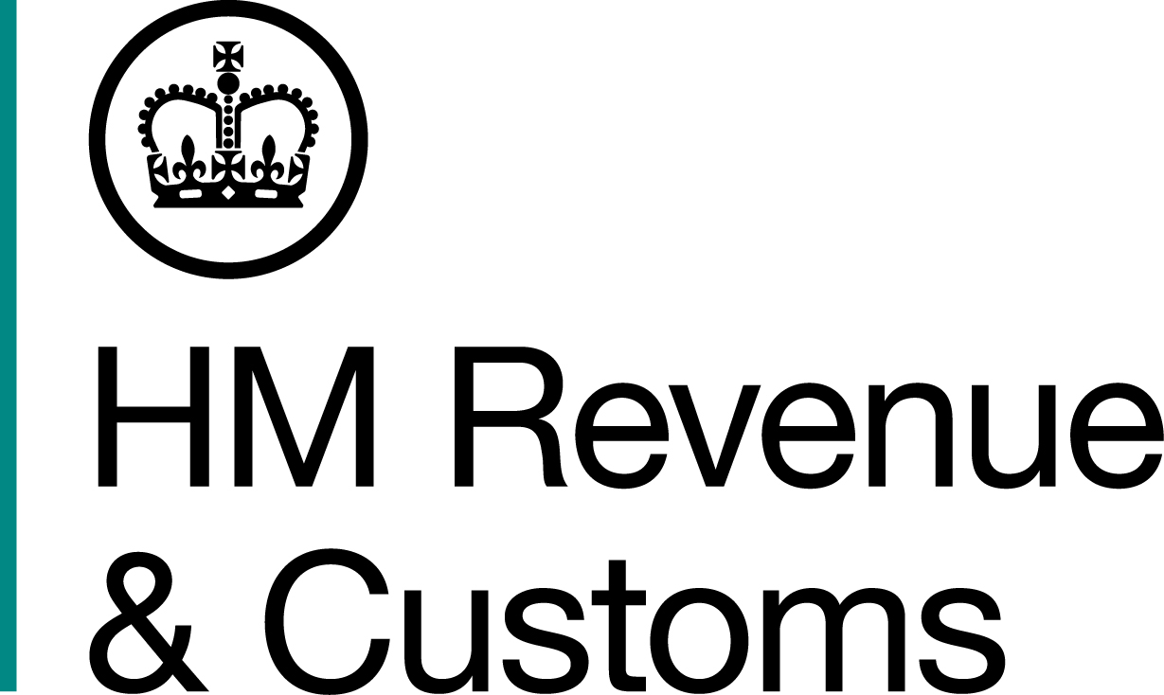
News Release

 | For the attention of News Desks |  | No. of pages: 4
 | Date: | 09 January 2016 | Ref: | NI 01/17

Organised crime gang sentenced in £2.6 million fuel scam

Nine people, including the owner of a Belfast based fuel supply company, have been sentenced for their part in the laundering, concealing and distribution of an estimated 4.5 million litres of red diesel after an investigation by HM Revenue and Customs (HMRC).

In a crime worth over £2.6 million in lost duty and taxes the gang, headed by Robert Clarke (65), the owner of Clarke fuels based on the Shankhill road, and Mark Pollock (37), laundered millions of litres of red diesel for sale as legitimate road fuel to unsuspecting motorists. Clarke from Dundrod Road, Crumlin, and Pollock from Lyndhurst Grove, Belfast, were jailed when they appeared at Laganside Crown Court today, Monday 9 January.

HMRC began investigating the gang in 2010 and over the next two years traced their illegal laundering activities, false paperwork trails and fuel distribution network, revealing a sophisticated organised crime network. As part of the investigation into the gang HMRC officers carried out searches of 13 commercial and private premises in Belfast and Co Antrim in June 2011 uncovering a mobile laundering plant, seizing more than £285,000 in cash and 74,000 litres of illicit fuel.

The investigation uncovered how Clarke had used his business to purchase huge quantities of red diesel, which was then laundered. Pollock oversaw the fraud, working with others to launder the fuel, dispose of the waste and hide the fraud behind a false paper trail.

Steve Tracey, Assistant Director, Fraud Investigation Service, HMRC, said:

“This was a determined, organised and sustained attack on the tax system, stealing public funds to line the pockets of criminals. Week in, week out, these crooks used apparently legitimate businesses to introduce huge quantities of laundered fuel into the region, attempting to hide the fraud behind a veneer of legitimacy.

“Disrupting criminal trade is at the heart of our strategy to clamp down on the illegal fuel market, which costs the taxpayer around £50 million a year and jeopardises the legitimate fuel retail trade in Northern Ireland. I encourage anyone with information on this type of fraud to contact our 24-hour hotline on 0800 59 5000.”

Before sentencing Clarke and Pollock, at Laganside Crown Court today (9 January) His Honour Judge Millar said:

“Both had an organisational role in the conspiracy – a professional smuggling organisation.”

Notes for editors

- Robert Clarke (DOB 26/12/1951) from Dundrod Road, Crumlin, was given a two years prison sentence, when he appeared at Laganside Crown Court on Monday 9 January. Clarke will serve 12 months in custody, the second year of his sentence will be served on licence. He pleaded guilty at an earlier hearing in November 2016 to the fraudulent evasion of Excise Duty contrary to Section 170 of the Customs and Excise Management Act 1979.

- Mark Pollock (DOB 28/01/1979), from Lyndhurst Grove, Belfast, was sentenced to two years and eight months prison when he appeared at Laganside Crown Court on Monday 9 January. Pollock will serve16 months in custody and the remaining 16 months on licence. He pleaded guilty at an earlier hearing in November 2016 to the fraudulent evasion of Excise Duty contrary to Section 170 of the Customs and Excise Management Act 1979 and possession of criminal property, contrary to S329(1) of the Proceeds Of Crime Act 2002.

The other gang members involved in the fraud and previously sentenced were:

- Billy George (DOB 08/07/1969) from Glenwood View, Poleglass, Dunmurry, was involved in the day-to-day fuel laundering activities including transportation of the laundered fuel. He was sentenced to two and a half years in prison, suspended for three years, when he appeared at Laganside Crown Court on Tuesday 4 October 2016. He pleaded guilty at an earlier hearing in September 2016 to the fraudulent evasion of Excise Duty contrary to Section 170 of the Customs and Excise Management Act 1979.

- Paul Keenan (DOB 21/12/1968) from Creeslough Park, Belfast, was involved in the day-to-day fuel laundering activities including transportation of the laundered fuel. He was sentenced to two and a half years in prison, suspended for three years, when he appeared at Laganside Crown Court on Monday 3 October 2016. He pleaded guilty at an earlier hearing in September 2016 to the fraudulent evasion of Excise Duty contrary to Section 170 of the Customs and Excise Management Act 1979.

- Rachel McKeown (DOB 15/01/1970) from Carntogher Road, Lisburn, Co. Down, as office clerk, aided in giving the conspiracy a veneer of legitimacy by creating false accounts and paperwork in an attempt to hide the true destination of the red diesel purchased by Clarke Fuels. She was sentenced to 12 months in prison, suspended for two years, when she appeared at Laganside Crown Court on Monday 27 June. McKeown pleaded guilty at an earlier hearing in June 2016 to having knowingly or recklessly made or signed declarations, on documents, contrary to section 167(1)(a) of the Customs and Excise Management Act 1979.

- Alan Mc Veigh (DOB 15/11/1982) from Forthriver way, Belfast, operated a filing station on the Crumlin road on behalf of the gang and was selling laundered fuel as legitimate road diesel. He was sentenced to two and a half years in prison, suspended for three years, when he appeared at Laganside Crown Court on Monday 3 October 2016. On 21 June 2011 HMRC officers entered a filling station in Belfast and carried out tests on the fuel. The road diesel on sale was found to be laundered red diesel. Alan McVeigh was arrested and interviewed. He pleaded guilty at an earlier hearing in September to the fraudulent evasion of Excise Duty contrary to Section 170 of the Customs and Excise Management Act 1979.

- Tracey O’Neill (DOB 24/09/1976) from Gortgonis Road, Coalisland, Dungannon, as bookkeeper, aided in giving the conspiracy a veneer of legitimacy by creating false accounts and paperwork in an attempt to hide the true destination of the red diesel purchased by Clarke Fuels. She was sentenced to two and a half years in prison, suspended for three years, when she appeared at Laganside Crown Court on Friday 7 October 2016. She pleaded guilty at an earlier hearing in September 2016 to the fraudulent evasion of Excise Duty contrary to Section 170 of the Customs and Excise Management Act 1979.

- Derek Stevenson (DOB 01/11/1961) from Gortnagallon Road, Crumlin, Co. Antrim, provided a shed at his home in the Gortnagallon Road area to launder the red diesel. He was sentenced to two years in prison, suspended for three years, when he appeared at Laganside Crown Court on Monday 3 October 2016. He pleaded guilty at an earlier hearing in April 2016 to the fraudulent evasion of Excise Duty contrary to Section 170 of the Customs and Excise Management Act 1979.

- Ian Thompson (DOB 16/03/1959) from Ballykennedy Road, Crumlin, provided a site for laundering fuel at Ballykennedy, Road Crumlin and assisted in the disposal of laundered waste. He was sentenced to a total of eleven years in prison, suspended for three years, when he appeared at Laganside Crown Court on Monday 3 October 2016. He pleaded guilty at an earlier hearing in September 2016 to:
  - one charge of fraudulent evasion of Excise Duty contrary to Section 170 of the Customs and Excise Management Act 1979
  - two charges of fraudulent evasion or attempted evasion of excise duty and Value Added Tax chargeable on goods, contrary to section 170(2) of the Customs and Excise Management Act 1979
  - two charges under The Waste and Contaminated Land (Northern Ireland) Order 1997.

- Anyone with information about people who may be involved in tax fraud can contact the Customs Hotline on 0800 59 5000.

- Follow HMRC's Press Office on Twitter @HMRCpressoffice

- HMRC’s Flickr channel www.flickr.com/hmrcgovuk

Issued by HM Revenue & Customs Press Office

Press enquiries only please contact:
Stephen Cassidy
Tel: 03000 511 593
Email: stephen.cassidy@hmrc.gsi.gov.uk

Out of hours Tel: 07860 359544 Website www.hmrc.gov.uk

