Bio for media

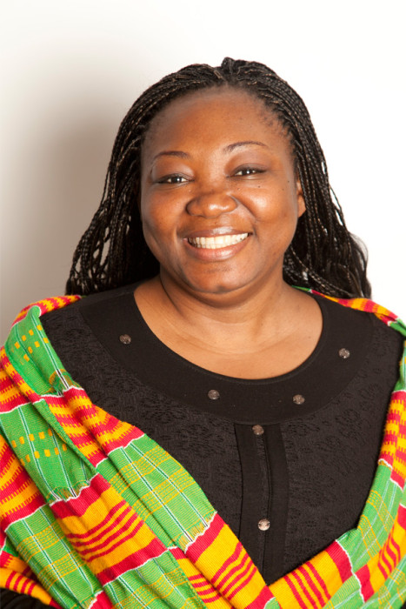
Nnenna Nwakanma (Twitter: @nnenna, email: nnenna.nwakanma@webfoundation.org)
Nnenna advocates for open data, open government and an open web across Africa. She is a Senior Policy Manager for the World Wide Web Foundation where she, among many other things, started the Foundation’s first gender data project – TechMousso, which brought together the data and tech communities with women’s rights organizations to tackle gender challenges in Côte d’Ivoire.

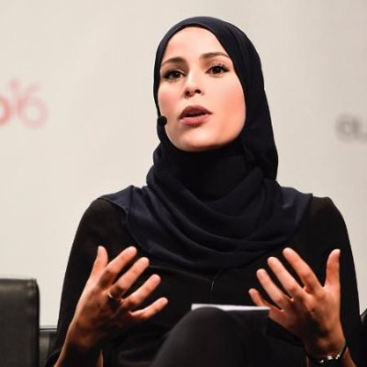
Alaa Murabit (Twitter: @almmura, email: alaa@alaamurabit.com)
Alaa Murabit is a medical doctor, the founder of Voice of Libyan Women (VLW) and The Omnis Institute as well as one of 17 United Nations Sustainable Development Goal Global Advocates. Murabit was born in Canada but moved with her family to Libya in 2004. She was recently named a 2017 Forbes Under 30 for her work in global health policy and a Harvard University Law 2017 “Woman Inspiring Change”.

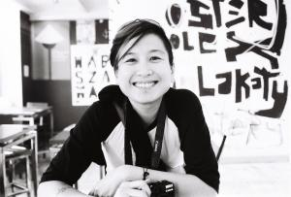
Jac sm kee (Twitter: @jhybe, email: jac@apcwomen.org)
Jac sm Kee is an internationally renowned feminist activist, writer and scholar from Malaysia. She leads APC’s Women’s Rights Programme, which works to prevent online violence against women, encourages web-based gender research, and facilitates network and movement building on feminism and technology.

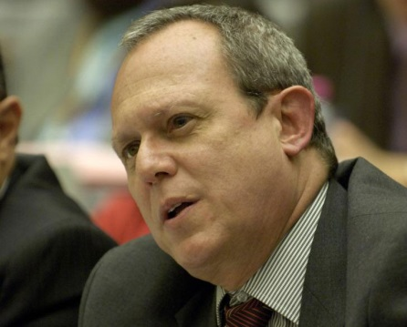
Frank La Rue (Twitter: @FLarue_libex, email: f.la-rue@unesco.org)
Frank La Rue is a Guatemalan labor and human rights law expert. After serving as a legal adviser for Guatemala’s largest labor union during the civil war, La Rue sought exile in the US in 1981. After his return in 1994, he brought the first genocide cases against former Guatemalan military dictatorships in 2000. In 2004 he was nominated for the Nobel Peace Prize. La Rue currently serves as Assistant Director-General for Communication and Information at UNESCO.

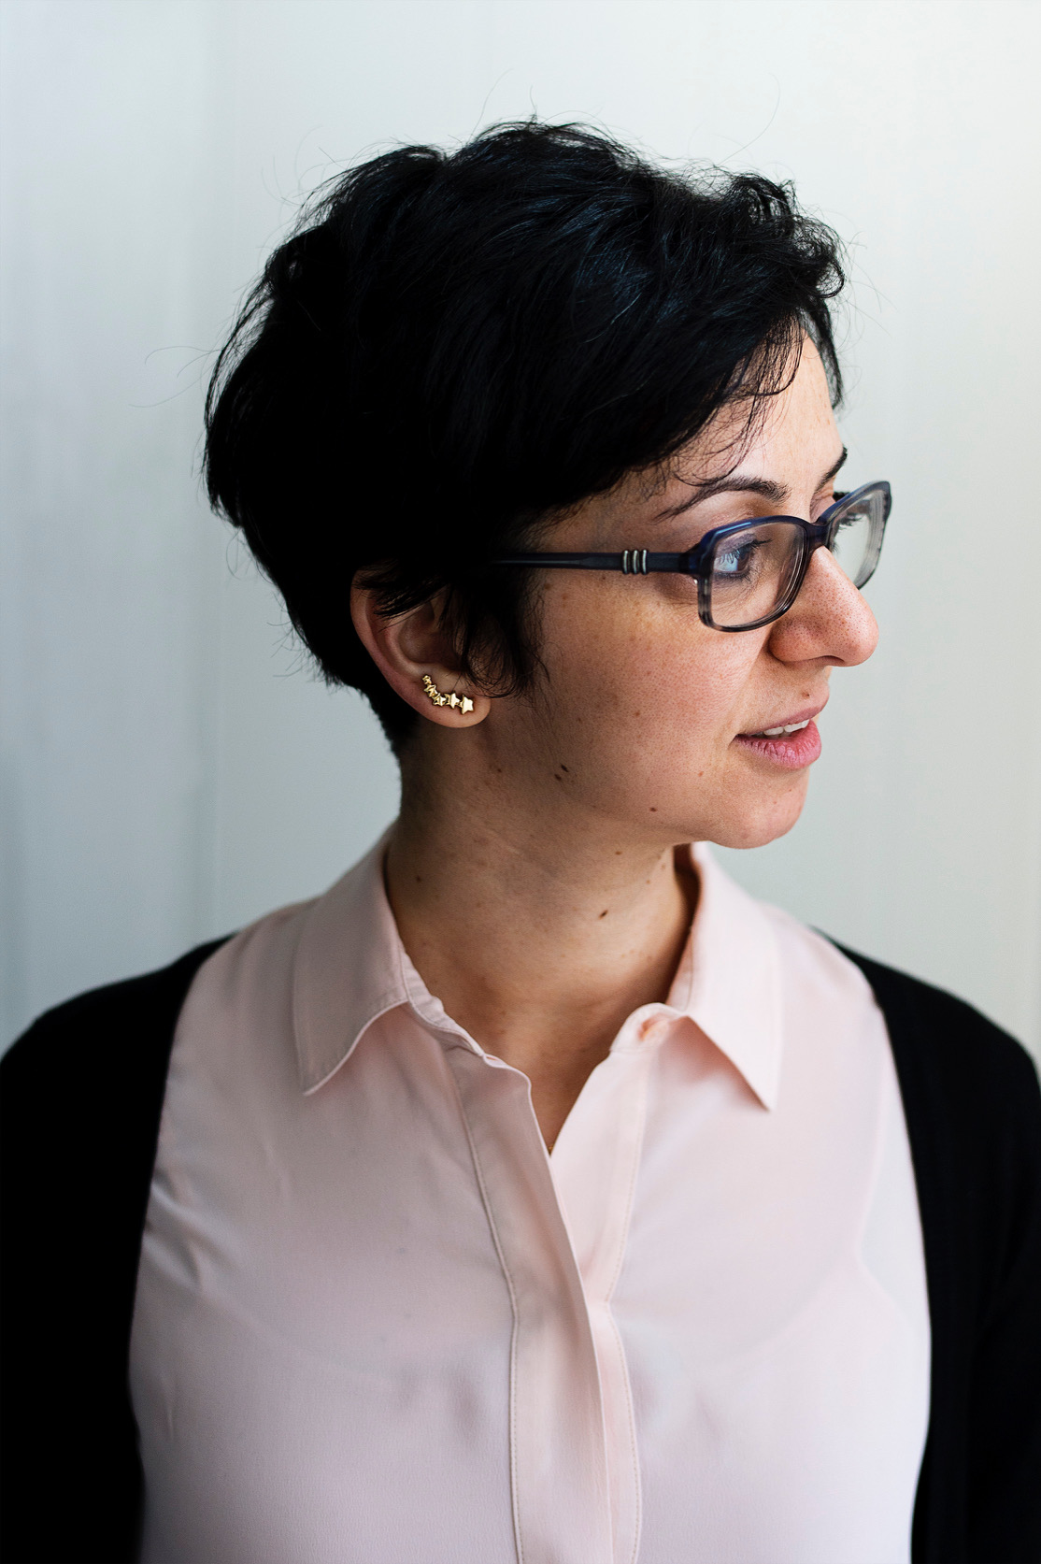
Lina Ejeilat (Twitter: @lina18, email: lina@7iber.com)
Lina Ejeilat is co-founder and executive editor of 7iber.com, an online magazine that publishes in-depth multimedia content and critical analysis on Jordan and the region. 7iber started in 2007 as a citizen media platform before evolving into a professional magazine in 2012, and has always defended values of human rights, accountability, rule of law, and pluralism.

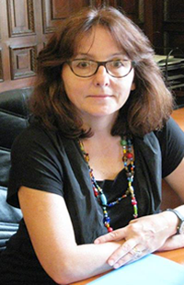
Dubravka Simonovic (email: dubravkasimonovic@yahoo.com)
Dubravka Šimonovic serves as United Nations Special Rapporteur on violence against women, its causes and consequences. For a number of years, she headed the Human Rights Department at the Ministry for Foreign Affairs of the Republic of Croatia. She was the Chairperson of the UN Commission on the Status of Women between 2001 and 2002 and also worked as a member of the UNIFEM Consultative Committee.

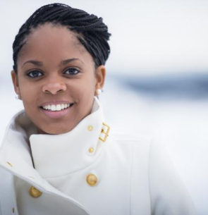
Jaqueline Pateguana (email: jpateguana@mocambiquedigital.gov.mz)
Jaqueline Pateguana is an advisor to the Minister of Transport and Communications in the Republic of Mozambique. She has a long experience working in the information and communications technology (ICT) sector in Mozambique. and has previously served in various positions for organizations including the National Commission for Digital Migration (COMID), Statoil Oil and Gas Mozambique AS, and Mozambique Cellular (mcel).

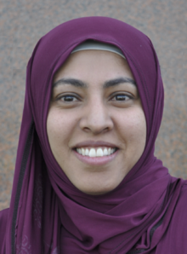
Nadia Al-Sakkaf (Twitter: @NadiaSakkaf, email: nadia.a.alsakkaf@gmail.com)
Nadia Al-Sakkaf is a journalist and a politician. Al-Sakkaf became the chief editor of the Yemen Times in March 2005, and quickly became a leading voice in Yemen and worldwide media on issues of media, gender, development and politics. In 2014, she became Yemen’s first female Minister of information. When the war in Yemen erupted, she used the Internet and particularly Twitter to get information about the unfolding situation. She is now a PhD researcher at Reading University in the United Kingdom.

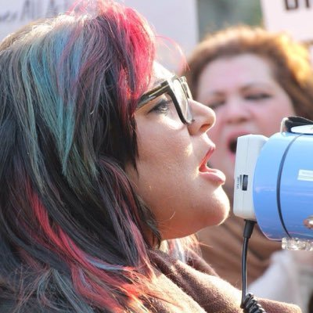
Nighat Dad (Twitter: @nighatdad, email: nighat@digitalrightsfoundation.pk)
Nighat Dad is the Executive Director of Digital Rights Foundation, Pakistan. She is an accomplished lawyer and a human rights activist. Nighat Dad is one of the pioneers who have been campaigning around access to open internet in Pakistan and globally. She has been actively engaging at a policy level on issues focusing on Internet Freedom, Women and technology, Digital Security and Women’s empowerment.

Bashar Lubbad (Twitter: @iBashar , email: bashar.lubbad@gmail.com)
Bashar Lubbad is a Palestinian videographer and editor who is also a rapper/blogger. Lubbad came to Sweden from Gaza through an exchange program with Lund University. In Lund he developed a successful spoken word concept Hope Spoken/Broken https://hopespokenbrokenblog.wordpress.com/

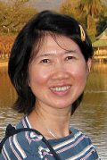
Nantiya Tangwisutijit (Twitter: @NTijit, email: nantiya@internews.org)
Tangwisutijiti is a grass root journalist who, with great engagement and dedication, covers questions regarding environment as well as the rights of Thailand’s farmers and fishermen. She received EU fellowship for environmental economics training at Roskilde University Centre in Denmark and an Asia Foundation research fellowship on water resources management in the United States.

Eva Blum-Dumontet (Twitter: @Arcadian_O, email: eva@privacyinternational.org)
Blum-Dumontet is a British/French activist who been spending the past years examining and controlling security issues regarding data and integrity in relation to our new (and future) smart cities. Eva is also a Research Officer at Privacy International and collaborates with international partners on promoting a better awareness of surveillance programs carried out in countries across Africa, South America and Asia.

Michael Carbone (Twitter: @wandermfc, email: michael@accessnow.org)
Michael Carbone is leading the work with the “digital security helpline”, a helpline created by Access Now for threatened journalists, activists, LGBT-oganisations and other defenders of human rights around the world. The helpline is open 24/7 and is answered by staff on three different continents. Previously, Carbone interned at the International Reporting Project and the Office of Communications and Information Policy at the US State Department.

Paulina Gutierrez (Twitter: @paulinagtzr, email: paulina@article19.org)
Paulina Gutierrez works for Mexican Article 19, an organization working for the safety of journalists in a country where journalists are continuously threated, disappearing and/or being killed.

