
Pressrelease Karlsborg 2012-12-05

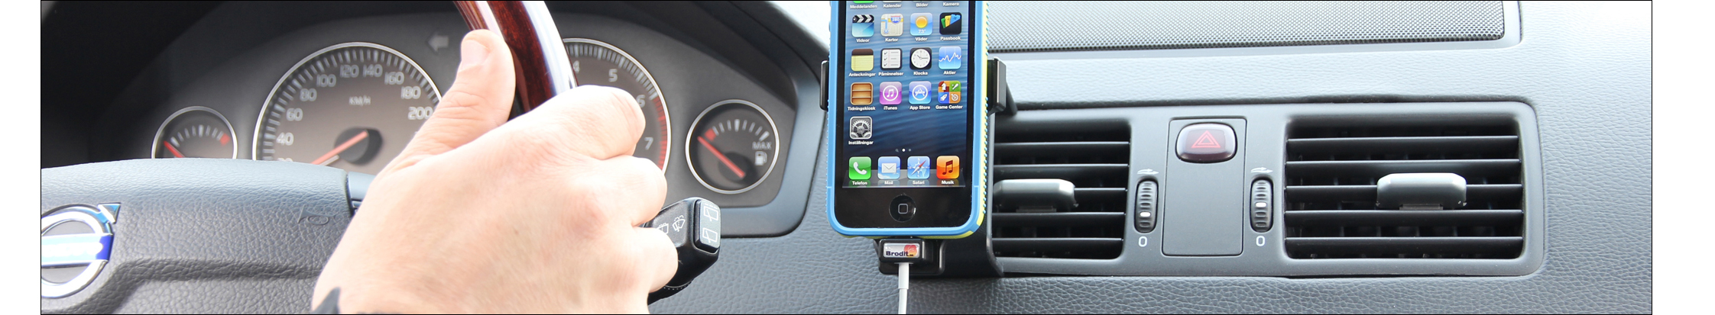

Charge your iPhone 5 while driving
By using a holder attached onto the dashboard it will be easier and safer to use your iPhone 5 while driving. The Swedish company Brodit has developed a holder which you place within easy sight and reach in the car, a holder which also can charge your iPhone 5.
There are not that many customized iPhone 5 accessories available to choose from yet. Brodit offers a range of models, the latest one is a unique solution; a holder for cable attachment. The product is to be combined with an Apple original Lightning cable in order to get power supply or to dock the device to iPhone ready cars.
Holders for cable attachment are available as two versions; one for Apple’s USB-cable and one for Apple’s 30-pin adapter cable. The later you use if you have an iPhone ready car. The version for the USB-cable is used for charging your iPhone, the cable is then connected to the car’s USB- socket, or, combined with an adapter, to the 12 Volt socket. The holder is available with and without the USB/12 Volt adapter. It is easy to attach the cable onto the holder; it is then firmly in place and connects automatically to the phone when you place it in the holder. The cables are not included with Brodit’s holder, they are available for purchase online e.g. on Apple store.
-We’ve noticed how users are demanding higher quality and usability also on accessories, Ebbe Johansson, founder and CEO of Brodit, says. Not only is it essential to have a great smartphone, now great accessories too are of the essence. People today want to use their phone in a smart and practical way, wherever they are, whatever they do. They are also more safety conscious while on the road. This is where our holders come in! Johansson says.
Brodit’s product concept consists of a two-part solution; a device holder and a vehicle mounting bracket (ProClip). The installation is quick and easy, you can do it yourself without drilling holes or in any other way damaging the interior. All products are model specific.
Holders for cable attachment are available both for iPhone with and without skin. A tilt swivel on the holder makes it easy to adjust the angle in order to avoid light reflections on the screen. The holder is available via Brodit’s distributors.
Prices starting from €45.
------
Pictures and more pressreleases regarding Brodit’s products are available at www.mynewsdesk.com/se/pressroom/brodit
For more information, do not hesitate to contact:
Heidi Eskonniemi, marketing assistant, +46 (0)505-177 78, heidi@brodit.se
About Brodit AB:
Brodit develops and manufactures products for installation of communication devices in vehicles. Brodit was founded in 1983 and is located in Karlsborg, Sweden. The company has 80 employees, is market leading in mounting solutions in vehicles and exports to 30 countries. More information at www.brodit.com

