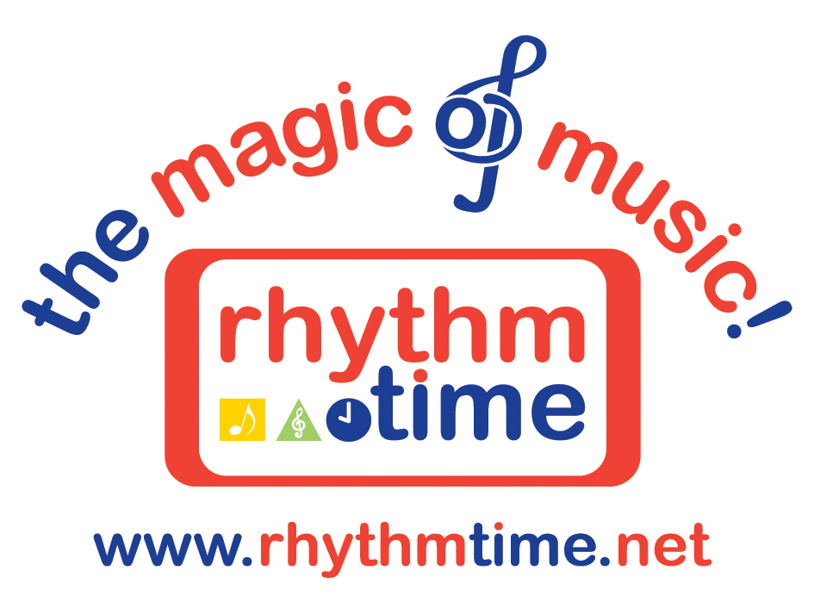

PRESS RELEASE
23 February 2012
(BABY MUSIC CLASS)

New Rhythm Time Baby Music Class Created from Latest Free Demonstration

Rhythm Time, one of the leading providers of educational music classes for babies, toddlers and pre-schoolers, is delighted to announce the creation of a brand new class in Solihull following the success of their latest free baby music class demonstration.

The free demonstration, held on the 6th February 2012 in Solihull, has been one of the most popular with over 30 parents and their babies being booked on the day. This has enabled the award-winning children’s music provider to add an extra baby class to their weekly timetable to satisfy demand for their popular music classes.

This is the latest of a highly successful number of baby music class demonstrations that Rhythm Time in Solihull run on a half-termly basis. Kathy Doolan, founder and owner of the Company is passionate about the benefits that music can bring to a young child. “Music stimulates all their senses and can enhance their development, for example through speech development, social skills, confidence, co-ordination, creativity, as well as many other areas,” she says.

Last year, Rhythm Time supported the National Year of Communication’s Hello campaign by helping to provide musical resources for families of children at Birmingham Children’s Hospital requiring Speech & Language Therapy (SLT). SLT Therapists at the BCH have been utilising Rhythm Time class principles to meet some of their aims to promote early language development and interaction opportunities.

“To enjoy music, it is important to nurture and foster an interest in it as early as possible, “ adds Kathy. “Children who are exposed to a wide variety of musical concepts and experiences (particularly at a baby music class and beyond) will enjoy music for the rest of their lives. They are also at their most receptive at this young age and research shows that it will benefit them in three ways: emotionally, intellectually and physically.”

Rhythm Time’s unique music courses, written by Kathy (previously Head of Music at a Scottish school) are aimed at three different age groups: babies, toddlers and pre-schoolers. Each course provides continuity of skills achieved at each stage.

In their baby music class, activities aim to stimulate vision, listening and sense of touch. This helps with eye tracking, balance, development of the inner ear, speech, language and small motor movements.

In their music classes for toddlers, the musical activities aid listening and concentration. Hand eye co-ordination and motor skills are strengthened by using musical instruments. Language and vocal chords are developed from singing.

In their music classes for pre-schoolers, their communication, language, literacy, maths skills and creative development are developed.

For a free trial at a Rhythm Time class throughout the UK, or for more information on owning a Rhythm Time music franchise, contact Kathy Doolan on 0121 711 4224 or visit www.rhythmtime.net

Ends
Word Count 457

Information for Editors
www.rhythmtime.net

Rhythm Time
76 Beechwood Park Road
Solihull
B91 1ES
Telephone: 07813 831516 / 0121 711 4224
Email: marketing@ftfg.co.uk

Rhythm Time was started in Solihull in 1995 by Kathy Doolan. After a very successful five years, Kathy decided to franchise the business in 2000.
Free demonstrations are held at the end of each half term in Solihull to show parents with young babies how music can assist in their child’s development.
All the courses have been created by Kathy, who trained at the Royal Scottish Academy of Music & Drama in Glasgow.
Rhythm Time now has franchises all over the UK, operating in 300 venues with approximately 9500 children attending classes
Rhythm Time offers three age-appropriate classes for babies (birth to 15 months), toddlers (15 months to three years) and pre-school (three to school age).
Children come to Rhythm Time as tiny babies and progress to toddler and pre-school classes, enjoying a wonderful introduction to music.
A free trial session is offered to all parents before they decide to join.
Kathy shares with all her franchisees and teachers a real passion and belief in the importance of music during a child’s formative years. She is also a strong believer that singing unaccompanied helps to develop a child’s speech and language from an early age and this forms a key element in all the classes.

