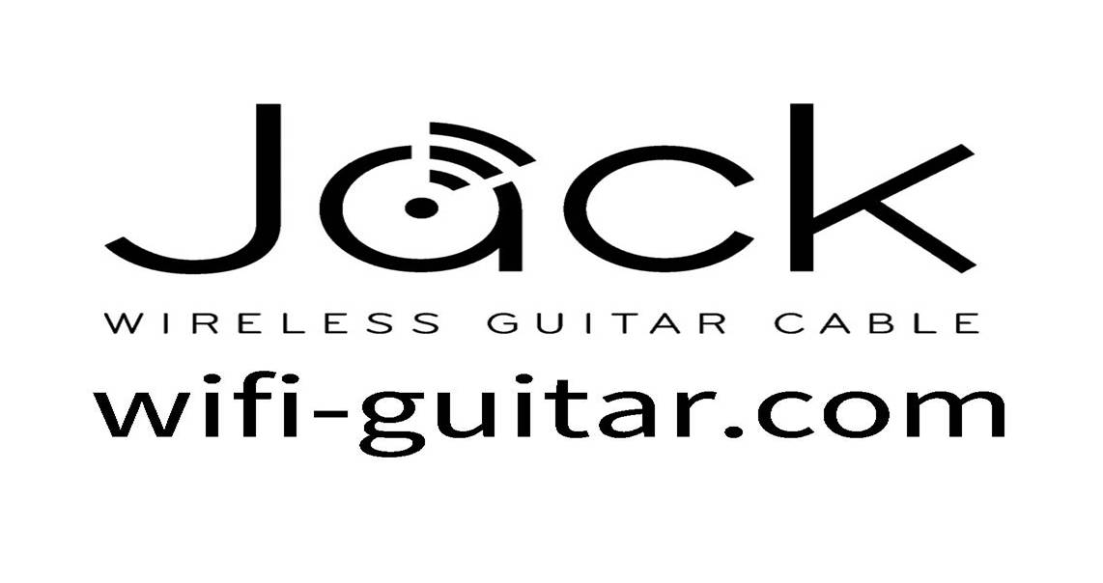
Ingenious Audio Limited
Edinburgh UK
Media Contact: John Crawford
(+44) 7889 350089
john@ingeniousaudio.co.uk

FOR IMMEDIATE RELEASE

JACK – Ditch the Cables with the World’s First WiFi Guitar Lead

Turning Wi-Fi Up To 11

Edinburgh, UK, January 5, 2015 – a new Scottish technology company is about make the biggest change to home music recording in 50 years with the launch of “Jack” on Kickstarter.com today.

Jack is the first plug-in device to turn any guitar or amplifier into a Wi-Fi device for wireless playback and studio quality connection to unmodified PCs, Tablets or Smartphones.

Users can then play in real time to their amplifiers or pedals and/or record, edit and share on their favorite Wi-Fi devices.

See the JACK demo video here: http://youtu.be/G1pDoA6xAp0

- The first Wi-Fi real time audio connection to amps, pedals or unmodified PCs, Tablets or Phones
- Studio quality uncompressed 24bit real time audio
- Ultra low latency - Jack’s patent pending technology is nearly 13 times quicker than conventional Bluetooth and about 3 times faster than compressed "low-latency" Bluetooth
- No need for a router, internet connection or PC
- Selected as a Kickstarter “staff pick”

This revolutionary technology does away with conventional cables and the need for expensive wired audio interface hardware and soundcards,

Ingenious Audio founder, John Crawford, said “Using Wi-Fi means Jack can connect to the 5 billion Wi-Fi enabled devices out there. Current wireless kits often fall into one of two camps, very basic old style radios which are prone to interference and questionable audio and hugely complex expensive systems really only suitable for big venues; none of which have the easy connection to devices that Wi-Fi does.”

For the millions of home guitarists who want to free themselves of wires and connect directly to their amps, pedals mobile devices, Jack is the answer.

www.wifi-guitar.com

Jack will be offered at early bird Kickstarter prices of $280 for two Jacks for connection to amp, pedal, and Wi-Fi device; and $148 for one Jack for connection to Wi-Fi device only

# # #

Formed in 2010 and based in Edinburgh with design teams in Glasgow, Ingenious Audio is a dedicated team of audio engineers and guitar fanatics.

