**Isansys’ ‘washable’ high-tech patient sensors feature in the Government’s latest Great Britain campaign**

**Abingdon, United Kingdom, July 08, 2017 -** Isansys Lifecare is delighted to announce that we have been chosen to feature in the “GREAT for Imagination” campaign.

This an initiative supported by the Intellectual Property office and the GREAT Britain campaign that marks the 400th anniversary of the grant of the first British patent.

“GREAT for Imagination” celebrates UK innovation over the last four centuries and our entry is linked to our ‘washable’ high-tech patient sensors which provide continuous individual monitoring and can be recycled and re-used for multiple patients. This makes treatment faster and more efficient, saving lives, reducing hospital stays and protecting the environment.

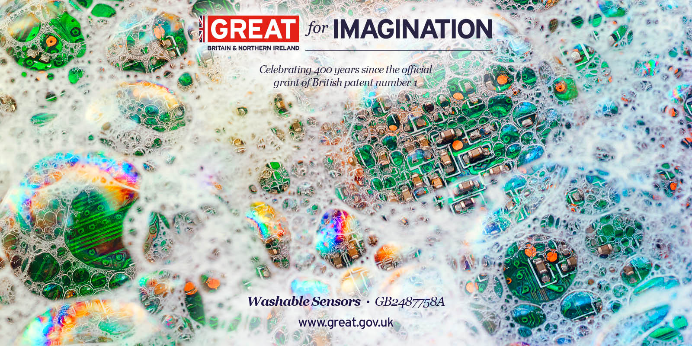

For more information about Isansys patent for its innovative patient monitoring platform, please click [here](http://www.isansys.com/newsrelease/65/Isansys+Lifecare+Granted+Key+Patent+for+Its+Innovative+Patient+Monitoring+Platform).

Find out more by following @GREATforImagination on Instagram or @GREATBritain on Twitter.

~ ENDS ~

**Press Contacts:**

Georgina Horton, PR and Marketing Executive

Tel: 01235 436229

Mob: 07852 181898

Email: [georgina.horton@isansys.com](mailto:georgina.horton@isansys.com)