Press Release
For immediate release

Did you leave the iron on this morning?
Putting you in control of your home’s electricity consumption with GEO’s new Home Energy Management System
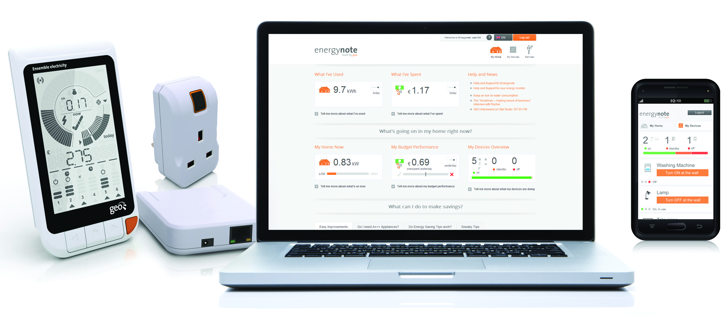

September 11th, 2012 (Cambridge, UK) – Green Energy Options (GEO) is launching the Ensemble home energy management system and GEO’s new energynote online service, providing an easy way to manage your home’s electricity consumption as well as controlling home appliances. Wherever you are, the Ensemble allows you to monitor and switch on or off individual appliances using GEO’s Smart Plugs, which can be controlled from the Ensemble display or from a PC, Tablet or Smartphone using energynote.

In-home, online or on the move, you can see if you left the iron on this morning!

The Ensemble home energy management system:
- displays energy consumption in real-time and against your home energy budget, giving you peace of mind
- enables up to 6 home appliances to be monitored and controlled remotely using GEO’s Smart Plugs
- brings this monitoring and control to wherever you are, using GEO’s new online services on a PC, Tablet or any major smartphone
- provides an historic view of energy consumption, helping you create an energy efficient home

How it works:
The Ensemble display helps households manage their energy consumption through a graphical ‘speedometer’ and ‘fuel gauge’ showing much electricity is being consumed right now and against the home’s energy budget, and a ‘milometer’ that shows how much electricity has been consumed today, yesterday, or over the last 7 or 30 days. Consumption information is shown in terms of cost, energy units (kWh) or CO₂ produced.

Two types of GEO Smart Plugs are available: an ‘Active’ version that can be monitored and controlled and a ‘Passive’ version that can only be monitored – suitable for appliances that shouldn’t be turned off such as fridges or freezers. One Active Smart Plug comes with every Ensemble system and more can be added.

Readings from the electricity meter are transmitted wirelessly to the Ensemble system using a Sensor Transmitter and ‘CT Clips’ that can be quickly and easily installed by the home owner themselves.

The Internet Bridge connects the display and Smart Plugs to GEO’s new online service, energynote, via the home broadband router. This enables electricity consumption in the home and by appliances connected to a GEO Smart Plug to be monitored and controlled remotely from Internet-connected devices including PCs, Tablets, iPads and smartphones using an Internet browser, so no separate app is required.
“This is a really exciting development for GEO, as the Ensemble provides households with the next level of managing their in-home energy consumption – as well as being able to see what energy your house is using it allows you to control what’s going on through the use of individual smart plugs on appliances. GEO’s new online service will assist by providing tailored advice and recommendations specific to each home. These web services are being introduced progressively so that home owners can learn how to achieve an energy-efficient home without being overwhelmed by technology from the outset. We believe it will be a captivating journey for users of our Ensemble system“, says Patrick Caiger-Smith, GEO’s Chief Executive Officer.

The Ensemble home energy management system, including the display, Internet Bridge and GEO Smart Plugs, is available now in the UK from a range of sources including www.USwitch.com and Amazon.co.uk.

--Ends—
Notes for Editors
Interviews can be arranged with Patrick Caiger-Smith.

About Green Energy Options

GEO designs and produces in-home energy displays, on-line energy services and mobile applications that make energy engaging. We enable energy suppliers, meter manufacturers and installers to strengthen the relationship with your customers by putting them in control of their energy consumption, their home appliances and their energy budget in a visual, informative and engaging way. Our products & services work together with pre-smart and smart meters and micro-generation to enable the energy-efficient home.

Media Enquiries: Christine Rush, GEO, +44 1223 851 390, christine@greenenergyoptions.co.uk
For more information visit: www.greenenergyoptions.co.uk

