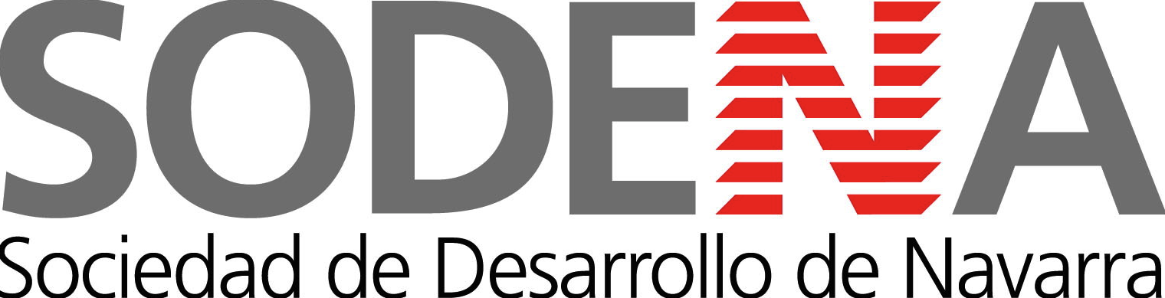

**Press release Lund, 11 November 2011**

**The Nordic Cleantech Showcase in Pamplona, Navarra, Spain**

We are happy to announce a great addition to the Nordic Cleantech Open event calendar!

On the 7-8th of March 2012 a two-day Nordic Cleantech Showcase in Spain will be hosted by Sodena, a long time investor in the Spanish Cleantech sector, now looking to expand its investment horizon to the Nordic Cleantech space!

Pamplona is the regional capital of the beautiful and prosperous Spanish region of Navarra. The region has experienced impressive growth during the last decades. This has resulted in a high economic and qualitative standard of living as well as the highest credit rating possible from Standard & Poor’s. The region is centrally located and is home to a thriving business environment. It is hard to imagine a better landing spot for a Nordic Cleantech start-up looking to expand in this part of Europe!

All the 25 Nordic Cleantech Open finalists will be offered a travel grant to join the Nordic Cleantech Showcase in Pamplona. Day one will feature meetings with investors, and industrials on site in Spain as well as clear and concise business advise on the pre-requisites for starting a business in the region. Day two of the program will be tailor-made to suit the individual company’s needs.

Sodena generously hosts the Nordic Cleantech showcase and provides the travel grants for participating companies. As well as being the official business development organisation to the Navarra region in Spain, Sodena is a very active venture capital company, with cleantech at the very core of its investment focus. A majority of the invested capital today has very successfully been employed in the energy and environment sector.

Among the success stories, Sodena was an early investor in wind turbine manufacturer Gamesa. Gamesa is the worlds third largest wind turbine manufacturer with an astonishing installed capacity of 22 000 MW.

The Navarra region is positioning itself as the prime location for cleantech company growth, and with a high degree of economic and political commitment they are in the drivers seat to achieve this.

We are very proud to present this addition to the program and to have Sodena as a partner to the Nordic Cleantech Open. We do believe that Spain is a good entry point to the European Market as well as an attractive market in its own right and we believe that we have found an optimal partner in Sodena. Their network of business contacts in the region and Sodena’s own VC fund are able to provide both business establishment support and potentially investments in companies that wish to establish a presence in the Navarra region and in Spain.

For more information, visit

<http://www.nordiccleantechopen.com>

or contact

Alexander Lidgren, +46736601007

[bigge@nordiccleantechopen.com](mailto:bigge@nordiccleantechopen.com)

**Sodena, Navarra, Spain**

http://www.sodena.com/