**MEDIA RELEASE**

**Summer Wine Dinner at Pan Pacific Manila**

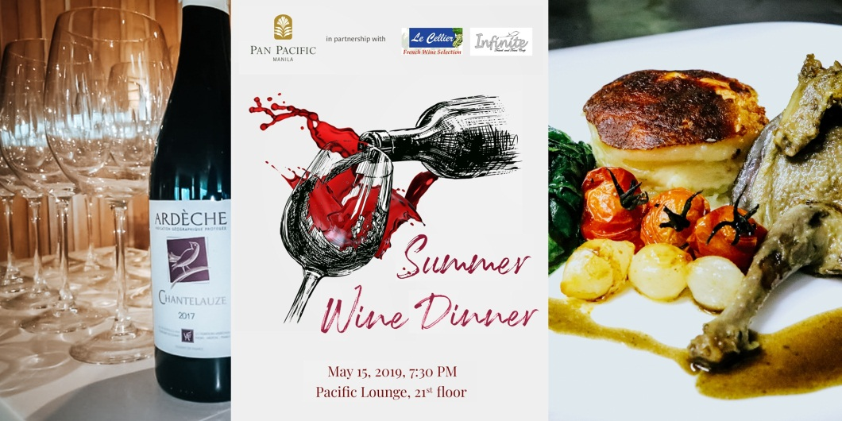

In Photo(L-R): Ardèche Rouge Chantelauze 2017, Event Poster, and Confit of “Pigeon”, Gratin Dauphinois, Wilted Kale Glazed Pearl onions and Baby Tomato, Petit Jus

21 May 2019, Manila– Pan Pacific Manila brought back the artistic flair in dining with a special wine and food pairing experience “Summer Wine Dinner” in partnership with Le Cellier French Wine Selection and Infinite Travel and Tours at their panoramic rooftop restaurant, Pacific Lounge last May 15, 2019 at 7:30 PM onwards. Guests were treated to a gastronomic world of aromas and flavors for only Php 3,500 net per person.

This tasting experience was attended by some of the prominent names in food & beverage scene and where they were welcomed with a lavish and sumptuous array of cocktails, amuse-bouche and overflowing Ardèche Blanc Chantelauze 2017 and Ardèche Rouge Chantelauze 2017 at the reception.

The Summer Wine Dinner at Pacific Lounge showcases five premium wines from Le Cellier, each paired with a distinct epicurean fare from our 4-course set dinner. Included on the menu is an appetizer of *Pan Seared Barramundi en Petit Mesclun, Warm Lemon Vinaigrette, Poached Shrimp with Basil Oil, Smoked Baby Squid with Ponzu Sauce* paired with **Vina Hermosa Blanco 2017**, followed by a *Confit of “Pigeon”, Gratin Dauphinois, Wilted Kale Glazed Pearl onions and Baby Tomato, Petit Jus* pared with **Vina Hermosa Crianza Red 2015**.

The highlight of the menu is *Herb Crusted US Lamb Tenderloin, Wild Mushroom Fricassee, Capellini with Herbs and Garlic in Red Wine Sauce* complemented by **La Grange Des Combes 2015 – Saint Chinian**, followed by a decadent dessert trio of *Mango Lychee Mille-feuille, Strawberry Moelleux, Chocolate Mint Macaron, Berries Coulis with Chocolate Cointreau Sauce* paired with **Muscat Sec 2016 IGP Pays dÓc Chateau Cabezac**.

Pacific Lounge is located on the 21st floor, Pan Pacific Manila, M. Adriatico cor. Gen Malvar Sts. Malate. For reservations, please contact (02) 318 0788 or email [dining.ppmnl@panpacific.com](mailto:dining.ppmnl@panpacific.com). Price is subject to change without prior notice.

For more information on Pan Pacific Manila, please visit:

<https://www.panpacific.com/en/hotels-resorts/philippines/manila>

**ENDS**

**Media Contact**

Stephanie Cabrejas

Assistant Marketing Manager

Pan Pacific Manila

Email: [stephanie.cabrejas@panpacific.com](mailto:stephanie.cabrejas@panpacific.com)

Tel: +63 2 917 595 1479/ +63 2 318 0788

**About Pan Pacific Manila**

The first and finest Butler hotel in the Philippines – ranked among the recommended hotel at the 2017, 2018 and 2019 Forbes Travel Guide, named one of the best places to stay in the TripAdvisor Travellers Choice Award, and also recognised among the Philippines’ Leading Business Hotels at the World Travel Awards, is conveniently located at the heart of the historical and cultural district of Malate in the Manila Bay area. Pan Pacific Manila is a short drive to the city’s convention, exhibition and business centres and a walk away from shopping, food and entertainment establishments. A business hotel, designed to offer a comfortable abode to business and leisure travellers with its excellent facilities and service, the hotel has 236 all-executive rooms and suites and 7 spacious function rooms.

**About Pan Pacific Hotels and Resorts**

With hotels, resorts and serviced suites across Asia, Oceania and North America, Pan Pacific provides a safe harbour in an ever-changing world. Places with less to worry about because, when you stay with us, rest assured that all will be taken care of. For this is where you will find your balance.

**About Pan Pacific Hotels Group**

Pan Pacific Hotels Group is a wholly-owned hotel subsidiary of Singapore-listed UOL Group Limited, one of Asia’s most established hotel and property companies with an outstanding portfolio of investment and development properties.

Based in Singapore, Pan Pacific Hotels Group owns and/or managers more than 40 hotels, resorts and serviced suites including those under development in 24 cities across Asia, Oceania, North America and Europe.

Voted “Best Regional Hotel Chain” by readers in Asia in 2017 and 2018, Pan Pacific Hotels Group comprises two acclaimed brands: its signature brand, Pan Pacific and its deluxe brand, PARKROYAL.

Sincerity is the hallmark of Pan Pacific Hotels Group. The Group is known to its guest’s partners, associates and owners for its sincerity in people and the sense of confidence which alleviates the stresses of today’s complex world.