**Small steps forward for the Bäckman’s**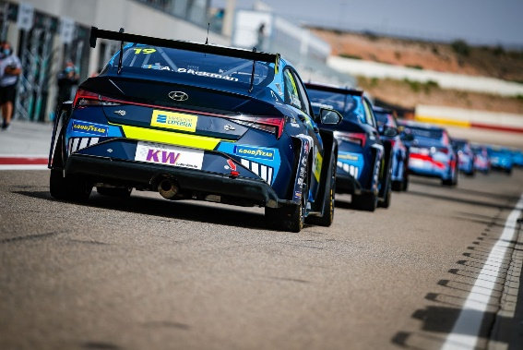Andreas and Jessica Bäckman in their Hyundai Elantra N TCR cars on the MotorLand Aragón track.   
Photo: FIA WTCR (Free rights to use the image)

**The siblings Andreas and Jessica Bäckman competed last weekend in the third round of WTCR - FIA World Touring Car Cup. It turned out to be a tough weekend for the siblings in the Spanish heat at the MotorLand Aragón track.  
- We took small steps forward together with the team with the car settings this weekend. But we are still far from where we want to be in the results list, Andreas Bäckman says.**

MotorLand Aragón, also known as the Circuito de Alcañiz, is a racing track located just outside Alcañiz in Spain. The track was built in 2007 and designed by the track designer Hermann Tilke together with the British architectural firm Foster and Partners and Formula 1 driver Pedro de la Rosa. 2010 announced that Aragón was awarded a contract to host MotoGP, which has been competing there ever since. 2020 was the first time that FIA WTCR arranged a competition on the famous track.

Last weekend, July 9th-11th, WTCR was held at the Spanish track, and it was time for the world’s top elite drivers to compete for new points. The Swedish National Team drivers Andreas and Jessica Bäckman were on the starting grid, competing for the Italian team Target Competition. The challenging track provided a race weekend with tough races, where the heat was a big challenge for the drivers and a big topic of conversation during the weekend in the paddock.

- It was almost up to 40 degrees celsius hot during the weekend, which made both races very challenging, as it gets up to 60 degrees celsius inside the cars during a race, **Jessica Bäckman** says.

**Tough weekend with some positives**The weekend started tough for the siblings during the practice sessions and also during the qualifying, where they qualified as 17th and 19th. However, there was still some positives to bring from Saturday, as the time difference to the fastest shrank a bit, which also showed during the race on Sunday. Sunday's two races offered tough duels and overtaking, where both Andreas and Jessica felt that they could keep up and challenge more than they have been able to in the last two race weekends, especially in the second race.

- Tough weekend but still a step in the right direction. We improved a lot from the practice to the qualifying, and we had a bit more speed in the races. But there is still something that is not quite right, the car is very difficult to drive, we simply do not get the car like we want, but we are working very hard to find solutions for the next race in Italy in about 3 weeks time, **Jessica Bäckman** says.

**Puncture on the last lap for Andreas**Andreas had a good start in Race 2 and drove up to 14th place in the beginning of the race. However, he had problems with the tires in the second half of the race and lost a lot of speed, which also unfortunately resulted in a puncture on the last lap and he had to retire from the race.

- We took small steps forward together with the team with the car settings this weekend and we were able to fight and compete more against the other drivers. Especially in Race 2, I had a good start and the speed to advance several positions up to a 14th place. Then it was very unfortunate that I got the puncture on the last lap meant that I had to retire and missed out on the points from that race. We are still far from where we want to be in the results, but we continue to work hard together with the team to find the solutions to the setup problems we have with the car at the moment and looking forward to the next race in Italy in two weeks, **Andreas Bäckman** says.

***Next up is the fourth round of the WTCR series, July 30th- August 1st, at Adria International Raceway in Italy.***

**Andreas’ results:**Free Practice 1: 21st place  
Free Practice 2: 22nd place  
Qualifying: 17th place  
Race 1: 16th place  
Race 2: Retired (DNF)

**Jessica’s results:**Free Practice 1: 22nd place  
Free Practice 2: 21st place  
Qualifying: 19th place  
Race 1: 19th place  
Race 2: 17th place

**WTCR Series Standings**

**FIA World Touring Car Cup for Drivers WTCR – Overall (Top 3)**FIA WTCR 2021 (After 3 of 8 race weekends)

1: Jean-Karl Vernay (FRA), 82 p.

2: Yann Ehrlacher (FRA), 74 p.

3: Yvan Muller (FRA), 67 p.

–

**21: Jessica Bäckman (SWE), 2 p.**

**22: Andreas Bäckman (SWE), 1 p.**

[See the full standings here](https://www.fiawtcr.com/standings/)

**WTCR Trophy – Overall (Top 3)**FIA WTCR 2021 (After 3 of 8 race weekends)

1: Gilles Magnus (BEL), 62 p.

2: Tom Coronel (NLD), 33 p.  
**3: Jessica Bäckman (SWE), 25 p.**-

**4: Andreas Bäckman (SWE), 22 p.**

[See the full standings here](https://www.fiawtcr.com/standings/)

**FIA World Touring Car Cup for Junior Drivers – Overall (Top 3)**FIA WTCR 2021 (After 3 of 8 race weekends)

1: Gilles Magnus (BEL), 166 p.

2: Luca Engstler (DEU), 125 p.

**3: Jessica Bäckman (SWE), 102 p.**

[See the full standings here](https://www.fiawtcr.com/standings/)

**WTCR – FIA World Touring Car Cup for Teams – Overall (Top 3)**FIA WTCR 2021 (After 3 of 8 race weekends)

1: Cyan Racing Lynk & Co, 141 p.

2: Engstler Hyundai N Liqui Moly Racing Team, 121 p.

3: Cyan Performance Lynk & Co, 112 p.

–

**11: Target Competition, 3 p.**

[See the full standings here](https://www.fiawtcr.com/standings/)

***Free rights to use the images.***

***Download press-photos here:***[***http://bit.ly/jabaeckman-photos***](http://bit.ly/jabaeckman-photos)[***https://www.mynewsdesk.com/se/ja-backman/images***](https://www.mynewsdesk.com/se/ja-backman/images)

