Meeting clinical needs in limited bone situations with Dentsply Sirona Implants’ documented solutions
Press Contact
Kerstin Wettby
Senior Manager
Global Communication & PR
Aminogatan 1
SE-43121 Mölndal, Sweden
Phone: +46 705 16 32 02
kerstin.wettby@dentsplysirona.com

About Dentsply Sirona Implants
Dentsply Sirona Implants offers comprehensive solutions for all phases of implant therapy, including
ANKYLOS®, ASTRA TECH Implant System™ and XiVE® implant lines, digital technologies, such as ATLANTIS™ patient-specific CAD/CAM solutions and SIMPLANT® guided surgery, SYMBIOS®
regenerative solutions, and professional and business development programs, such as STEPPS™. Dentsply Sirona Implants creates value for dental professionals and allows for predictable and lasting
implant treatment outcomes, resulting in enhanced quality of life for patients.

About Dentsply Sirona
Dentsply Sirona is the world’s largest manufacturer of professional dental products and technologies, with a 130-year history of innovation and service to the dental industry and patients worldwide. Dentsply Sirona develops, manufactures, and markets a comprehensive solutions offering including dental and oral health products as well as other consumable medical devices under a strong portfolio of world class brands. As
The Dental Solutions CompanyTM, Dentsply Sirona’s products provide innovative, high-quality and effective solutions to advance patient care and deliver better, safer and faster dentistry. Dentsply Sirona’s global headquarters is located in York, Pennsylvania, and the international headquarters is based in Salzburg, Austria. The company’s shares are listed in the United States on NASDAQ under the symbol XRAY.
Visit www.dentsplysirona.com for more information about Dentsply Sirona and its products.
Press Release

April 2016—The daily clinical challenges of limited bone situations and marginal bone level maintenance are met with clinically proven and documented treatment solutions from Dentsply Sirona Implants.

“We know that clinicians struggle every day with compromised cases where there is a lack of bone for successful implant treatment. With these solutions, clinicians are able to solve these various challenges and, as a result, they can deliver long-term function and esthetics to their patients,” says Björn Delin, DDS, and Vice President Global Platform Implant Systems at Dentsply Sirona Implants.

Short implants
If the height of a jaw bone is insufficient, bone augmentation is often required before implant placement. The short ANKYLOS 6.6 mm implant can be used to minimize the need for bone augmentation procedures.
In addition, in posterior regions of the maxilla and mandible, using longer implants can be a challenge due to lack of sufficient bone volume. In such situations, the use of short implants could be a mean to avoid different bone grafting treatments. In 3 randomized, controlled, clinical studies it was shown that 6 mm OsseoSpeed implants (ASTRA TECH Implant System) were equally successful when compared with 11 mm long implants with respect to implant survival and marginal bone level maintenance.¹⁻⁴
For more information on our short implants, see the Scientific Review “Short Implants” at www.dentsplyimplants.com/Science/Scientific reviews

OsseoSpeed Profile EV implant
Marginal bone preservation is an important factor to achieve excellent esthetic results. However, it is a clinical reality that crestal bone resorbs after tooth extraction or tooth loss. This resorption is often more pronounced on the buccal side, resulting in a lingual-to-buccal
sloped ridge.
The OsseoSpeed Profile EV implant is placed level with both buccal and lingual marginal bone, where the design supports the soft tissue by preserving marginal bone 360 degrees around the implant. In addition, it may reduce the need for bone augmentation.
OsseoSpeed Profile EV is the second generation of the uniquely shaped, patented implant specifically designed for sloped ridge situations that was first introduced in 2011. The implant is now upgraded with the simplicity and design principles of the ASTRA TECH Implant System EV and a welcome addition to the portfolio.

SYMBIOS Regenerative Solutions
In clinical cases where patients lack bone quantities for stable implant placement, bone graft material can help create new bone or remodel existing ridges.
Bone formation and stability are advanced with two products in the SYMBIOS regenerative solutions portfolio: the SYMBIOS Biphasic Bone Graft Material and the SYMBIOS Collagen Membrane SR (slow resorbable).
From plant origin, SYMBIOS Biphasic Bone Graft Material is a composition of 20% hydroxyapatite and 80% ß-tricalciumphosphate, resorbing significantly faster than pure hydroxyapatite. The material is used for reconstruction of bony defects in maxillofacial surgery and augmentations. The SYMBIOS Collagen Membrane SR is a slow resorbable collagen membrane, designed to be absorbed in order to eliminate the need for surgical removal.

The SmartFix Concept
With the SmartFix concept for ANKYLOS and XiVE implant systems, the need for bone grafting may be avoided. Augmentation and critical anatomical areas can be largely circumvented by using implants placed in an angled position.

REFERENCES
1. Gulje F, Abrahamsson I, Chen S, et al. Implants of 6 mm vs. 11 mm lengths in the posterior maxilla and mandible: A 1-year multicenter randomized controlled trial. Clin Oral Implants Res 2013;24(12):1325-31.
2. Gulje FL, Raghoebar GM, Vissink A, et al. Single crowns in the resorbed posterior maxilla supported by either 6-mm implants or by 11-mm implants combined with sinus floor elevation surgery: A 1-year randomised controlled trial. Eur J Oral Implantol 2014;7(3):247-55.
3. Thoma DS, Haas R, Tutak M, et al. Randomized controlled multicentre study comparing short dental implants (6 mm) versus longer dental implants (11-15 mm) in combination with sinus floor elevation procedures. Part 1: Demographics and patient-reported outcomes at 1 year of loading. J Clin Periodontol 2015;42(1):72-80.
4. Schincaglia GP, Thoma DS, Haas R, et al. Randomized controlled multicenter study comparing short dental implants (6mm) versus longer dental implants (11-15mm) in combination with sinus floor elevation procedures. Part 2: Clinical and radiographic outcomes at 1 year of loading. J Clin Periodontol 2015;E-pub Oct 1, doi:10.1111/jcpe.12465.

IMAGES
are available in our News & Press Room at:
www.dentsplyimplants.com/en/Resources/News-and-Press
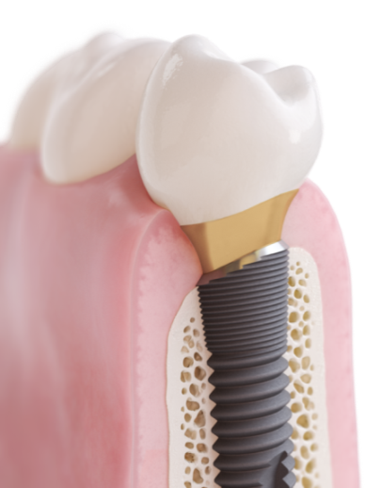 |  |  | 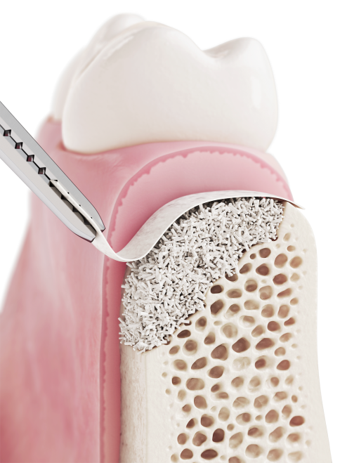
Fig.1: OsseoSpeed Profile EV implant |  |  | Fig.2: OsseoSpeed Profile EV implant
Fig.3: The SmartFix concept for ANKYLOS |  |  | Fig.4: The SmartFix concept for XiVE

