News Release July 23, 2019

Yanmar Demonstrates Autonomous Tractors Using
Precision Positioning Technology in Thailand
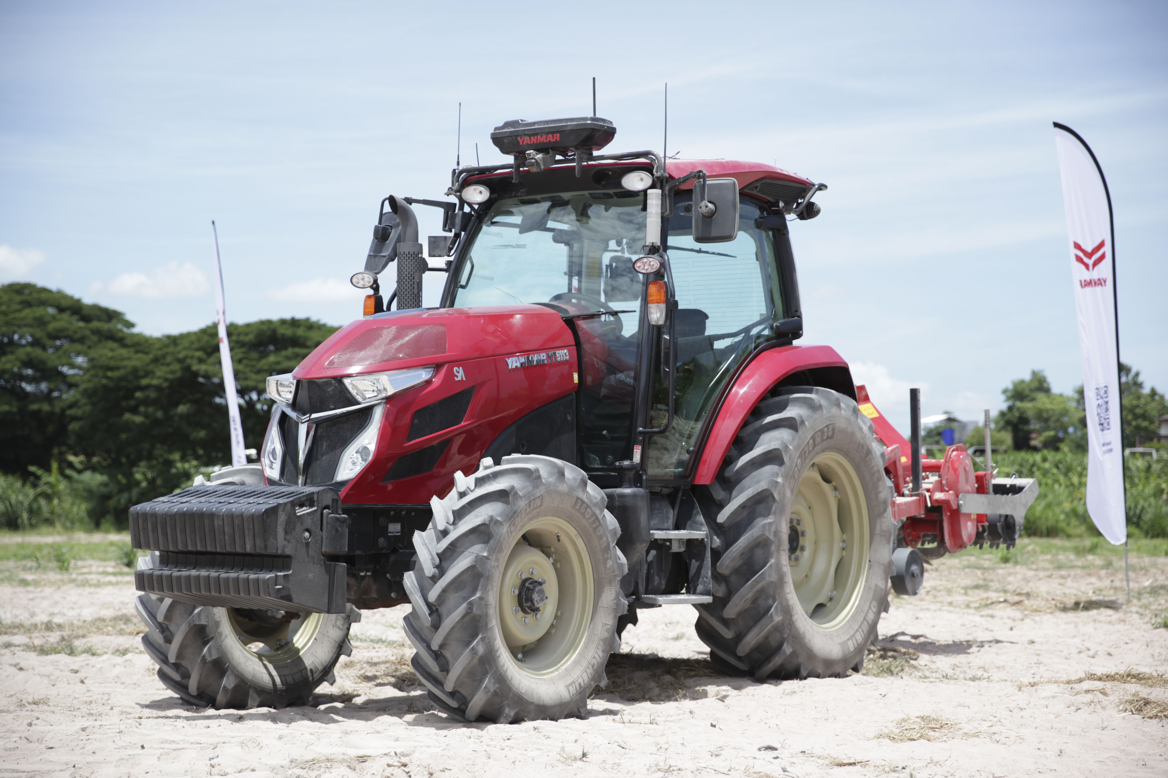
The Robot Tractor (YT5113A)
Bangkok Thailand (July 23rd, 2019), Yanmar have participated in a field test to demonstrate the use of precision location technology in autonomous agricultural equipment held by the Japan International Cooperation Agency (JICA) and the working group consisting of Thai and Japan organizations. The demonstration in the Sri Racha District of Chonburi, southeast of the capital of Bangkok, served to draw attention to the labor-saving potential of autonomous technologies in agriculture.
With the agricultural population expected to fall, even in Thailand, robot agricultural technologies will be required to maintain and raise agricultural productivity. The demonstration event was held with the cooperation of the Thai government to further development of precision positioning technologies. For its part, Yanmar is to conduct testing in Thai fields of its Robot Tractor that went on sale in Japan in October of 2018.
Through its participation in the demonstration event, Yanmar hopes to further the development of agricultural technologies in Thailand, while contributing to the realization of a sustainable agriculture through the delivery of labor-saving, highly efficient agricultural machinery and services enabled with advanced IT and communications technologies.
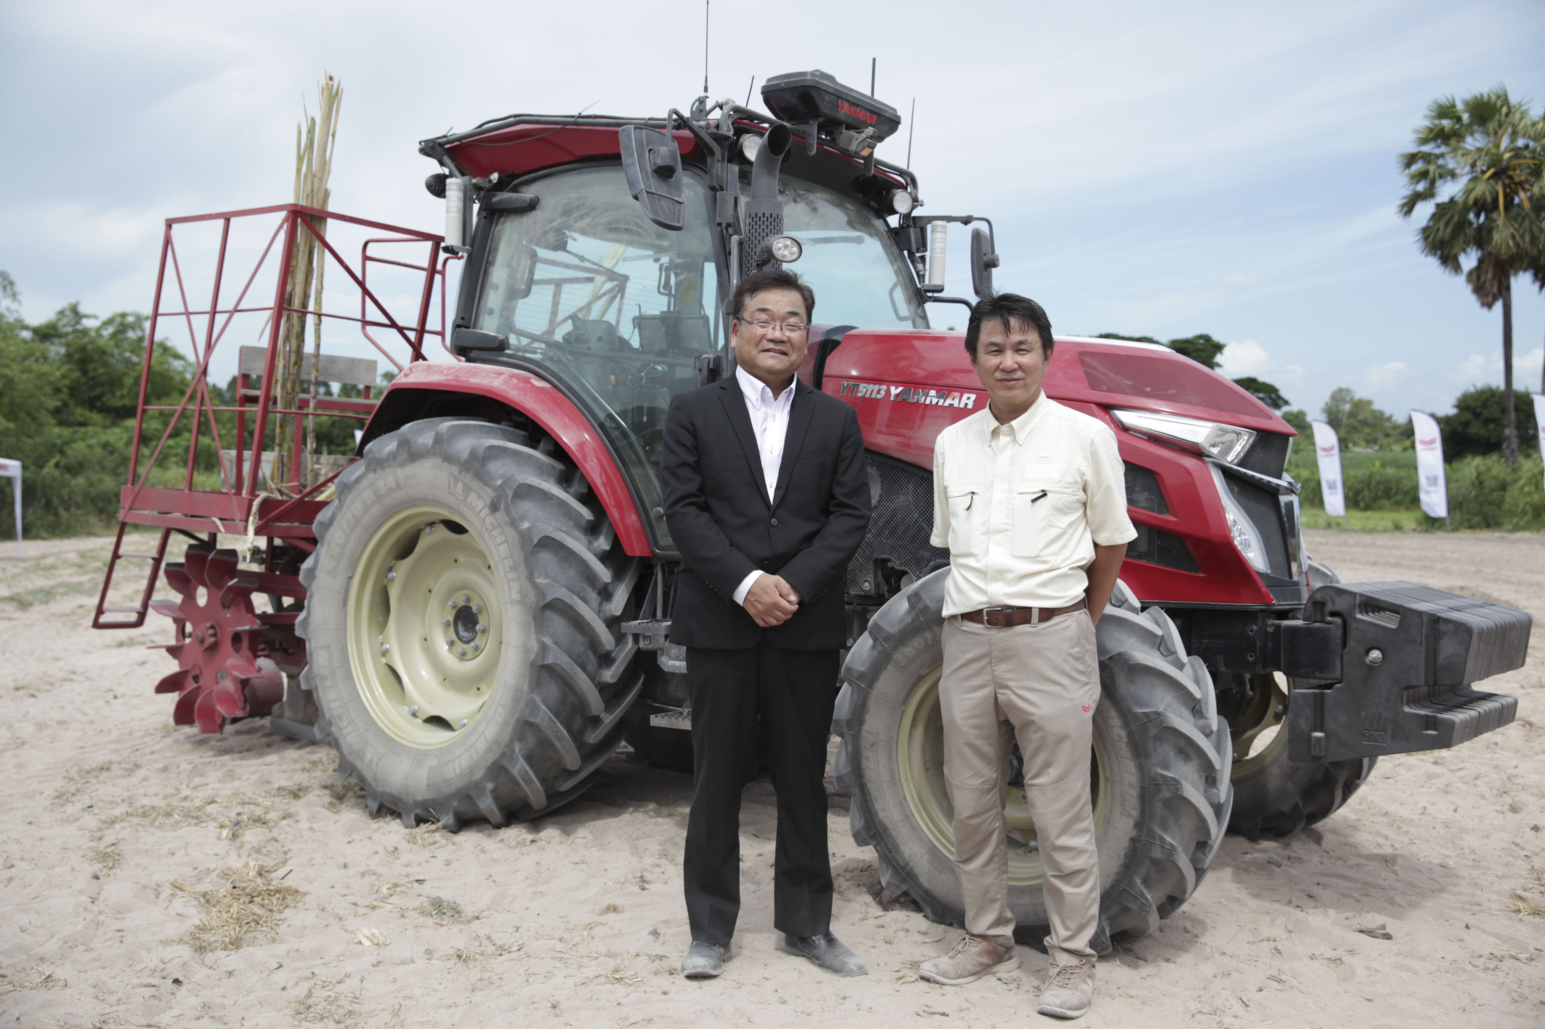
YSP President* Mr. Suenaga (left) and Executive Engineering Officer Mr. Hidaka in front of the robot tractor.
The Demonstration Project
In February of 2015, the Thai and Japanese governments made a joint, top-level announcement regarding cooperation in the introduction in Thailand of electronic reference point network using satellite positioning technology. Then in June of 2017, the two governments concluded a memorandum of intent regarding cooperation on the improvement of electronic reference point network. Since then, the Japanese government has established the GNSS Japan Pavilion in the Space Krenovation Park of the Geo-Informatics and Space Technology Development Agency (GISTDA), to support development of high precision positioning technologies in various fields of industry.
The Thai government also operates various infrastructure such as the National Electronic Data Standards Center. In order to provide the Thai government with technical support in this endeavor, JICA gathers related basic information and carries out surveys, with Yanmar also taking part in demonstrations trials as part of survey activities, towards technology adoption in the agricultural domain.
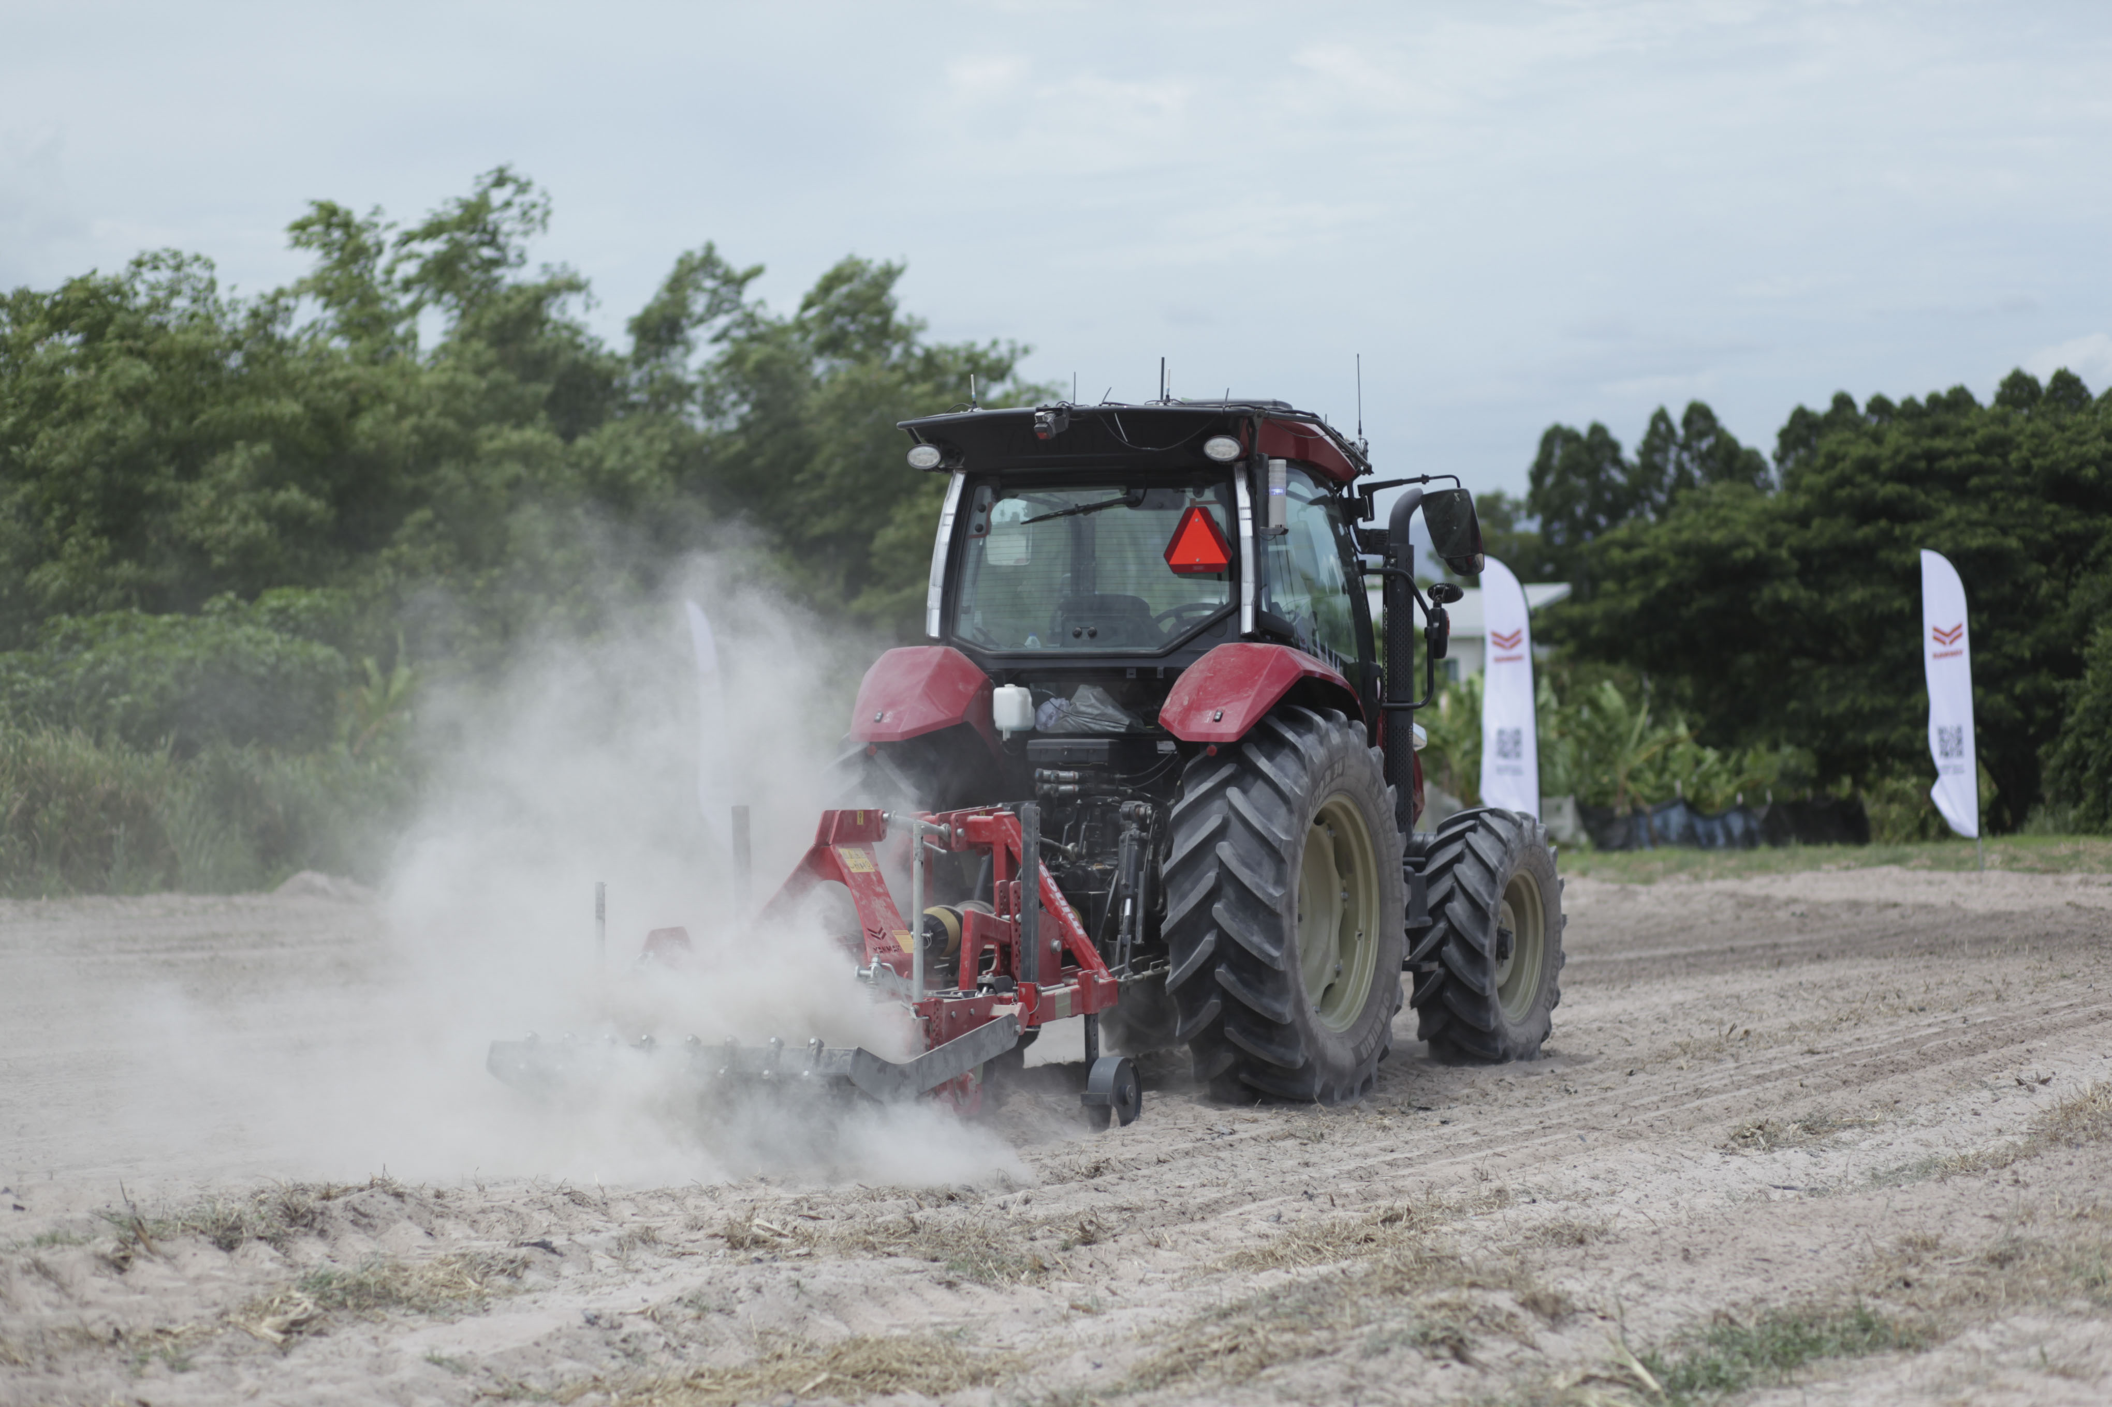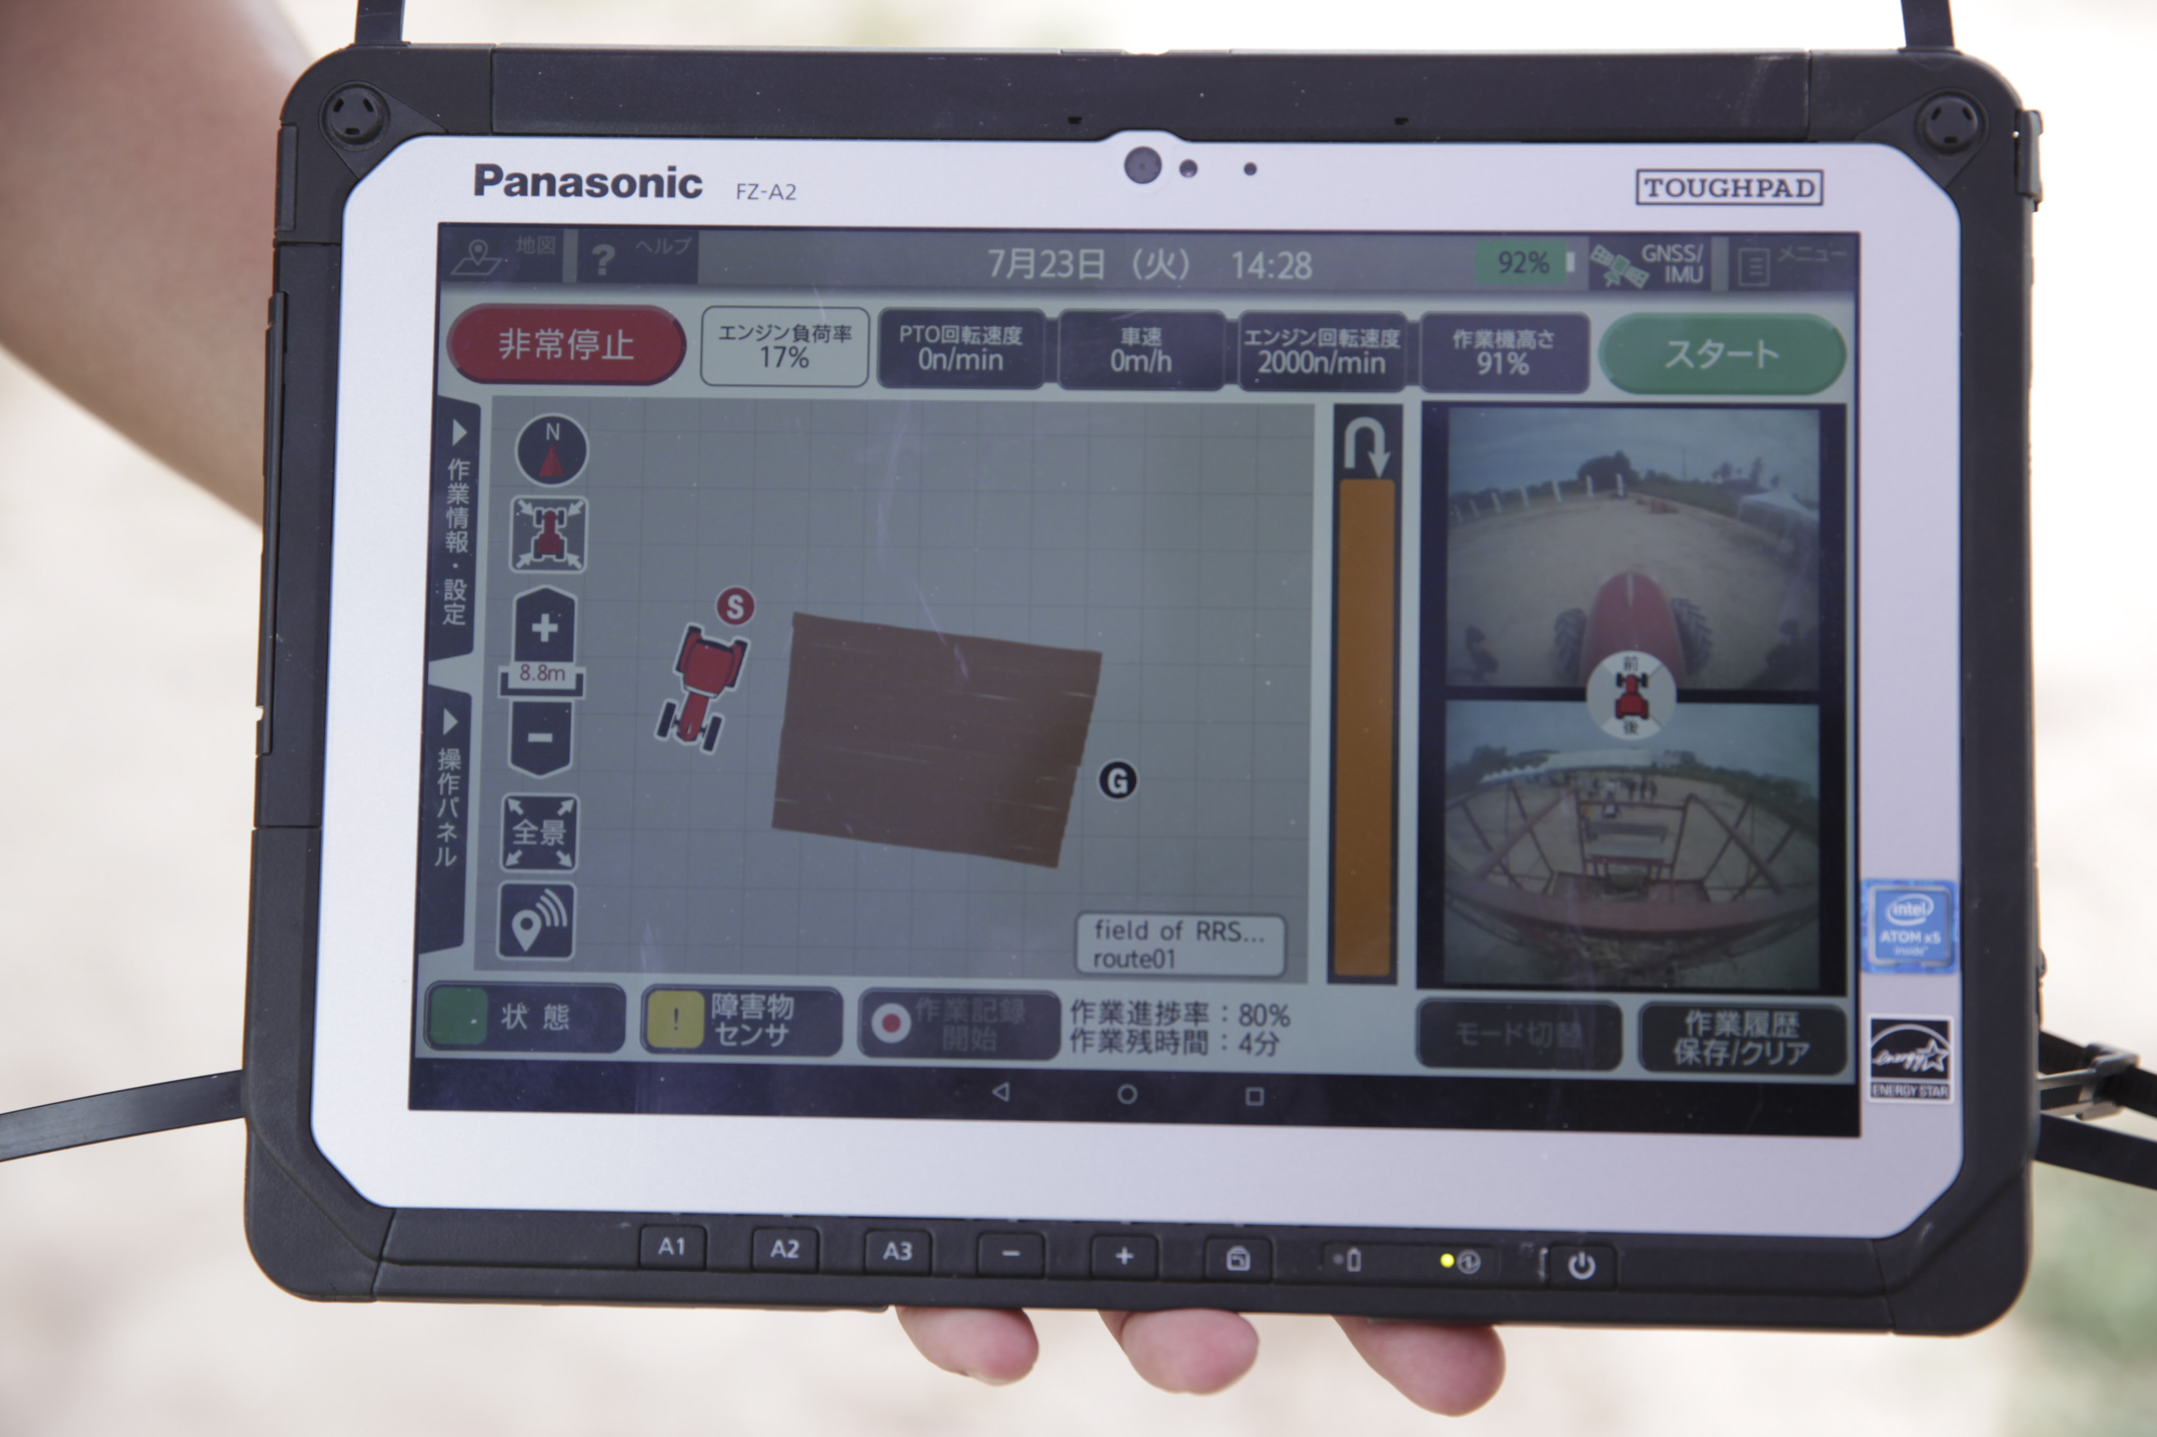
The robot tractor working in the field (left). Control tablet for operation and settings (right).
Equipment: Robot Tractor (YT5113A)
Main features
- Two modes of autonomous operation
In addition to advancing forward, “Auto Mode” allows the tractor to automatically drive in reverse, stop and execute turns. In “Linear Mode,” while certain driving maneuvers such as turning are performed by hand, the tractor can travel back and forth on its own when cultivating land. Switching between these two modes is possible in the 2-Series, allowing you to customize it for different operators, or according to skill of the individual and the work itself.
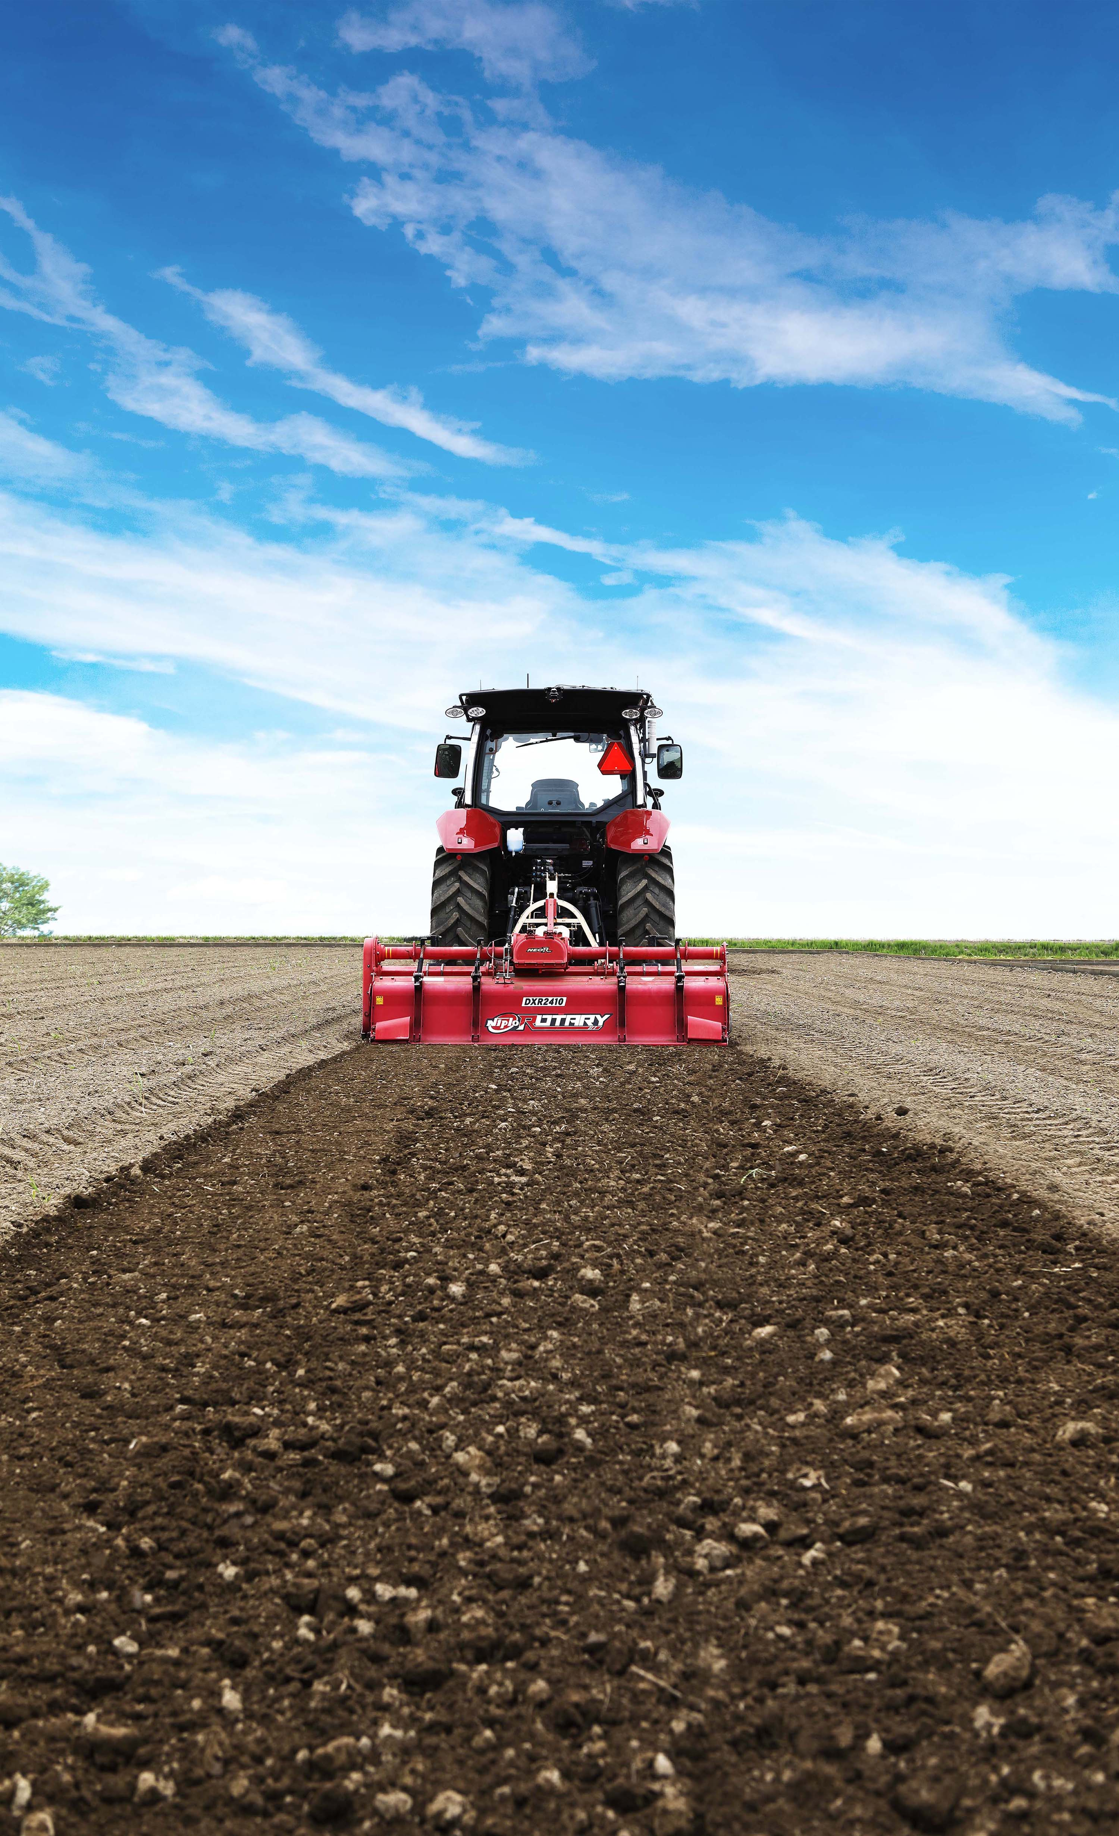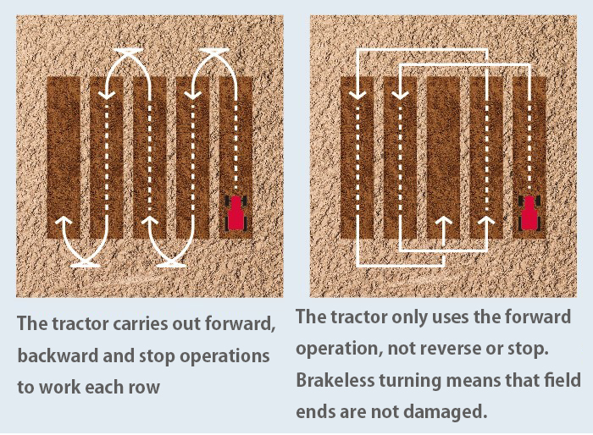
Linear mode (right) for autonomous forward movement and Auto mode (left)
(2) Improved workability through intuitive operation and highly-accurate positioning
Operation and settings are controlled via a durable, dustproof and waterproof 10-in. tablet to assure and reliability in the often-harsh environment of farming. Also, it allows for one person to operate two tractors, as the tablet in the manned tractor can be used to operate the unmanned tractor side-by-side with the manned tractor, or even in reverse.
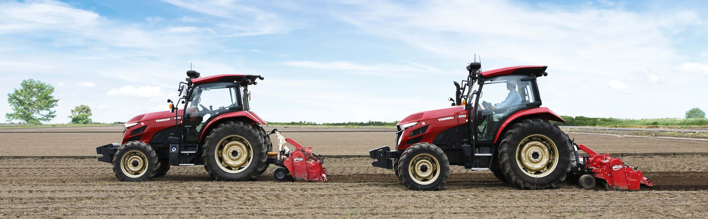
2 tractors work the field
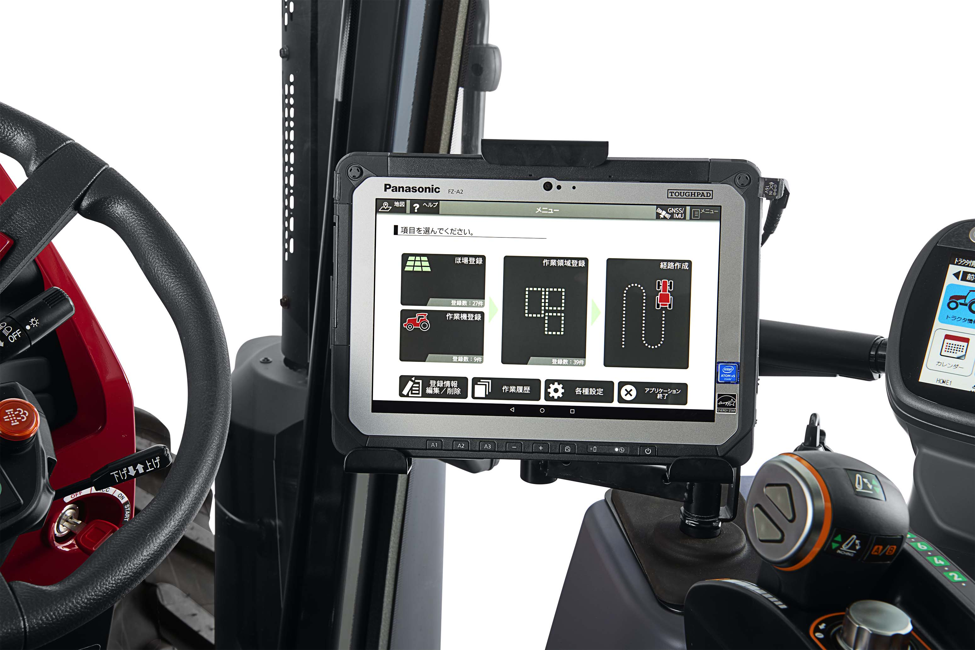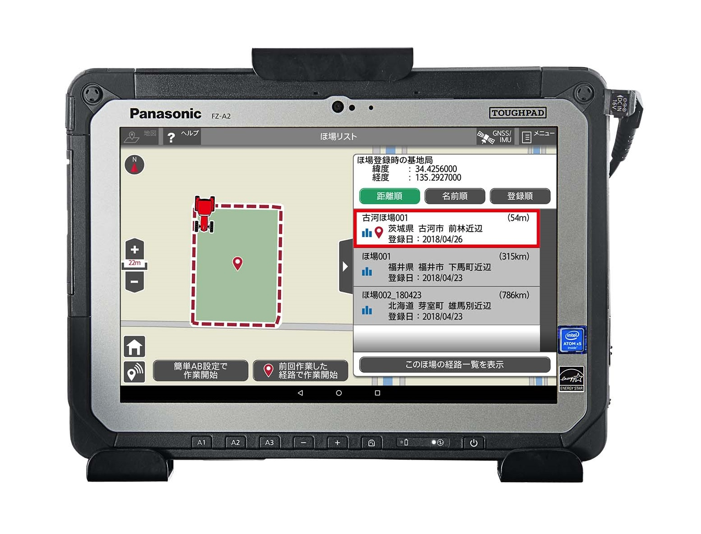
Settings screen for tablet operation

(3) Extensive safety equipment for peace of mind
Assuring safety for those in the proximity of the Robot Tractor, which is capable of unmanned driving and operation under the surveillance of an operator, are numerous sensors and safety lights. Also, the user can perform functions such as emergency stops on the control tablet.
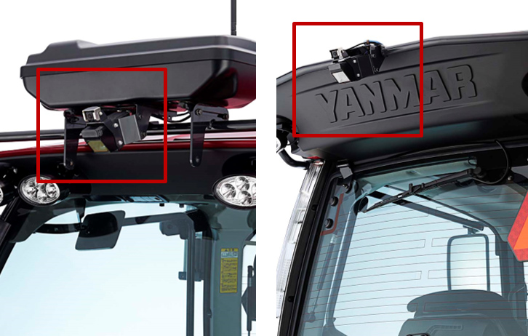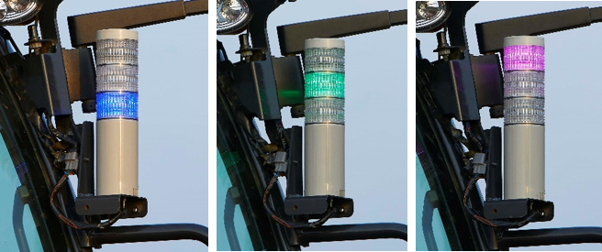
The safety sensor detects people or obstacles (left), and the three-color safety lamp (right)

About Yanmar
With beginnings in Osaka, Japan, in 1912, Yanmar was the first to succeed in making a compact diesel engine of a practical size in 1933. Then, with industrial diesel engines as the cornerstone of its enterprise, Yanmar has continued to expand its product range, services, and expertise to deliver total solutions as an industrial equipment manufacturer. As a provider of small and large engines, agricultural machinery and facilities, construction equipment, energy systems, marine equipment, machine tools, and components, Yanmar’s global business operations span seven domains.

On land, at sea, and in the city, Yanmar’s mission of “providing sustainable solutions focused on the challenges customers face, in food production and harnessing power, thereby enriching people's lives for all our tomorrows” is a testament to Yanmar's determination to provide us with “A Sustainable Future.”
For more details, please visit the official website of Yanmar Co., Ltd.,: https://www.yanmar.com/global/about/

About YANMAR S.P. CO., LTD.
YANMAR S.P. started operations as part of the former Yanmar Diesel in 1978 in Thailand and manufactures and distributes agricultural machinery such as power tillers, tractors, rice transplanters, combine harvesters and sugarcane harvesters, multipurpose diesel engines, and industrial equipment such as small to large excavators. YANMAR S.P. has a nationwide network of dealers with service centers, as well as a subsidiary, YANMAR CAPITAL (THAILAND) CO., LTD. which offers comprehensive finance to YANMAR customers in Thailand.

＜NOTE＞
The contents of this news release reflect what was mentioned in the press announcement. Please be aware that the contents of this release may differ with new information and developments.

