PRESS INFORMATION
Gothenburg October 25th

Ulrika Wernståhl, the CEVT employee who finds her inspiration in Ironman races.
The Vice President of CEVT program development for quality leads a team of 17 in her daytime job. At turning 50 she competes in Ironman races across the world, to find her own inspiration, and to be an inspiration to others in the company.
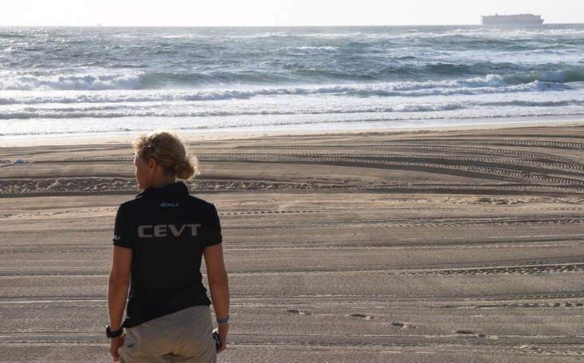
“I joined CEVT in September 2015 and have not regretted it one day. The core values and culture of this company is something that a competitive, and team person, like myself really enjoy.” Ulrika Wernståhl says. “When I was running alongside some 3000 athletes in the Australian heat in September, I felt that I who am just an ordinary person really can do extraordinary things when I set my mind to it. It was tough, yes, the heat was a surprise to me who is used to Swedish temperatures, but I think imagining the finishing line ahead and me crossing it really helped me to find a way to just push on. Just like at work, where we have a crazy tempo sometimes, and you really have to come up with new ways of solving problems that just pop up ahead of you. “
“At CEVT we like to envision that our employees really live the core values, and Ulrika is really one of those characters in the company that embodies the statements the other of us sometimes only talk about.” Bengt Enbom, Senior Vice President CEVT HR, says. “What is significant for CEVT company culture is to think big, finding the way and to get inspired. I can’t possibly think of a better way to symbolize this than an Ironman race.” Bengt continues. “We are proud sponsors of Ulrika, and she has inspired us to get the CEVT sports club really up and running, no pun intended.”
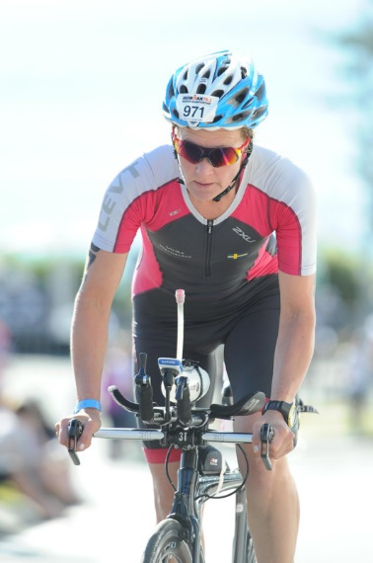
During 2o16 Ulrika competed in two Ironman races. One in Norway where she finished in second place in the women’s 50-54 age group, and one in Australia, the Mooloolaba beach Ironman where she finished in 45th place after 6 hours in the sun. CEVT sponsored the specialized outfit that is engineered to keep the body temperate and the sun’s rays out.
About Ulrika
Joined CEVT on 1 September 2015 and has been working in the auto industry for some 25 years at General motors, SAAB and Volvo. Now, as the vice president of Program Development Quality, she has a team of 17 people. The unit judge the quality of the products and ensure that the products follow the development plans.
Developing cars for a different tomorrow. CEVT is a development and innovation centre for the Geely Group focused on finding smarter ways to build cars – through modular development, by pushing the boundaries of virtual engineering, and by taking on new customer desires to create all-new cars. CEVT currently consists of some 2000 people with offices in Gothenburg and Trollhättan in Sweden. CEVT is a subsidiary of Zhejiang Geely Holding Group. For more information about CEVT, go to www.cevt.se
Press contact: Stefan.lundin@cevt.se, +46-721-843598

