**News Release**

**CLARKE QUAY ENDS 2016 WITH A BANG,**

**BRINGS IN SLEW OF EXCITING NEW CONCEPTS**

**New offerings provide a multitude of unique dining and entertainment experiences this year-end holiday season!**

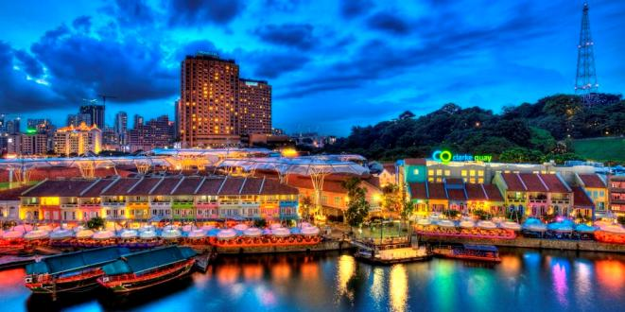

**Singapore December 2016** -Clarke Quay, Asia’s leading riverside F&B and entertainment hub, is pleased to welcome seven new concepts to its line up of over 60 clubs, bars and restaurants. With the expanded offerings, party-goers, as well as families and friends looking to bond over good food and quality ambience will be able to find an ideal venue for any occasion at Clarke Quay.

In the past year, Clarke Quay has been transformed with the introduction of about ten dining and entertainment concepts in its newly revamped Block A and Block C. We have not stopped since and are now ending the year with the opening of two anchor tenants and a myriad of new concepts.

Mr Adrian Lai, Clarke Quay’s Centre Manager, said: “Over the years, Clarke Quay has contributed to the revitalisation of the Singapore River by unlocking the potential of riverfront dining and astutely synergising premier entertainment with local heritage. We are committed to bringing in exciting entertainment and F&B concepts that reinforce Clarke Quay’s positioning as a must-visit destination for locals and tourists to wine, dine and have a good time.”

**New Anchor Tenants**

Opened since September 2016, **VLV Singapore** houses a stylish modern Chinese restaurant, a glamorous Club Lounge and an alfresco courtyard bar within the 20,000 square feet historic River House which was built in the 1880s. The 140-seater VLV Restaurant presents over 60 fine Chinese delicacies with a focus on traditional Cantonese flavours styled for a modern day dining experience. The kitchen is helmed by Executive Chef Martin Foo who has more than 25 years of culinary and management experience across Asia.

As the sun sets, unwind with a cocktail at the courtyard bar or party up a storm at VLV Club Lounge. Set in a trendy space filled with luxe leather booths, VLV Club Lounge has state of the art visual and audio technology for an immersive party experience. Guests can look forward to grooving on a dance floor pumped with open format range of music that is adaptable to the mood of the crowd.

Clarke Quay’s newest anchor tenant, **Zouk Singapore**, starts a new chapter in Clarke Quay with the unveiling of its spanking new multi-concept club on 17 December 2016.

Zouk is a 25 year-old music-driven entertainment institution that provides a world-class clubbing experience by pushing the boundaries of electronic dance music and bringing in a constant flow of internationally renowned DJs. Recently ranked #6 in DJ Mag Top 100 clubs for 2016; Zouk is geared to continue their legacy in the next generation at their new digs.

**Red Tail by Zouk** serves up creative cocktails made from the finest and freshest ingredients, great wines and craft beers, perfect with the array of delectable Asian sharing plate bites.

**Housing homegrown concepts**

Seasoned home-grown operators such as Creative Eateries and Red House Seafood are adding new to market concepts to Clarke Quay.

A recent addition to the riverfront is **Talay Thai**; the first Thai Tapas Restaurant Bar in Singapore and the latest venture by Creative Eateries. “Talay”, which means seafood in Thai, introduces dishes with a contemporary twist on traditional flavours. With an extensive menu of over 50 items ranging from tapas bites to cocktail concoctions promising an explosion of flavours, diners can look forward to an authentic Thai experience.

Need a cosy bar for a round of beer and darts with the buds?The newly opened **Beer Xchange** hits all the right notes with their wide ranging list of beers, spirits and comprehensive western menu of Italian favourites and delicious bar bites. Beer Xchange also plays host to the popular Shagies Live Band every Tuesdays to Saturdays.

Last but not least is **Red House Seafood**, taking over the double storey space facing River Valley Road.The 7,000 square feet and 200-seater restaurant is the latest addition to the esteemed home-grown restaurant chain. Over the years, Red House Seafood has built a strong reputation for good quality, fresh seafood specialising in Asian seafood dishes and Singaporean favourites such as Crabs in Red House Chilli Stew and their Scottish Brown Crabs. Their intimate attention to flavours makes them popular amongst locals, expatriates and tourists. Red House Seafood is slated to open 16 December 2016.

**NEW TO MARKET CONCEPT**

Making its first foray into Southeast Asia is **Da Miao HotPot (大妙火锅)** a high quality Chinese hotpot chain from Chengdu which will be opening its first outlet outside of China in Clarke Quay at the end of December. A feast awaits diners with their wide selection of fresh hotpot ingredients and authentic Szechuan dishes. Their signature hot and spicy or thick clear soup bases are made from more than twenty spices, plant oils and herbs. Another highlight is their daily entertainment, including traditional Chinese performances such the legendary mask changing show, specially programmed to keep diners engaged!

Their relentless effort in maintaining the high quality of traditional Sichuan hotpot in Chengdu has made them a popular choice among political leaders and celebrities, including US First Lady Michelle Obama, King Willem-Alexander of Netherlands and President of the Czech Republic Miloš Zeman.

**NON STOP ENTERTAINMENT TO USHER IN THE NEW YEAR**

Ending the year with a big bang is **Clarke Quay Supernova Countdown** on 31 December 2016; an epic New Year’s Eve party as we bid farewell to 2016 and embrace 2017 with non-stop dancing, singing and of course lots of partying!

Looking ahead in 2017, Clarke Quay has lined up a slew of exciting events which include Singapore Festival of Fun, Music After Sevens, Music Jam and Halloween. Not forgetting our promise of everyday cheer with our value Set Lunch and Happy Hour promotions.

Stay tuned to [www.clarkequay.com.sg](http://www.clarkequay.com.sg) for more to come.

###

**About CLARKE QUAY**

Located along the iconic Singapore River at the fringe of Singapore’s Central Business District, Clarke Quay sits on a historical commercial site dating back to the 19th Century. Today, Clarke Quay has been boldly restored and refurbished into five beautiful waterfront godowns under a climate controlled canopy illuminated by coloured lighting, creating a modern and cosmopolitan ambience amidst the tradition and history. Owned by CapitaLand Mall Trust and managed by CapitaLand Mall Asia, Clarke Quay plays host to a wide array of over 60 restaurants, wine bars, and entertainment outlets, attracting about one million visitors every month.

Clarke Quay was crowned Singapore’s best nightspot at the 2014 AsiaOne People’s Choice Awards, organised by AsiaOne, Singapore’s leading news portal. Last year, Clarke Quay was awarded the 2015 Certificate of Excellence by TripAdvisor and identified by TripAdvsor as one of 50 iconic places to visit in Singapore, based on the travel website’s data on the most-reviewed attractions and eateries.

Website: [www.clarkequay.com.sg](http://www.clarkequay.com.sg)

Like us on Facebook: <https://www.facebook.com/ClarkeQuay>

Follow us on Instagram: <https://www.instagram.com/clarkequaySG/>

#clarkequaysg

#winedinegoodtimes

Media contact

Elene Foo (Ms)

Manager, Marketing Communications

Clarke Quay

Tel : +65 6557 7063

Email : [elene.foo@capitaland.com](mailto:elene.foo@capitaland.com)

About the New Outlets @ Clarke Quay

[**VLV Singapore**](http://www.vlv.life/)

Block A #01-02

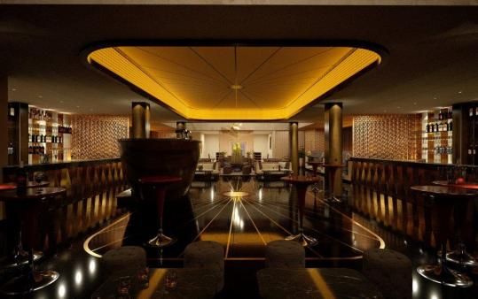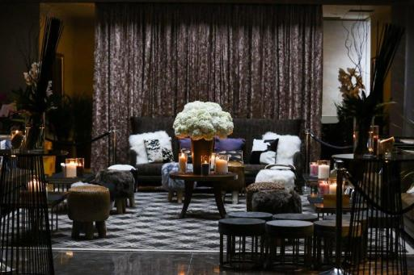

Housed in a stunning heritage building along the Singapore riverfront, VLV Singapore is an

effortless blend of stylish modernity and tradition. Within its historic walls is a world-class culinary and entertainment oasis; stylish Chinese dining and glamorous club lounge takes centre stage, while a charming alfresco bar and a festive seafood enclave by the river completes the sensuous experience.

Dine at the Chinese restaurant and savour a masterful menu of modern Chinese cuisine by an award-winning culinary team. A comprehensive, top-notch selection of premium wines and alcohol are specially curated to create that perfect palate of taste. Wine, dine and host your private event amidst a century-old structure with a contemporary setting enhanced with oriental flair.

Immerse yourself in the chart-topping beats at the 7,000 sq ft Club Lounge, where our resident DJs helm the booths crafting unforgettable party nights. Asia’s leading nightlife destination, VLV Club Lounge is equipped with the leading-edge light and sound technology for a transformative party atmosphere while our luxurious booth seats make available an intimate party space for our VIPs to entertain in comfort. Our all-day bar menu is served from the Restaurant to complement VLV signature cocktails and spirits, delivering the perfect nosh and tipple to carry you from day to night.

Head to the VLV Courtyard where shooting the breeze with your tipple of choice in Singapore’s balmy tropical weather is your kind of style. Relax and chill out at the al fresco bar with delicious light bites and exquisite cocktails. For an alternative dining option, the Riverside is the perfect place to enjoy the freshest live seafood, while overlooking the once-busy river mouth of the grand Singapore River.

VLV Singapore, a peerless global destination for the lifestyle connoisseurs.

[**ZOUK**](http://zoukclub.com/)

Block C, #01-05, #02-06 – opening 17 December 2016

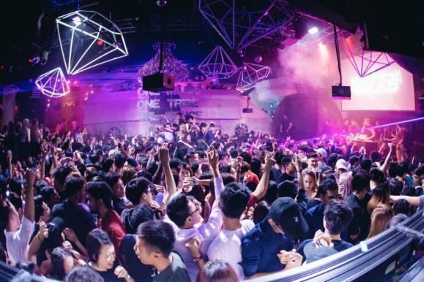

Zouk is a 25 year-old music-driven entertainment institution that provides a world-class clubbing experience by pushing the boundaries of electronic dance music and bringing in a constant flow of internationally renowned DJs such as Hardwell, Tiesto and Disclosure just to name a few.

With the mission to remain forward thinking, Zouk strives to be the pacesetter in propelling Asia’s dance music scene forward and leading Singapore to the forefront of global clubbing culture by balancing edginess and uniqueness with viable commercial success and continued support for the local music, arts and fashion communities. Zouk’s focus is to provide the highest standards of service satisfaction while assuring ample security and safety, and at the same time, delivering a matchless and unforgettable visitor experience for all customers.



[**RED TAIL BY ZOUK**](http://www.redtailbar.com/)

Block C, #01-04

Red Tail serves up dynamic craft cocktails made from the finest and freshest ingredients, great wines and craft beers, perfect with the array of delectable fun sharing plate bites.

Red Tail will be the place for those in the know, those who have a taste for the best in drinks, food, music and service.

Red Tail is THE DRAMA BEFORE THE PARTY.

[**TALAY THAI**](http://www.talaythai.com.sg/)

**Block E #01-05**

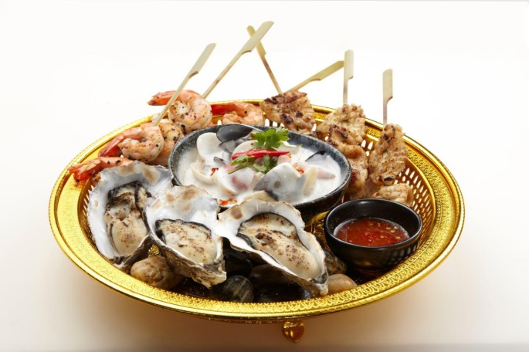Talay Thai serves authentic Thai food with an urban twist - it’s a modern, warm and avant-garde “drinking hole” where suits and foods collide. “Talay” which means seafood in Thai, pushes the boundaries of Thai Cuisine by introducing dishes with a small, yet stimulating contemporary twist on traditional taste.

The interior décor exudes a resounding punch of personality; the orchestrated harmony of the rustic deep red floors, eclectic fish scale feature walls and ornate traditional Thai displays is a sight to behold and drinking hole worth a go.

With an extensive menu of over 50 items, Talay Thai will leave you spoilt for choices. From more than 20 variety of tapas bites to unique Thai cocktail concoctions, enjoy the authentic Thai experience and take your taste buds on a flavour explosion. The stars of the delectable menu include: Aroy Mak Tasting Platter, Tom Yum Lobster Bisque, Spanner Crab Miang Kham, Live Raw Prawn Ceviche, White Bait with Tom Yum Powder, Chicken Skin Crackling, Stingray Fish with Tamarind Glaze, Dragon Fruit Cocktail and Lychee Rambutan Thai-jito Duo.

Not forgetting our extensive wine list with up to 66 wine labels from Australia, New Zealand and France with countless selections that will pair perfectly with your seafood or red meat.

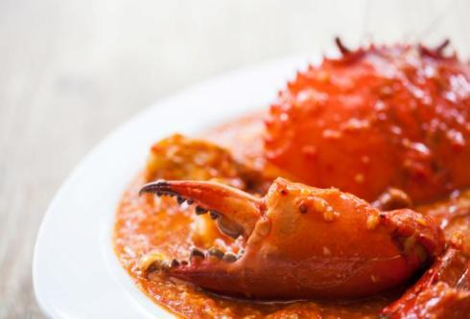[**RED HOUSE SEAFOOD**](http://redhouseseafood.com/)

Block C, #01-02

Established in 1976, Red House Seafood has built a strong reputation of pairing fresh seafood with Asian flavours.

 In order to guarantee our customers the freshest seafood, they have built robust relationships with global seafood suppliers and continue to scour the globe to search for new additions.  These efforts, coupled with signature culinary techniques and intimate knowledge of flavours, makes Red House a distinct and reliable choice for every occasion.  Their food reflects the diversity within the Singapore society, cutting across various local flavour profiles to provide diners with a genuine experience of Singapore cuisine.

[**DA MIAO HOTPOT (大妙火锅)**](https://www.facebook.com/damiaohotpotsg/)Block C, #01-11

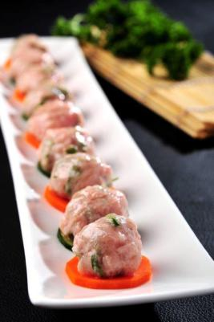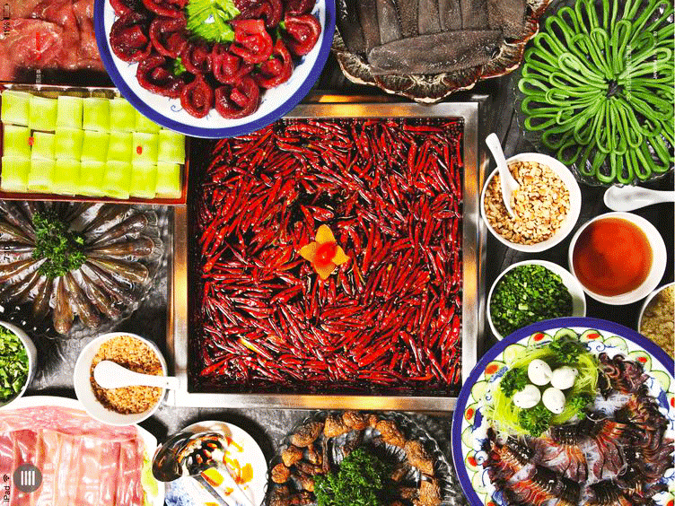

Da Miao Hot Pot (大妙火锅) is committed to foster high-quality hotpot culture with Chengdu’s signature features, providing customers with comfortable, unique services and a differentiated dining experience. Da Miao Hotpot promises to create a feast for every Da Miao Hotpot customers who walked into their restaurant. You will be greeted with their traditional performances by their professional “Stage Artist” while savouring the flavourful soup base.

The key attribute of their signature soup is the combination of more than twenty spices, added with special plant oil and herbs, making it delectable and creamy while not greasy. The professional chefs from Da Miao Hotpot guarantee the quality and freshness of the ingredients from the stage of purchasing, delivery, storage and presented with the most appetising plating for the every customer.

[**BEER XCHANGE**](https://www.facebook.com/BeerXchangeSG/)

Blk B #01-17

Other than the unique beers, Beer Xchange serves full Western Italian menu and completes with the performances by the fabulous Shagies live band and the amazing DJ Maverick on the decks.

**-End-**