**Press release**

Gothenburg, December 14, 2015

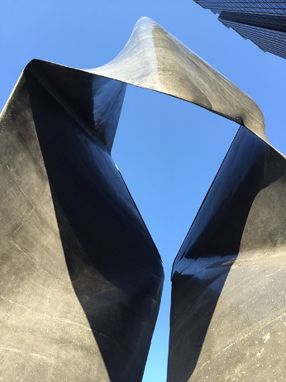 **Thomas Concrete Group delivered**

**Monolithic Sculpture in Concrete   
Looks like Steel**  
**The 11-meter high sculpture called Stealth, with its sharp edges, shiny surfaces and twisted forms gleams as if it is made of steel. But looks deceive, because it’s composed of black concrete. The sculpture stands in downtown Atlanta in the United States, and is made from a special concrete developed by the Swedish family owned company, Thomas Concrete Group.**

The artist's goal was to create an urban portal symbolizing the changing cityscape around Atlanta’s Midtown Arts Center. The result is a jet-black, polished monolithic concrete sculpture, defined by stunning curved forms.

Work on the project began more than two years ago, led by artist and architect Tristan Al-Haddad, the owner and creative force of Formation Studios, and also Assistant Professor at the Georgia Institute of Technology’s School of Architecture in Atlanta. Al-Haddad, assisted by 11 colleagues at Formation Studios, first created a 3D model, and then constructed the complex formwork in which the sculpture would be cast.

Recently inaugurated, Stealth weighs almost 100 tons and is made of 40 cubic meters of concrete and eight tons of steel reinforcing bars. The casting process was a challenge. Each reinforcing bar had to be cut by hand, then bent and placed in position with extreme precision.

The special purpose concrete from Thomas Concrete Group was poured successively into each section of the formwork. The concrete had to have high strength and meet stringent design requirements, while having the ability to flow into the sharply angled shapes of the structure. It also had to be highly resistant to cracking over time.

Experts at Thomas Concrete Group were able to meet Stealth’s design requirements by developing a concrete based on black sand from a special granite rock, with iron oxide and carbon pigments and synthetic macro fiber reinforcement. This exclusive mix gives Stealth its deep black color. After casting, the sculpture was diamond-honed to remove any imperfections, and each part was wet polished to obtain the sheer, gloss finish in blue-black.

"We worked for months to create the high-performance concrete product that met the requirements of such a visually appealing design,” says Hans Karlander, President and CEO of Thomas Concrete Group AB. “It took several different recipe and material combinations to achieve the desired appearance and performance.”

Thomas Concrete Group’s headquarters and development center are located in Gothenburg, Sweden. The Group is engaged in manufacturing concrete products in Sweden, Germany, Poland and USA.  
  
  
For more information contact:

Hans Karlander, President and CEO Thomas Concrete Group AB  
Email: hans.karlander@thomasconcretegroup.com  
Phone: +46 10 450 50 00

High resolution photos can be downloaded here:  
<http://www.thomasconcretegroup.com/en/newsroom/image-bank>

***Thomas Concrete Group AB***

*Thomas Concrete Group is a Swedish family-owned company which produces and distributes high-quality concrete for cast in-place construction. The company was established in 1955 in Karlstad, Sweden, by Martin Thomas and currently operates in USA, Poland, Germany, Norway and Sweden. Headquartered in Gothenburg, the group has 1,500 employees. In 2014, it produced 3.2 million m3 of concrete, with sales totaling approximately SEK 3.2 billion****www.thomasconcretegroup.com***