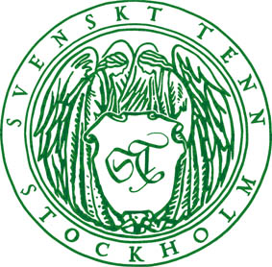

Press Release

February 2, 2015

**Production Designer Maria Djurkovic sets the stage at Svenskt Tenn**

**What would a set design of a movie that takes place in the 1930s, 1950s or 1980s look like if it was created with classic furniture, textile and accessories from Svenskt Tenn? The answer to that question is revealed on February 3 when the exhibition ‘’Three Decades’’ by award-winning British Production Designer Maria Djurkovic opens at Svenskt Tenn in Stockholm.**

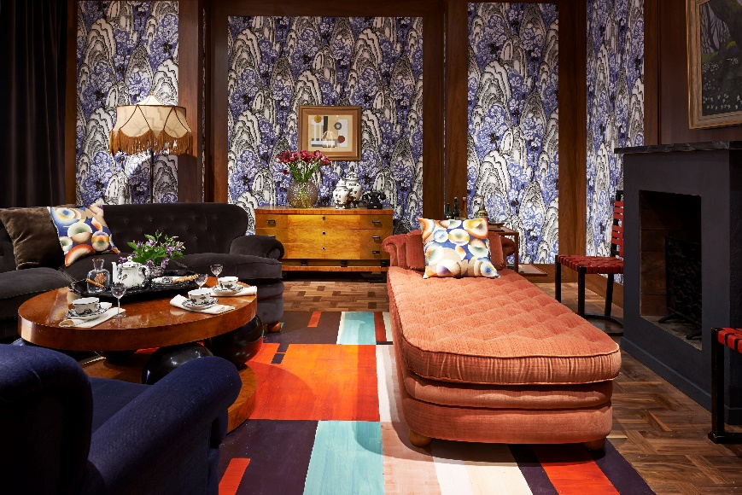

Maria Djurkovic’s credits as creator of the visual identity for movies includes *Tinker Tailor Soldier Spy*, *Billy Elliot* and the recently released *The* *Imitation Game*. She often uses Svenskt Tenn products in her work. Many will recall the scenes in the movie *Mamma Mia*, where Meryl Streep was surrounded by Josef Frank’s colorful textile prints. Maria Djurkovic, who appreciated them and their connection to Sweden and ABBA, had borrowed the textiles from Svenskt Tenn.

“I loved the Josef Frank fabrics the first time I saw them in Liberty in London, they just jump out and grab you! The immediate appeal of the design was apparent for me – the sheer *joie de vivre*, the bold and wonderful color,” said Maria Djurkovic.

She was invited to design an exhibition of her own at the Svenskt Tenn store in Stockholm. Here, she has created three exhibition rooms, which appear to have been cut from movies set in the 1930s, 1950s and 1980s, respectively. The textiles Rox & Fix, Terrazzo and Tulips by Josef Frank, that to her most clearly evoke the feeling of each decade, were selected to define the character of the rooms.

The exhibition will open on February 3 and runs through March 29. In conjunction, Svenskt Tenn will release a series of trays designed by Maria Djurkovic, decorated with Victorian wallpaper patterns, in a limited edition of 100 pieces. Prices: SEK 340-400.

**For further information, please contact:**

Vicky Nordh, Marketing Assistant: +46 8-670 16 23 or vicky.nordh@svenskttenn.se

Thommy Bindefeld, Marketing Director: +46 8 670 16 02 or thommy.bindefeld@svenskttenn.se

Image bank: [*www.svenskttennpress.se*](http://www.svenskttennpress.se) User name: *Press* Password: *Tenn*

Svenskt Tenn is an interior design company with retail stores at Strandvägen in Stockholm and online. Since 1975, Svenskt Tenn is owned by the Kjell and Märta Beijer Foundation, which provides research grants within ecology, medicine and the preservation of Swedish interior design tradition.