FOR IMMEDIATE RELEASE

Fischer Panda UK Showcases Innovative Hybrid Drive Systems at METSTRADE

Hybrid solutions from Fischer Panda and Bellmarine, plus leading technologies from
Dometic, Mastervolt/CZone, Sea Recovery, HRO and Village Marine

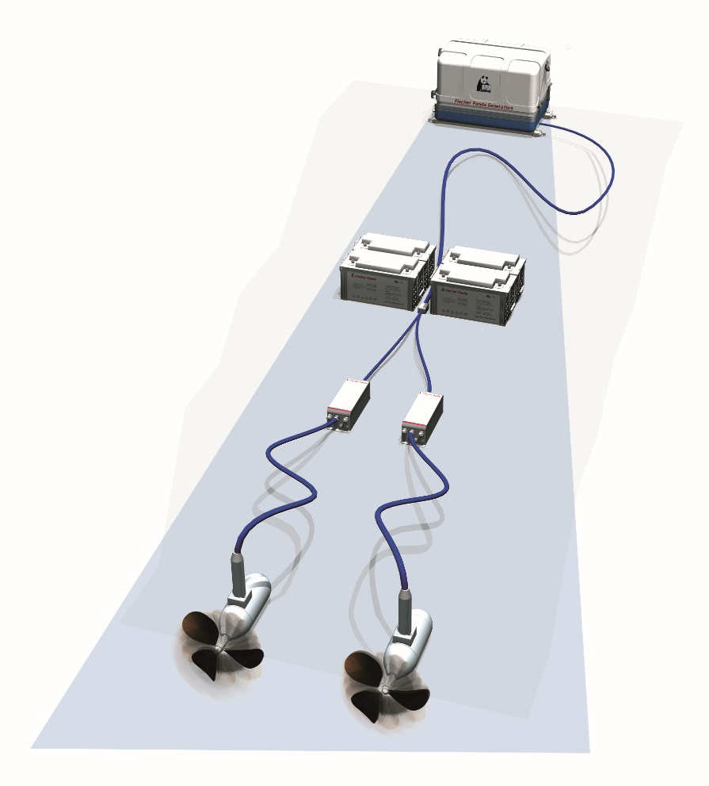
A Fischer Panda electric drive system
Fischer Panda UK’s broad range of hybrid and electric propulsion solutions will be on display at METSTRADE on the Fischer Panda (02.500) and Bellmarine (02.421) stands. Fischer Panda offer complete systems based around a choice of shaft motors, parallel hybrid drives or podded underwater motors, in addition to high voltage DC systems up to 100kW, capable of powering vessels with displacements of 40 tonnes or more. Bellmarine provide a choice of propulsion options for leisure and commercial craft, including shaft-, sail- and stern-drive motors, as well as control electronics to support them.
Hybrid drives have dramatically increased the demand for DC generators, and Fischer Panda’s whisper-quiet variable speed AGT range is ideally suited to the task. Using a DC generator increases efficiency by directly charging the batteries only as required, and through combination with one of Fischer Panda’s ‘plug and play’ hybrid systems – such as the 48V DC EasyBox – makes their hybrid solutions the simplest on the market to install, ideal for both boat builders and retrofits alike.
Fischer Panda UK will also be represented on the Parker Sea Recovery stand (11.101) in the Superyacht Pavilion, where a selection of watermakers – including those from HRO and Village Marine – will be on display. The company’s integrated mobile power solutions and smart digital switching systems will be represented by Mastervolt/CZone (stand 02.321), while Dometic’s
air-conditioning systems and other products will be available to view on stands 07.131, 07.138, 07.143 and 07.147.
For more information about Fischer Panda UK’s range of products, go to www.fischerpanda.co.uk.
Ends

Media Contacts
Chris Fower Jules Riegal
Fischer Panda Saltwater Stone
+44 (0)1202 820840 +44 (0) 1202 669244
chris.fower@fischerpanda.co.uk j.riegal@saltwater-stone.com
www.fischerpanda.co.uk www.saltwater-stone.com
About Fischer Panda UK
Celebrating its 25th anniversary year, Fischer Panda UK Ltd offers full-system design capability, servicing and aftercare as a leading distributor of diesel generators and a major supplier of the latest technology in air-conditioning systems, hybrid electric propulsion systems, integrated mobile power solutions and watermakers for a variety of commercial and leisure vessels.
Renowned worldwide as innovative, reliable and extremely quiet, the extensive Fischer Panda range of compact diesel generators includes its next generation highly efficient and powerful variable speed iSeries-Generators. Fischer Panda generators from the Panda 4000s Neo up to the next generation iSeries Panda 45i genset have passed type approval by members of the IACS (International Association of Classification Societies) board.
Other world-class products from Fischer Panda UK include desalination systems from Sea Recovery, HRO, and Village Marine, with models suitable for day-boats to warships and offshore platforms, plus air-conditioning systems from leading marine HVAC supplier Dometic, CZone digital switching and Mastervolt power solutions.
Fischer Panda UK is ISO UKAS 9000/1 accredited and operates from a purpose built 9,000 sq. ft facility in Verwood, Dorset. Its experienced engineers, sales and operational staff work with OEMs to develop integrated systems for custom vessels and offer specialist technical support and on-going aftercare to its customers.
Also active in the military and automotive sectors, the company works with UK MOD and other armies around the world providing solutions for specialist vehicle and land-based applications. Two thirds of Formula 1 mobile truck units install Fischer Panda generators, as do the BBC, Sky and many other mobile broadcasting vehicles.
Operating since 1977, Fischer Panda GmbH is headquartered in Paderborn, Germany. The Fischer Panda team covers more than 500 technicians and partners in over 90 countries worldwide.

