Press Release
Stockholm, May 31, 2016

Indoors turns outdoors at Svenskt Tenn during summertime

As the summer exhibition ”Window” opens at Svenskt Tenn, the line between indoors and outdoors is erased. Svenskt Tenn’s Tea Room serves ice cream outside the Strandvägen store. And the new Josef Frank garden table is just as well suited for interior furnishing.
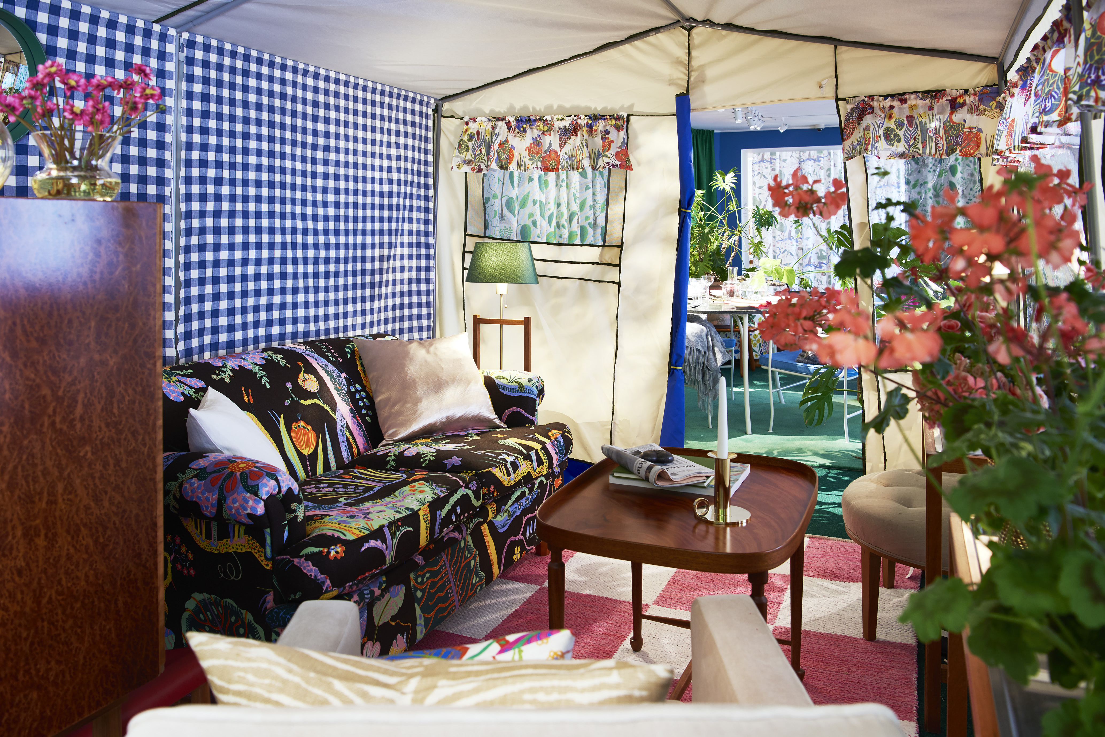
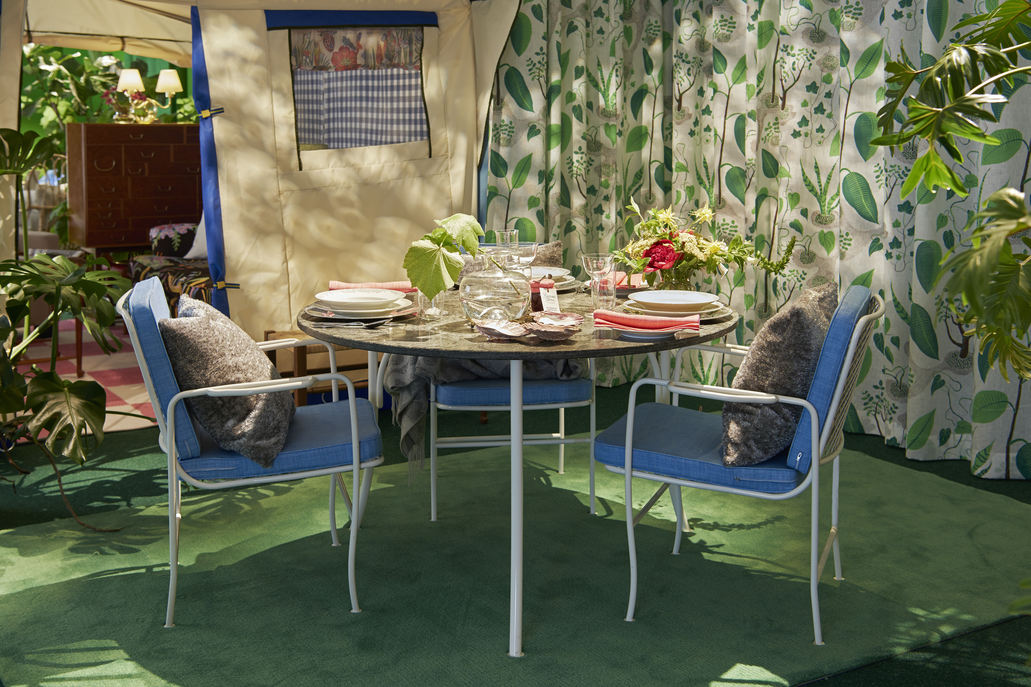
At the ”Window” exhibition, two tents are raised on a lawn-like carpet covering the floor. Inside and around the tents, garden furniture made of iron, stone, rattan and bamboo are displayed, together with classic Svenskt Tenn furniture.

Josef Frank’s Window textile design with a plant pattern is forming the backdrop, and outside the store, the Tea Room introduces outdoor seating, serving ice cream and refreshing, cold-brew iced teas.
”Each element in the exhibition has been selected to create the impression of being outdoors,” says Thommy Bindefeld, Marketing Director at Svenskt Tenn. ”The interior details brings a blossoming garden to mind and lighting creates the illusion of leaves dancing in the wind.”

For the exhibition, Svenskt Tenn introduces a new garden table, designed by Josef Frank in the 1930s. The table is handmade in Sweden, with electroplated and painted steel legs, and a top made from green granite. Price: SEK 32,000.

The Window exhibition and outdoor seating both open on June 1 and stay open until August 25.

For further information, please contact:

Vicky Nordh, Marketing Assistant: +46 8-670 16 23 or vicky.nordh@svenskttenn.se

Thommy Bindefeld, Marketing Director: +46 8 670 16 02 or thommy.bindefeld@svenskttenn.se

Images can be downloaded from svenskttennpress.se. Username: Press. Password: Tenn

Svenskt Tenn is an interior design company with retail stores at Strandvägen in Stockholm and online. Since 1975, Svenskt Tenn is owned by the Kjell and Märta Beijer Foundation, which provides research grants within ecology, medicine and the preservation of Swedish interior design tradition.

