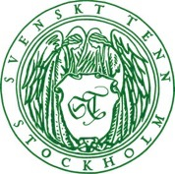
Press Release
Stockholm, February 7, 2017

Harri Koskinen collaborates with Svenskt Tenn to stage Shadow Play

Svenskt Tenn now introduces two new lighting items designed by Harri Koskinen. A floor lamp and a table lamp, where shades resemble Monstera foliage, are now added to the range.
These designs are debuted in the Shadow Play exhibition, displayed with other Svenskt Tenn items and Koskinen-designed furniture upholstered with classic Josef Frank textiles.

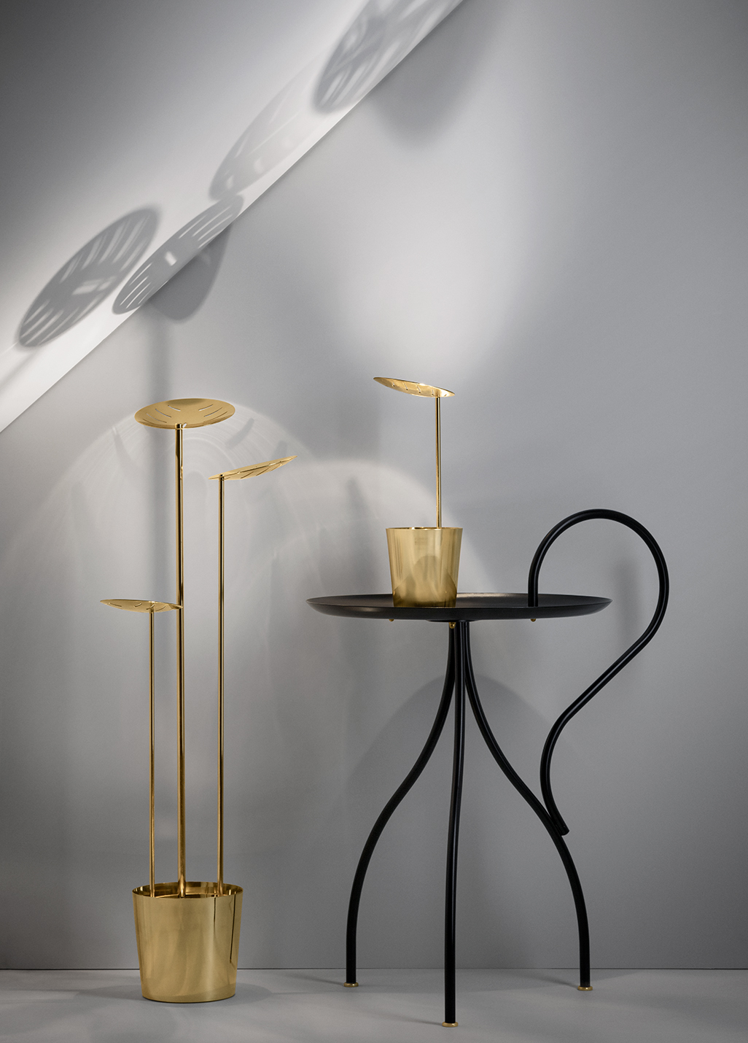
A visit to the Svenskt Tenn store at Strandvägen in Stockholm spurred the idea of transforming a Monstera plant into modern lighting. Finnish designer Harri Koskinen found inspiration to this inventive design in the frequent presence of houseplants in the store interiors.

“The leaves with their narrow incisions cast decorative shadows on the ceiling and walls, which we demonstrate in the Shadow Play exhibition,” says Harri Koskinen. “The exhibition is also a celebration of two neighboring countries, a modern interpretation of the longtime bond of friendship between Sweden and Finland, and a place where different design worlds can meet.”

Over the years, Koskinen has been showered with prizes and awards, at home and internationally. Early in his career, he created the multiple award-winning Block Lamp, recognized as an instant classic, and in 2009 he received the prestigious Torsten and Wanja Söderbergs Prize, awarded annually by the Röhsska Museum in Gothenburg.

”Harri Koskinen is truly one of the great Nordic designers active today,” says Thommy Bindefeld, Marketing Director at Svenskt Tenn. ”We invited him to a collaboration, as part of our intent to match modernism with cultural legacy, historical with contemporary and functionality with artistry, in all that we do.”

Also introduced at the exhibition, a tray by Harri Koskinen is available in a limited, numbered edition of 100. The Shadow Play exhibition is displayed in the Svenskt Tenn store at Strandvägen 5 in Stockholm from February 7 through March 26.

Pricing of items: Table lamp, SEK 5,600, Floor lamp, SEK 11,800 and Tray, SEK 600.

For further information, please contact:

Vicky Nordh, Marketing Assistant: +46 8-670 16 23 or vicky.nordh@svenskttenn.se

Thommy Bindefeld, Marketing Director: +46 8 670 16 02 or thommy.bindefeld@svenskttenn.se

Images can be downloaded from svenskttennpress.se. Username: Press. Password: Tenn

Svenskt Tenn is an interior design company with retail stores at Strandvägen in Stockholm and online. Since 1975, Svenskt Tenn is owned by the Kjell and Märta Beijer Foundation, which provides research grants within ecology, medicine and the preservation of Swedish interior design tradition.

