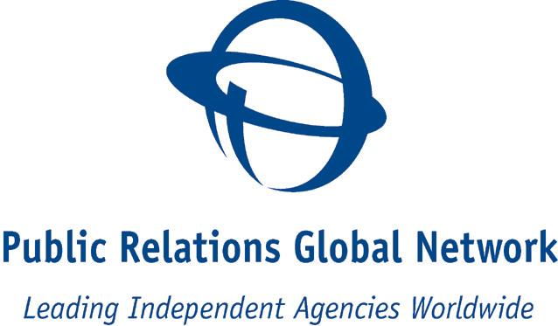



Contact

KG Rickhamre, CEO
Coast Communications
+46 709 549 109

PRGN expands throughout Southeast Asia, India and Europe

Frank Cullen elected new President

Stockholm May 5, 2008; Public Relations Global Network, the international network of leading independent public relations agencies, today announced a major expansion to its roster with the addition of three new agencies in Singapore, India and The Netherlands. The worldwide network now numbers 38 independently-owned public relations agencies on six continents. Joining the ranks of PRGN are:

PRGN – Singapore - Mileage Communications
Mileage Communications, headed by Boh-Tiong Yap, is Singapore’s biggest independent public relations agency with 8 regional offices in India, Thailand, Malaysia and Indonesia. The agency services blue-chip clients in the healthcare, financial, technology, consumer & lifestyle, shipping and sports sectors and also is the leading regional player in crisis management.

PRGN – Holland Evident PR
Evident PR is among The Netherland’s top independent public relations agencies and specializes in the areas of home & lifestyle, well-being, food and business-to-business (B2B). Managing Director/Owner Coen A. Staal and his team of experts oversee the diverse array of clients, which include: Bosch, Bowers & Wilkins, Cadac, Candy/Hoover, Dr. Oetker, Enia Carpets, Georgia Pacific, Henkel Laundry & Home Care, Kneipp and Wolf-Garten.

PRGN – India Aspire Communications
Based in Pune, with offices in Maharashtra and Madhya Pradesh, Aspire communications is headed by Varsha Marathe. Key practice areas include: media relations, corporate management, investor relations, crisis management and brand management. Clients include Sony Pictures, Harbinger Group, Petonia, Wipro, Bank of Maharashtra, Greaves and more.

New PRGN President Named
Frank Cullen, chief executive of PRGN – Ireland has taken over as President of the network.

“It’s a tremendous honour to have been elected President of PRGN and I will do my best to continue the good work,” Mr. Cullen said. “The network is in a period of rapid expansion.”

Founded in 1996, PRGN now has a presence in 22 of the world’s top 30 GDP-ranked countries. Agency members are independent, owner-operated public relations and communications agencies sharing expertise and resources and providing broad-based comprehensive communications strategies to clients worldwide.

“We’re very happy to welcome our new colleagues from India, Singapore and the Netherlands. We know that they will prove to be valuable members of our network,” commented KG Rickhamre, CEO Coast Communications. “We are systematically adding specialities to our range and expanding our global reach, and that is good news for our collective client base.”

Coast Communications is the Scandinavian PRGN member affiliate.
www.prgn.com

