**MEDIA RELEASE**

**Exciting New Grab & Go Selection**

**at Pan Pacific Manila**

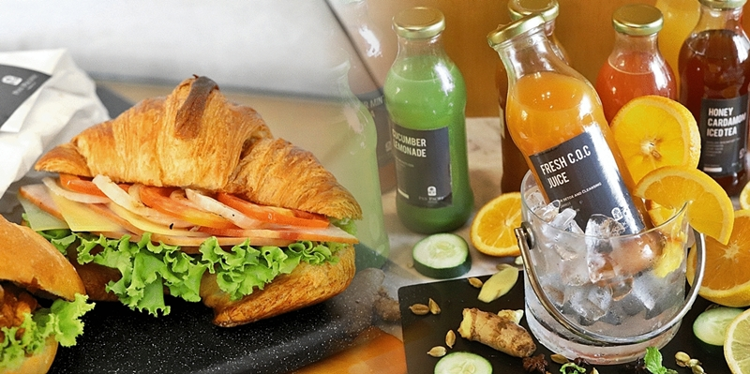

**In photo:** Ham & Cheese Croissant and Fresh C.O.C Healthy Juice

18 June 2019, Manila– For the tastiest and freshest sandwiches and salads head to Pan Pacific Manila’s **Lobby Lounge**. Delight in varied and interesting sandwiches and salads for only **Php 200 net per order** perfect for folks in a hurry and for those in search of something new to try.

At the top of the list are new gourmet creations such as New Orleans signature **Muffaletta Sandwich in Focaccia Bread**, a layering of chorizo, pepperoni, ham, mozzarella, cheddar, and gruyère cheese, lettuce and olive tapenade served on warm focaccia bread, and **Ham and Cheese Croissant** made of sliced farmer’s ham, tomato, onion, lettuce, and gruyère cheese on a flaky croissant. Just as delicious is the **Chicken Tortilla Wrap** composed of sautéed chicken strips, white onions, lettuce, tomato, and cucumber, and garlic mayo sauce wrapped in wheat tortilla. Another classic favourite is the **Pulled Pork ala Cubano** of slow-braised pork, caramelized onions, cheddar cheese on Cuban bread.

Complement your choice sandwich with an appetizing vegetarian fare of **Mango Kani Salad** comprised of fresh sweet mangoes, crab stick, and cucumber, topped with fish roe and dried seaweed or **G&G Salad** made with selected fresh greens, mango, grapes, tomato, feta cheese, walnut, topped with grilled chicken breast drizzled in garlic-mayo dressing.

Kick start the healthy routine further with refreshing selection of healthy drinks of **Citrus Earl Iced** (a concoction of Earl Grey Tea, Fresh Orange, Lime, Lemon, and Honey), **Honey Cardamom Iced Tea** (English breakfast Tea, Cardamom, Star Anise, Cinnamon, and Honey), **Ginger Mint Iced Tea** (Peppermint Tea with Ginger and Lychee), **Cucumber Lemonade** (a refreshing mix of Cucumber, Lemon, and Honey), **Fresh C.O.C Juice** (Carrot, Orange, and Cucumber), and **Maple Cranberry Juice** (Cranberry, Calamansi, Fresh Orange, and Maple) available for only **Php 180 net**.

The Lobby Lounge offers an a la carte menu of international and local dishes, open from 7 AM to 1AM. Lobby Lounge is located at the Ground floor of Pan Pacific Manila, M. Adriatico cor. Gen. Malvar Streets, Malate, Manila. For reservations, please contact (02) 318 0788 or email [dining.ppmnl@panpacific.com](mailto:dining.ppmnl@panpacific.com). Price is subject to change without prior notice.

For more information on Pan Pacific Manila, please visit:

<https://www.panpacific.com/en/hotels-resorts/philippines/manila>

**ENDS**

**Media Contact**

Stephanie Cabrejas

Assistant Marketing Manager

Pan Pacific Manila

Email: [stephanie.cabrejas@panpacific.com](mailto:stephanie.cabrejas@panpacific.com)

Tel: +63 2 917 595 1479/ +63 2 318 0788

**About Pan Pacific Manila**

The first and finest Butler hotel in the Philippines – ranked among the recommended hotel at the 2017, 2018 and 2019 Forbes Travel Guide, named one of the best places to stay in the TripAdvisor Travellers Choice Award, and also recognised among the Philippines’ Leading Business Hotels at the World Travel Awards, is conveniently located at the heart of the historical and cultural district of Malate in the Manila Bay area. Pan Pacific Manila is a short drive to the city’s convention, exhibition and business centres and a walk away from shopping, food and entertainment establishments. A business hotel, designed to offer a comfortable abode to business and leisure travellers with its excellent facilities and service, the hotel has 236 all-executive rooms and suites and 7 spacious function rooms.

**About Pan Pacific Hotels and Resorts**

With hotels, resorts and serviced suites across Asia, Oceania and North America, Pan Pacific provides a safe harbour in an ever-changing world. Places with less to worry about because, when you stay with us, rest assured that all will be taken care of. For this is where you will find your balance.

**About Pan Pacific Hotels Group**

Pan Pacific Hotels Group is a wholly-owned hotel subsidiary of Singapore-listed UOL Group Limited, one of Asia’s most established hotel and property companies with an outstanding portfolio of investment and development properties.

Based in Singapore, Pan Pacific Hotels Group owns and/or managers more than 40 hotels, resorts and serviced suites including those under development in 24 cities across Asia, Oceania, North America and Europe.

Voted “Best Regional Hotel Chain” by readers in Asia in 2017 and 2018, Pan Pacific Hotels Group comprises two acclaimed brands: its signature brand, Pan Pacific and its deluxe brand, PARKROYAL.

Sincerity is the hallmark of Pan Pacific Hotels Group. The Group is known to its guest’s partners, associates and owners for its sincerity in people and the sense of confidence which alleviates the stresses of today’s complex world.