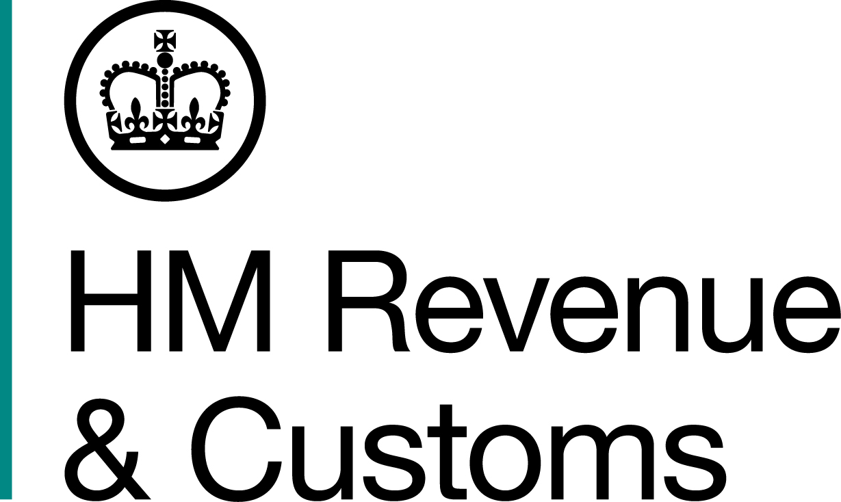
News Release

 | For the attention of News Desks |  | No of pages: 2
 | Date: | 9 November 2018 | Ref: | NI 08/18

Tobacco and cigarettes seized in Newry

An estimated ten tonnes of loose tobacco, and 411,000 cigarettes, have been seized by HM Revenue and Customs (HMRC) in the Newry area.

HMRC officers, accompanied by the Police Service of Northern Ireland, searched a commercial premises in the Newry area on Thursday 8 November. The cigarettes and tobacco, believed to be worth an estimated £5 million in lost duty and taxes, were discovered inside — the site of a suspected illicit tobacco factory.

Steve Tracey, Assistant Director, Fraud Investigation Service, HMRC, said:

“The trade in illicit tobacco is unregulated and makes cheaper tobacco more readily available to the young and vulnerable.

“The sale of illegal tobacco will not be tolerated by us or our partner agencies. Disrupting criminal trade is at the heart of our strategy to clampdown on the illicit tobacco market, which costs the UK around £2.5 billion a year. This is theft from the taxpayer and undermines legitimate traders.

“We encourage anyone with information about the illegal sale of tobacco to report it online or call the Fraud Hotline on 0800 788 887.”

Cigarette processing equipment, filters, and packaging were also found on the premises. Investigations into the suspected fraud are ongoing.

Notes for editors

- Details of the searches:
  - One commercial premises was searched in the Newry area.

- Since 2000, we have reduced the illicit market in cigarettes by around a third. In the last two financial years alone, over 2.8 billion illicit cigarettes and over 660 tonnes of hand-rolling tobacco have been seized resulting in approximately 700 prosecutions.

- HMRC can also levy civil penalties on anyone handling, using or supplying non-duty paid tobacco products.

- Anyone with information regarding tobacco fraud is encouraged to report it via the website http://www.hmrc.gov.uk/reportingfraud/online.htm or call the Fraud Hotline on 0800 788 887.

- Follow HMRC’s Press Office on Twitter @HMRCpressoffice

Issued by HM Revenue & Customs Press Office

Press enquiries only please contact:

Alyson Nicholl
Tel: 03000 518 552 / 07741 615692
Email: alyson.nicholl@hmrc.gsi.gov.uk

Out of hours
Tel: 07860 359544
Website www.hmrc.gov.uk

