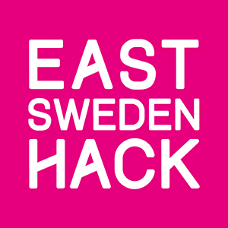

East Sweden Hack strives to bring new solutions to society challenges

This weekend, it’s time for East Sweden Hack 2016 – a competition where 20 teams take on the challenge to produce new ideas and products to face society challenges. By combining open data with Internet of Things they will make completely new solutions in only 24 hours.

The teams come from different parts of the world. One team comes from China, and one from Holland. There is also one contestant flying in from Russia as well as several international students who are based in Sweden. They all join togehter in the creative and technical challenges that a hackathon can offer.

This year the mission is to develop new solutions addressing society challenges; energy & sustainability, integration, health care and medical care as well as society construction and transportation. In the process of collecting ideas to the hackathon, citizens from Norrköping and Linköping has been engaged to share their daily problems and their thoughts of how to simplify daily life by connectivity.

Partners to the hackathon offert open data, and companies and organizations from the region offers support of various kind; technical coaches, sales pitching, innovation counseling.

The winners get to join the well recognized Consumer Electronics exhibition in Las Vegas. The Prize ceremony takes place Friday night, and will be broadcasted at Bambuser.

During Saturday the public is welcome to join in as we through open seminars between 10 am – 15 pm. Their will also be livestreaming from FB Live.

For further information, contact:
Lena Miranda, CEO Mjärdevi Science Park, +46 705 29 56 45

