PINK FLOYD – P.U.L.S.E. RESTORED & RE-EDITED

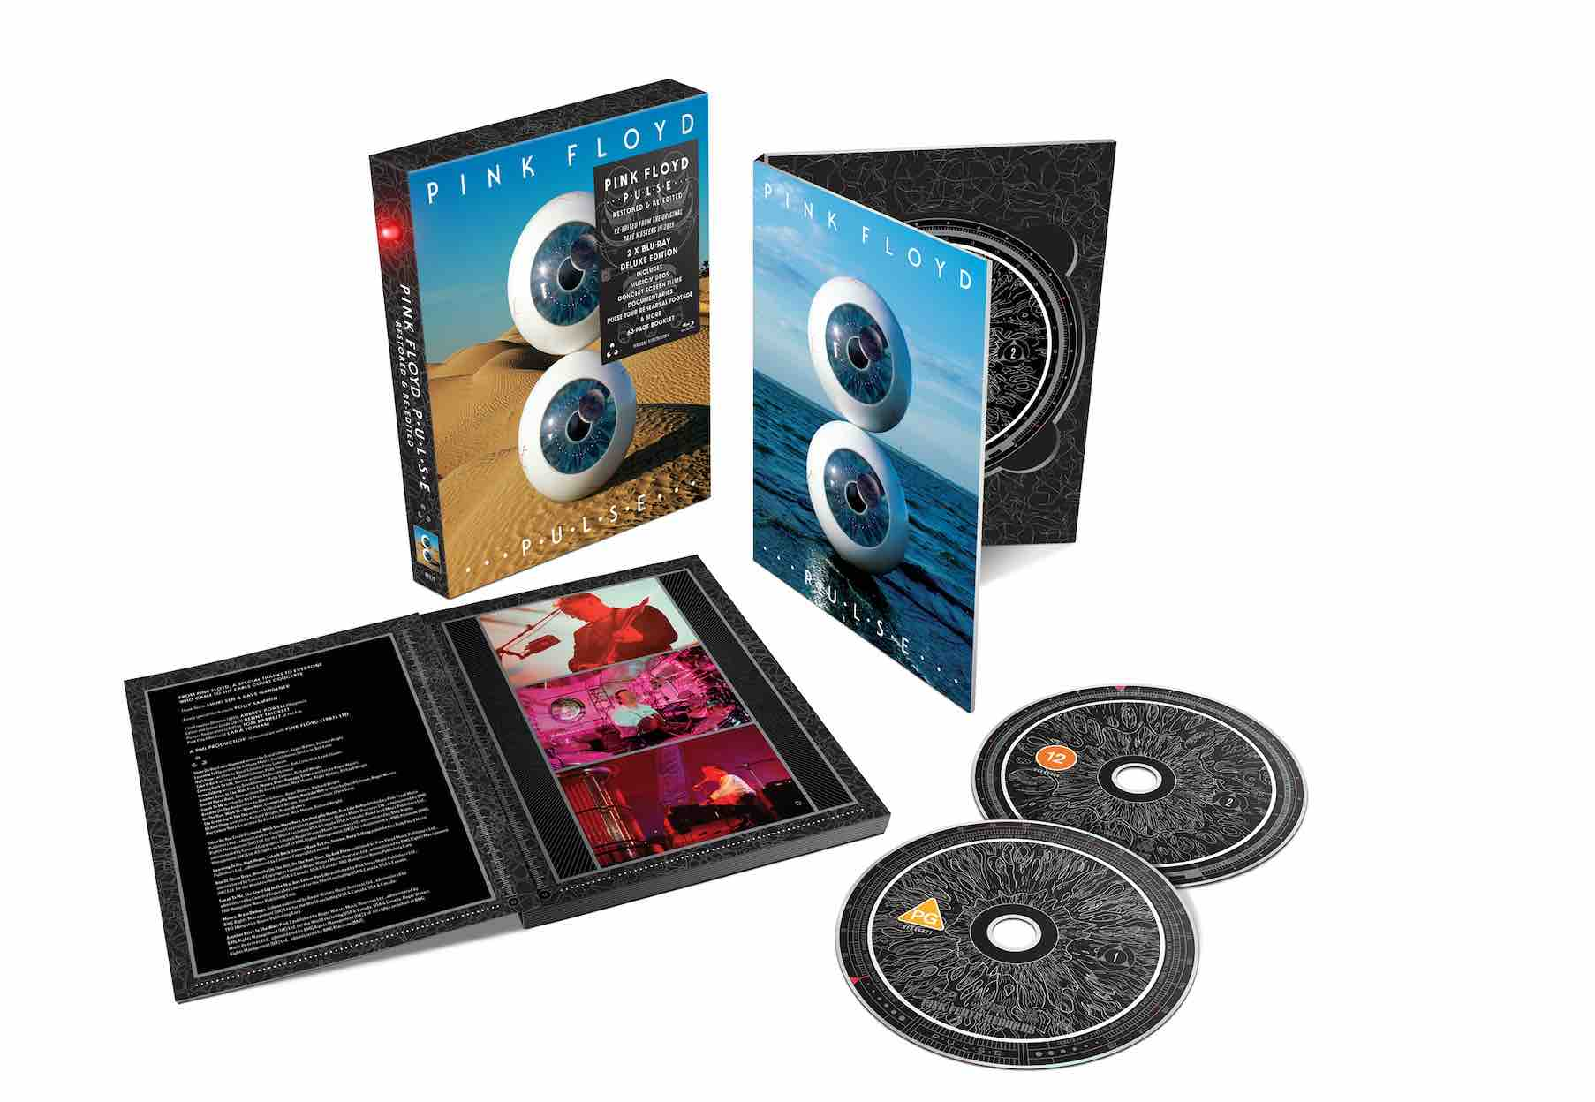
RELEASED 18 FEBRUARY 2022

AVAILABLE FOR THE FIRST TIME ON BLU-RAY

PACKAGING FEATURES THE ICONIC PULSING LIGHT

CONCERT FILMED LIVE ON 20 OCTOBER 1994 AT EARLS COURT, LONDON UK

RESTORED & RE-EDITED IN 2019 FROM THE ORIGINAL TAPE MASTERS

Pre-order link here
Teaser video here

London, UK, December 16, 2021: Warner Music [Sony Music outside Europe] today announced that Pink Floyd’s ‘P.U.L.S.E. Restored & Re-Edited’, will be released for the first time on Blu-ray on 18 February 2022.

The P.U.L.S.E. concert film (helmed by esteemed director David Mallet) will be available as 2x Blu-ray and 2x DVD deluxe box sets, with the video footage having been expertly re-edited by Aubrey Powell/Hipgnosis from the original tape masters especially for The Later Years release in 2019. The cover design, originally created by Storm Thorgerson and Peter Curzon for the 2006 DVD release, has also been updated with photography by Aubrey Powell/Hipgnosis and Rupert Truman/StormStudios. The packaging artwork is designed by Peter Curzon from StormStudios, under the direction of Aubrey Powell/Hignosis.

This release also sees the reintroduction of the iconic pulsating light as per the original 1995 CD release, this time operated by 2 replaceable AA batteries. The deluxe packages include music videos, concert screen films, documentaries, Pulse Tour rehearsal footage & more, alongside a 60-page booklet.

P.U.L.S.E., originally released as an album in 1995, was recorded on the European leg of the Division Bell tour and the DVD and Blu-Ray packages include the whole live performance of ‘The Dark Side Of The Moon’ - the only full live filmed recording of this seminal album. The concert, filmed on 20 October 1994 at Earls Court in London, saw Pink Floyd play some of their classic tracks as well as highlights from the recently released album ‘The Division Bell’. Standout tracks include ‘High Hopes’, ‘Keep Talking’, ‘Sorrow’, ‘Wish You Were Here’, ‘Comfortably Numb’ and ‘The Great Gig In The Sky’.

Nick Mason reflects on the original CD release and the pulsing LED light: “Essentially, it's a device which we thought was entertaining. It's an idea of Storm Thorgerson’s which related to The Dark Side Of The Moon and the pulse, and it's a live album so the box is "alive". After that, in terms of seriously deep meanings, one might be struggling a bit.”

For More Information:
Official Website: https://www.pinkfloyd.com/
Twitter: https://twitter.com/pinkfloyd
Facebook: https://www.facebook.com/pinkfloyd/
Instagram: https://www.instagram.com/pinkfloyd/

Notes to Editors

DISC 1 THE CONCERT FILM
BLU-RAY: STEREO PCM 48/24, 5.1 dts MASTER AUDIO 96/24
DVD: Stereo PCM 48/16, 5.1 dts MASTER AUDIO 48/16

David Gilmour Guitars, Vocals
Nick Mason Drums
Richard Wright Keyboards, Vocals

Sam Brown Backing Vocals
Jon Carin Keyboards, Vocals
Claudia Fontaine Backing Vocals
Durga McBroom Backing Vocals
Dick Parry Saxophones
Guy Pratt Bass Guitars, Vocals
Tim Renwick Guitars, Vocals
Gary Wallis Percussion

Tracklisting:

1. SHINE ON YOU CRAZY DIAMOND, PARTS 1-5,7
2. LEARNING TO FLY
3. HIGH HOPES
4. TAKE IT BACK
5. COMING BACK TO LIFE
6. SORROW
7. KEEP TALKING
8. ANOTHER BRICK IN THE WALL, PART 2
9. ONE OF THESE DAYS
THE DARK SIDE OF THE MOON
10. SPEAK TO ME
11. BREATHE (IN THE AIR)
12. ON THE RUN
13. TIME
14. THE GREAT GIG IN THE SKY
15. MONEY
16. US AND THEM
17. ANY COLOUR YOU LIKE
18. BRAIN DAMAGE
19. ECLIPSE
ENCORES
20. WISH YOU WERE HERE
21. COMFORTABLY NUMB
22. RUN LIKE HELL

DISC 2 MUSIC VIDEOS, TOUR SCREEN FILMS, DOCUMENTARIES & ADDITIONAL MATERIAL
all in STEREO ONLY

MUSIC VIDEOS (BD 48/24, DVD 48/16)
- TAKE IT BACK 1994
- HIGH HOPES 1994
- MAROONED 2014
PULSE TOUR REHEARSAL 1994 (BD 96/24, DVD 48/16)
- A GREAT DAY FOR FREEDOM VERSION 1
- A GREAT DAY FOR FREEDOM VERSION 2
- LOST FOR WORDS
CONCERT SCREEN FILMS 1994 (BD 96/24, DVD 48/16)
- SHINE ON YOU CRAZY DIAMOND PARTS 1-4,7
- SPEAK TO ME
- TIME
- THE GREAT GIG IN THE SKY
- MONEY
- US AND THEM (BLACK & WHITE)
- US AND THEM (COLOUR)
- BRAIN DAMAGE + ECLIPSE North American Dates
- BRAIN DAMAGE + ECLIPSE European Dates
- BRAIN DAMAGE Earls Court, London Dates
DOCUMENTARIES & ADDITIONAL MATERIAL (BD 48/24, DVD 48/16)
- THE DIVISION BELL ALBUM COVER PHOTOGRAPHY (Ely, Cambridgeshire, UK) 1994
- PULSE TV AD 1995
- THE DIVISION BELL AIRSHIPS 1994
- BEHIND THE SCENES Interviews with the Lead Technicians for the Division Bell Tour
ROCK & ROLL HALL OF FAME INDUCTION 1996 (BD 48/24, DVD 48/16)
- WISH YOU WERE HERE with BILLY CORGAN
AUDIO-ONLY LIVE RECORDINGS (BD&DVD 96/24)
- ONE OF THESE DAYS LIVE IN HANOVER 1994
- ASTRONOMY DOMINE LIVE IN MIAMI

