MEDIA RELEASE

Double Honours for Pan Pacific Hotels Group as “Best Regional Hotel Chain”, As it Poise for Future Growth with its Recent Brand Refresh

The Group is voted in twice this year as the best hotel chain in Asia Pacific by the readers of leading trade publications, TTG Asia and Travel Weekly Asia

17 October 2018, Singapore — Pan Pacific Hotels Group has clinched “Best Regional Hotel Chain” at the annual Travel Weekly Asia’s Readers’ Choice Awards held on 15th October. This follows the Group’s earlier win of “Best Regional Hotel Chain” at the annual TTG Travel Awards held on 20th September.

This comes as the Group revitalised its brands in May this year with a core focus on connecting with its customers through brand repositioning and a fresh take on digital marketing, loyalty programmes and service offerings.
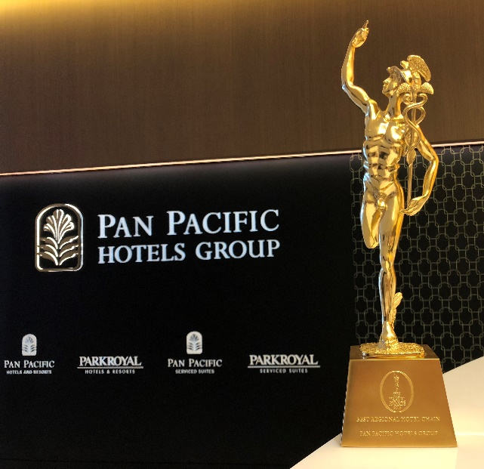
Held in Bangkok on 20th September, the 29th TTG Travel Awards has been recognising the best of Asia-Pacific’s travel industry since 1989. This year, the TTG Travel Awards honoured 84 winners across four categories: Travel Supplier, Travel Agency, Outstanding Achievement and Travel Hall of Fame. As one of the most coveted and influential awards in the travel industry, winning “Best Regional Hotel Chain” at the TTG Travel Awards has propelled Pan Pacific Hotels Group to the frontline of the best in the regional travel industry.

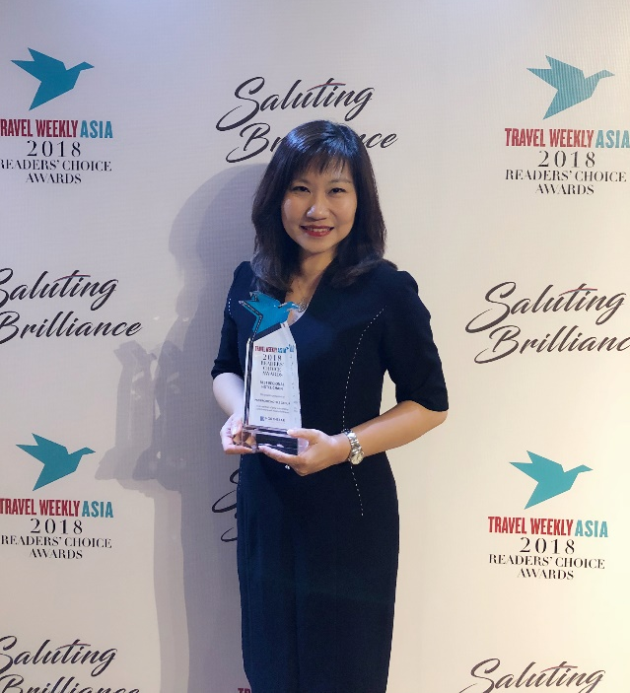
Now into its fourth edition, the Travel Weekly Asia Readers’ Choice Awards 2018 recognised 56 winners across 10 categories — Airline, Cruise, Car Rental, Destination, Hotel, Resort, Serviced Residence, Travel Agent, Travel Technology and Tourism Experience. Pan Pacific Hotels Group clinched the “Best Regional Hotel Chain” award for the second consecutive year, a reassuring vote of confidence from its guests and partners towards excellence in product and service from a hospitality company.

Ms Cinn Tan, Chief Sales and Marketing Officer, Pan Pacific Hotels Group (pictured above), says, “It is an incredible honour to be awarded the region’s best hospitality company not once – but twice – in the same year. These prestigious awards are a culmination of our intentional efforts to emphasise sincerity in everything we do, along with our brand refresh journey. We are humbled yet proud to be standing amongst the finest in Asia-Pacific’s travel industry. These recognitions are especially meaningful as they provide a boost of confidence to our associates, to know that we are trusted and preferred by our valued guests, partners and industry friends.”

As part of its brand refresh, Pan Pacific Hotels Group overhauled its website, private-labelled its loyalty programme to Pan Pacific DISCOVERY (introducing changes such as exclusive room rates, late check outs, and room upgrades for direct bookings while integrating its serviced suites portfolio into the programme – an industry first) and launched the invitation-only Pan Pacific Connections to reward loyal corporate clients for booking rooms, meetings and events at its properties globally, amongst other initiatives. Recognising that its people are at the heart of its business, Pan Pacific Hotels Group focused on reinforcing its “heartware” through a series of service excellence and brand training sessions, while nurturing a culture of based on trust through the shared values of integrity, teamwork, results, respect and creativity.

-END-
Media Contact
Cuili NG
Brand & Corporate Communications Manager
Pan Pacific Hotels Group
DID: +65 6808 1269
Mobile: +65 9634 4425
Email: ng.cuili@pphg.com

Pan Pacific Hotels Group
Pan Pacific Hotels Group is a wholly-owned hotel subsidiary of Singapore-listed UOL Group Limited, one of Asia’s most established hotel and property companies with an outstanding portfolio of investment and development properties.

Based in Singapore, Pan Pacific Hotels Group owns and/or manages more than 40 hotels, resorts and serviced suites including those under development in 24 cities across Asia, Oceania, North America and Europe.

Voted “Best Regional Hotel Chain” by readers in Asia-Pacific in 2017 and 2018, Pan Pacific Hotels Group comprises two acclaimed brands: its signature brand, Pan Pacific and its deluxe brand, PARKROYAL.

Sincerity is the hallmark of Pan Pacific Hotels Group. The Group is known to its guests, partners, associates and owners for its sincerity in people and the sense of confidence which alleviates the stresses of today’s complex world. Visit us at www.panpacific.com.

