Capture One releases new ‘Pacific’ & ‘Infinite Peaks’ Latitude Style packs

New, nature-inspired looks for the cherished Latitude series, developed by leading photographers exclusively for Capture One
COPENHAGEN, June 20th, 2019: Capture One, the world’s premier name in photo editing software, releases new Styles in the ‘Latitude’ series, crafted by acclaimed commercial photographer John Schell and Fujifilm X-Photographer Bryan Minear. Their signature looks have garnered clients like Skechers and Budweiser, and these new Capture One Styles mark the first time they have been made available to anyone on any platform.
Both John and Bryan have their photographic roots anchored in nature, and their work is heavily inspired by their love for it. From the Californian coast to the foothills of the Appalachians, the new Latitude Styles reflect some of the most beautiful scenes and destinations around the world. They aim to embrace and heighten the natural aesthetic of any scene and subject, from portraits to seascapes.
Capture One Latitude Styles are precisely-developed presets that are designed and tested to work with an extensive variety of images. They adjust the overall look and feel of any image with one click and can be tuned to suit individual taste. With the option to add each Style as a layer and control its intensity, as well as use multiple layers and Styles per image, Capture One Styles can serve as a starting point, a finishing touch or to give a specific nuanced flair.
Both ‘Pacific’ and ‘Infinite Peaks’, the new Latitude Style packs, include a diverse set of Styles that complement each other, while providing enough variation to suit any scene. The wide selection of Styles offer endless possibilities to create professional and distinguished editorial images, be it fashion, street, travel, wedding, portraiture, or any other genre of your editorial work.

Pricing and Availability
Latitude ‘Pacific’ and ‘Infinite Peaks’ Style Packs are now available: www.captureone.com/store/styles/latitude-styles-kit
The Styles can be purchased per pack or as a bundle with all 4 Style Packs in the Latitude series, and for a limited time as a bundle with only the 2 new packs:
- Price per Style Pack:
EUR: 39. USD: 34. GBP: 34
- Price for Latitude Style kit including Infinite Peaks and Pacific (Limited offer):
EUR: 59. USD: 49. GBP: 49
- Price for Latitude Style kit including Infinite Peaks, Pacific, Deep Forest, and Sunbound:
EUR: 109. USD: 99. GBP: 99
*The limited offer will expire June 30th, 2019, after which the Latitude Styles can only be purchased all together or as individual packs.

Note to editors:
Please find Before/After example imagery below, pricing, and annexed documentation for links to video instruction and demonstration together with more information from the artists.
Contact: Global Public Relations Manager, Nadia Julie Froberg: njf@phaseone.com

John Schell

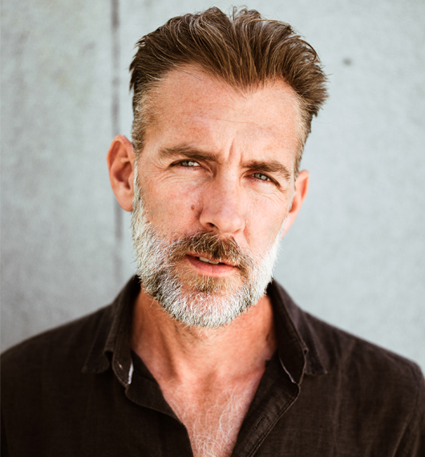
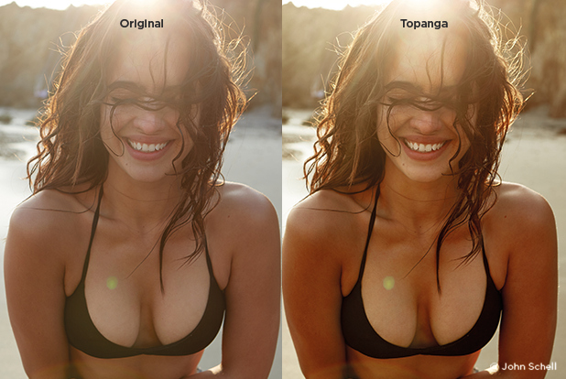

John Schell:
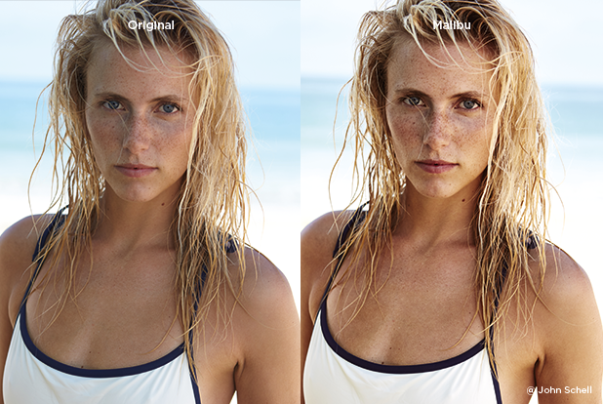
John Schell is a lifestyle, commercial, editorial and advertising photographer based in Los Angeles, California.
www.johnschellphoto.com
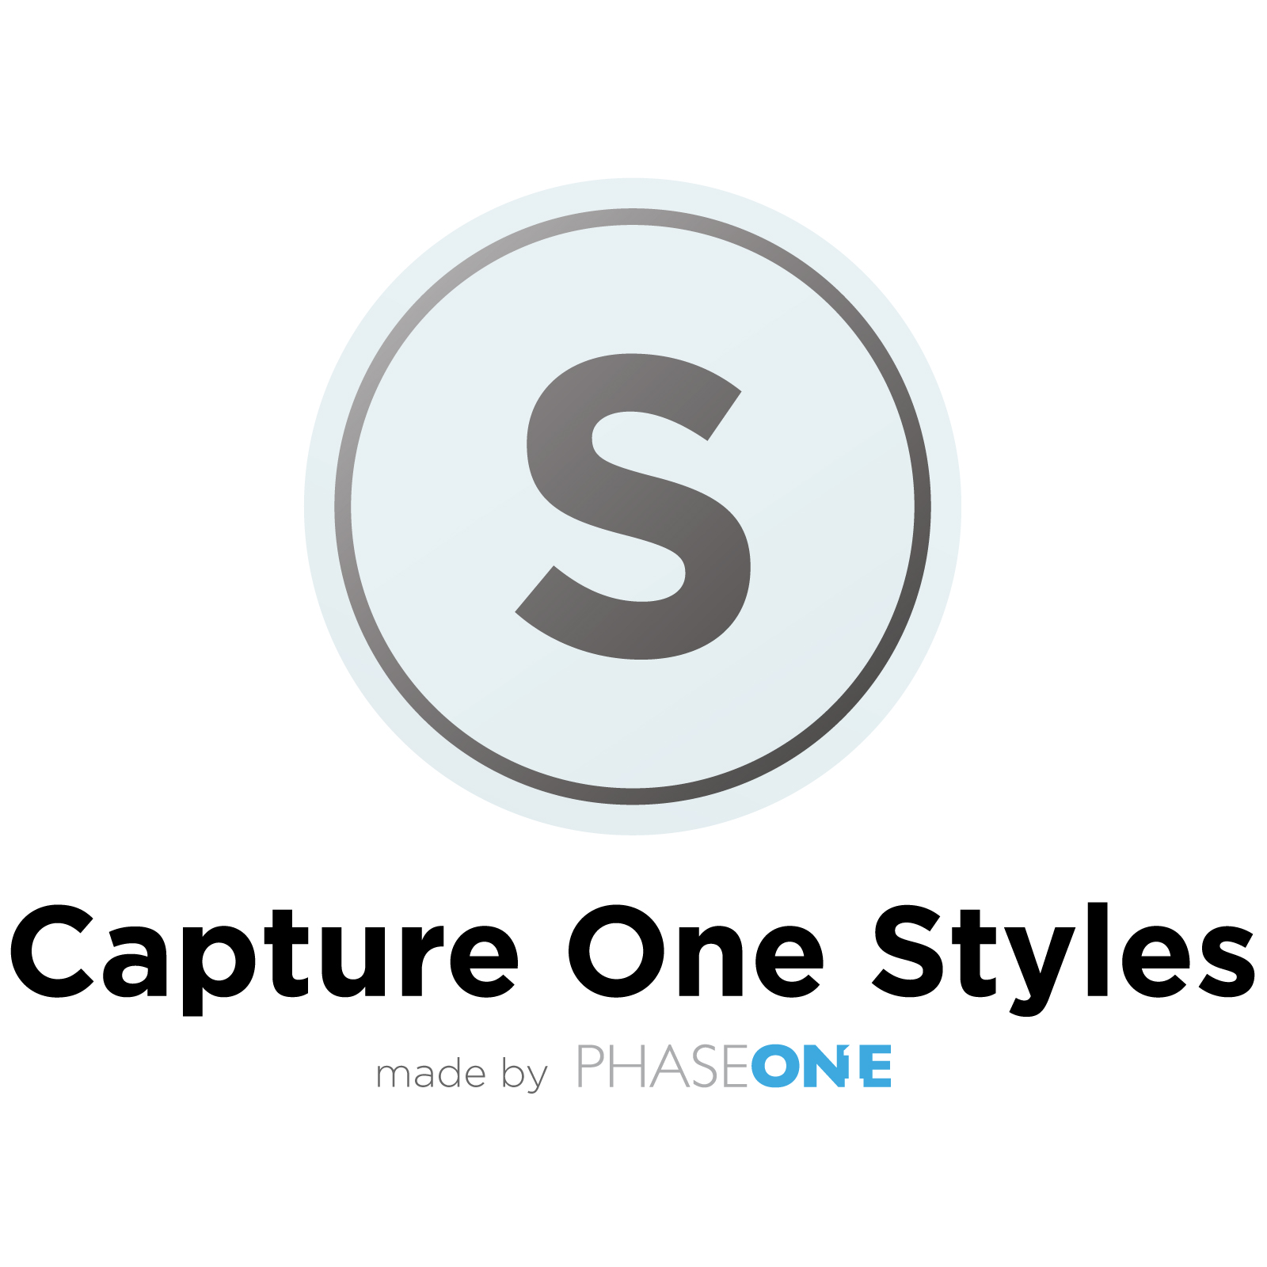

Bryan Minear

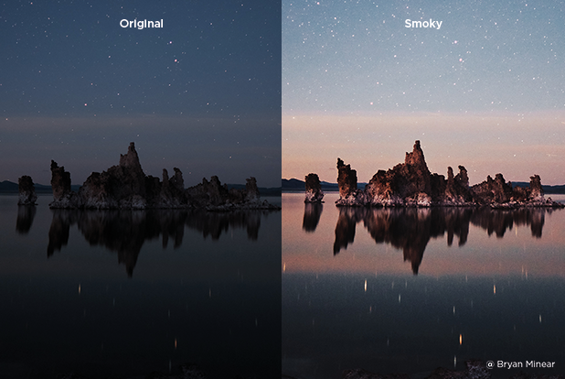
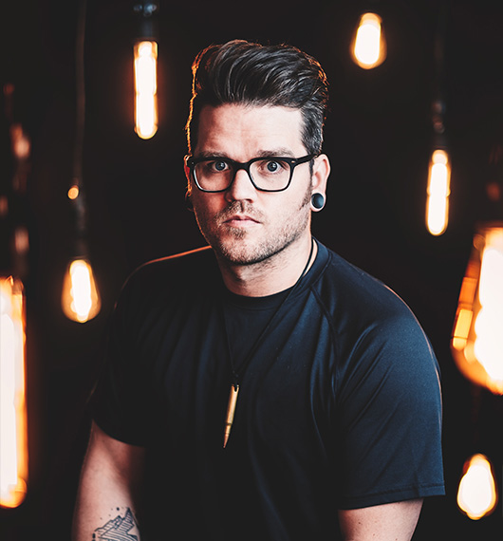

Bryan Minear:
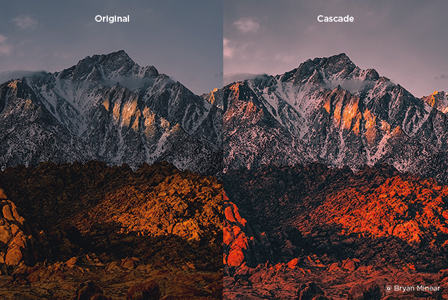
Bryan Minear is a fine art and landscape photographer currently based in Michigan. His goal is to travel the world to portray atmosphere and emotion though his work.
www.bryanminear.com

About Phase One and Capture One
Capture One is the award-winning professional choice in photo editing software. With native support for more than 500 camera models, Capture One software offers fast and powerful RAW conversion, photo editing and asset management. Capture One features a highly responsive processing engine, unmatched color handling, precision-editing tools, and seamless tethered support.
Capture One is developed by Phase One A/S, the world’s leading manufacturer of medium format digital photography systems and imaging solutions for professional photographers, and cultural heritage and industrial solutions. Established in 1993, Phase One has pioneered the field of digital camera systems and imaging software, including multiple breakthroughs – from the world’s first 100MP camera systems to advanced imaging workflows in Capture One.
By controlling all aspects of the medium format camera system supply chain, Phase One is uniquely positioned to help photographers and imaging experts everywhere stand out from the competition and realize their creative visions without compromise.
Based in Copenhagen, Denmark, and with offices in New York, Tokyo, Cologne, Shanghai and Tel Aviv, Phase One is committed to delivering an unmatched level of service and support to every customer through this expert team of global partners.
Phase One and Capture One are registered trademarks of Phase One A/S. All other brand or product names are trademarks or registered trademarks of their respective holders.
Learn more here:
Capture One at: www.captureone.com
Phase One at: www.phaseone.com
Facebook at: www.facebook.com/CaptureOnePro
Instagram at: www.instagram.com/CaptureOnePro
YouTube at: www.youtube.com/CaptureOneProDK
LinkedIn at: www.linkedin.com/company/capture-one

