PRESS RELEASE
FOR IMMEDIATE RELEASE

World’s First 3LCD 25,000 lumens laser projector

Laser light-source and inorganic components delivers superior heat and light resistance for 20,000 hours of maintenance-free operations

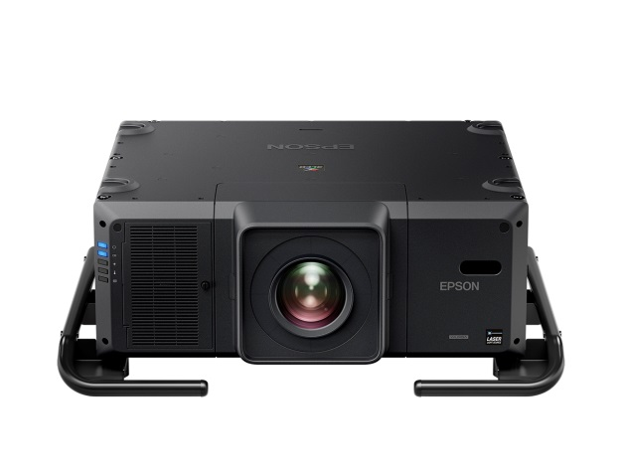 | 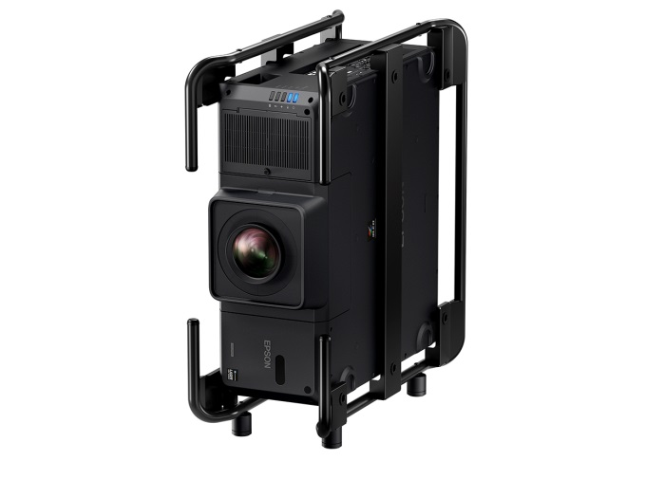
Epson EB-L25000U laser projector

Yogyakarta, 13 October 2016 – Epson, the number-one selling projector brand worldwide, today announced the launch of the EB-L25000U laser projector in Southeast Asia – the world's first 3LCD 25,000 lumens laser projector, consisting of 25,000 lumens of colour brightness and white brightness to deliver spectacular image quality for outdoor and large venues.

A technological breakthrough and industry first, the EB-L25000U integrates a fully sealed laser optical engine with laser-light source and inorganic components to deliver advanced performance, quality, and flexibility. The use of a laser light source contributes to a high contrast ratio of 2,500,000:1 that provides absolute black and vivid colour.

The projector is capable of delivering bright and vibrant images for extremely long periods – this is due to its LCD panels and a phosphor wheel, which are made up of inorganic materials that have superior light and heat resistance. Users are able to operate continuously 24/7 for 20,000 hours of operation before the brightness starts to decrease.

The EB-L25000U is ideal for rental and staging, as well as permanent large venue installations. Designed for installation flexibility, it is able to rotate and tilt 360 degrees in all directions. It comes with a wide array of motorized 4K compatible lenses, which when paired with the 4K Enhancement feature, turns projected images into a true-to-life, immersive experience.

“The EB-L25000U is Epson’s highest lumen projector and helps to significantly expand our presence in the high brightness projector market. We have steadily increased our line-up of projectors and with our laser projectors, we are better able to meet the needs of the high end segments within the region. The high-lumen projector market is forecast to grow by 125% by 2020, and Epson is continuing to invest heavily in developing technologies and products to meet the expanding needs,” said Siew Jin Kiat, Regional General Manager (Southeast Asia), Printers & Visual Instruments Division, Epson Singapore.

Epson’s EB-L25000U projector was launched with a projection mapping on the 47-metre high Prambanan Temple in Central Java in Indonesia, a UNESCO World Heritage Site. The projection mapping tells the story of the history of the temple construction which started in the mid-9th century.

The EB-L25000U projector has been recognised in multiple industry awards. It was recently recognised in the Good Design Award 2016 organised by the Japan Institute for Design Promotion, and was awarded the prestigious Best New Rental / Staging Projector by rAVe Best of ISE 2016 Awards. Other awards won included NewBay Media’s Best of Show Awards at Infocomm 2016 from Digital Signage and Sound & Video Contractor magazines.

The EB-L25000U uses advanced edge blending, a built-in camera for colour calibration and lens position memory function. Features for large venue installations and staging include:

- Exceptional Full HD Widescreen Display – Native WUXGA (1920 x 1200) with 4K Enhancement technology
- 4K-Ready Lenses – These future-proof lenses project crisp images and are ready for true 4K applications
- 4K Enhancement Technology – Revolutionary technology accepts 4K signal and enhances a 1080p signal to output that surpasses Full HD image quality. 4K Enhancement technology shifts each pixel diagonally by 0.5 pixels to double the resolution, delivering crisp, high-definition images.
- Solid-State Laser Light Source – Provides virtually maintenance-free operation up to 20,000 hours²
- Versatile Connectivity – Supports the full range of inputs including HDBaseT, 3G-SDI, and compatible with Crestron RoomView, AMX, Extron XTP, Control4, and Art-Net for easy integration
- Web-based Remote Management – Control and monitor projector status via a Web browser
- Professional Installation Features – Full 360-degree installation flexibility, including Portrait Mode, instant On/Off power, quieter performance, and absolute black contract ration

About Epson
Epson is a global technology leader dedicated to connecting people, things and information with its original efficient, compact and precision technologies. With a line-up that ranges from inkjet printers and digital printing systems to 3LCD projectors, smart glasses, sensing systems and industrial robots, the company is focused on driving innovations and exceeding customer expectations in inkjet, visual communications, wearables and robotics. Led by the Japan-based Seiko Epson Corporation, the Epson Group comprises more than 67,000 employees in 90 companies around the world, and is proud of its contributions to the communities in which it operates and its ongoing efforts to reduce environmental impacts.

About Epson Malaysia
Epson began operations in Malaysia in 1991 as Epson Trading (M) Sdn Bhd before being incorporated as Epson Malaysia Sdn Bhd. The company has the exclusive rights to market, distribute and support a complete range of leading-edge Epson consumer and business digital imaging products in Malaysia and Brunei. Today, Epson Malaysia has 84 employees and an extensive network of 61 authorised service outlets throughout the country. For more details, please visit www.epson.com.my or connect with us at www.facebook.com.my/EpsonMalaysia.

_{Media Enquiries:}
_{Epson Malaysia Sdn Bhd}  _{Chua Li Tinn}  Manager – Marketing Communications  _{Tel: (03) 5628 8288 Ext 274}  Email: ltchua@emsb.epson.com.my | _{SWOT Communications}  _{Edina Manuel}  _{Tel: 012 2500142}  Email: Edina@swotcommunications.com

Colour brightness (colour light output) and white brightness (white light output) will vary depending on usage conditions. Colour light output measured in accordance with IDMS 15.4; white light output measured in accordance with ISO 21118.
20,000 hours is the estimated projector life when used in Normal Mode. Actual hours may vary depending on mode and usage environment. The projectors come with a limited warranty of three years or 20,000 hours, whichever comes first.

