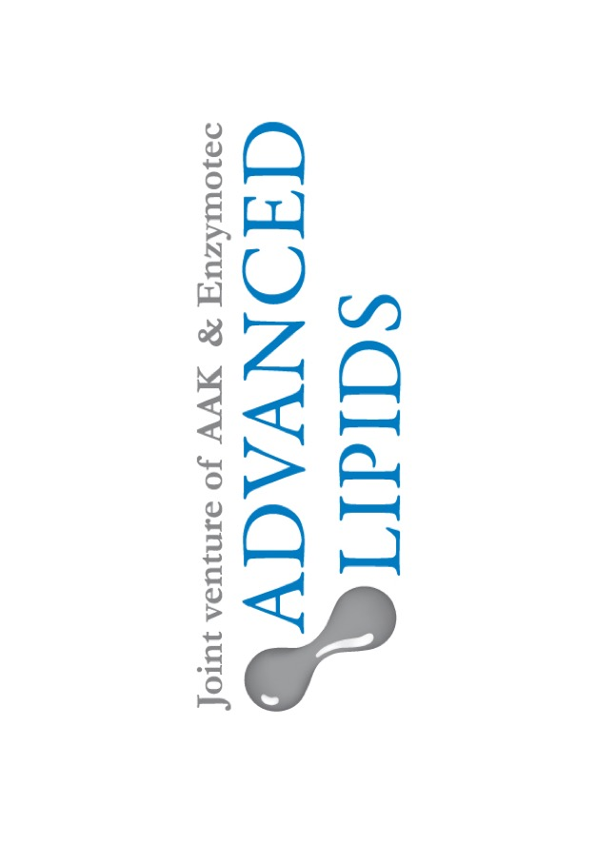
Infants fed with formula containing SN-2 palmitate cry less and sleep more, study shows

For immediate release: Tuesday 25 July 2017

Infants fed with formula containing INFAT®, the SN-2 palmitate ingredient from Advanced Lipids, cry less and sleep more, a clinical study has shown.

SN-2 palmitate is a bioactive ingredient used in some infant formulas. It has been shown to offer a range of benefits for babies, including better fat and calcium absorption and softer stools.

The clinical study looked at 171 healthy term infants. One group was fed formula containing INFAT® – Advanced Lipids’ SN-2 palmitate ingredient; the second was fed a control formula; and a third group of breastfed infants was included for reference.

The frequency of crying, length of crying episodes, daily number of sleep periods and sleep duration were measured at six weeks of age, and again at 12 weeks.

Patterns of both crying and sleep differed significantly between the two formula-fed groups. The breast-fed babies, and those fed on the formula containing SN-2, had fewer crying episodes than the babies fed on standard formula. The duration of their crying was also shorter.

Furthermore, the infants fed on formula containing SN-2 enjoyed longer average sleep duration than those fed on standard formula.

The researchers conclude that SN-2 palmitate is associated with both less crying and better sleeping, thereby improving the well-being of formula-fed infants and consequently the quality of life of their parents. This further emphasizes the importance of SN2-palmitate for infant nutrition.

The paper is published in Clinics in Mother and Child Health. Commenting on the findings, Dr. Sigalit Zchut, Clinical Marketing Manager and Technical Director at Advanced Lipids, said:

“Breast-feeding will always be the gold standard. However, by mimicking the fatty acid structure of breast milk, SN-2 helps us offer many of the same benefits in formula. This research adds to the growing body of clinical evidence for the many advantages of SN-2 palmitate. It’s great news for manufacturers but also for parents, for whom infant crying and sleep are major concerns.”

View the paper at:

https://www.omicsonline.com/open-access/sn2palmitate-improves-crying-and-sleep-in-infants-fed-formula-withprebiotics-a-doubleblind-randomized-clinical-trial-2090-7214-1000263.php?aid=90668

About Advanced Lipids
Advanced Lipids is a joint venture established by Enzymotec, a leading biotech company specializing in lipid-based bio-functional ingredients, and AAK, a global producer and supplier of speciality vegetable fats and oils for the infant formula industry. Combining Enzymotec’s clinical and chemical expertise in lipid technologies with AAK’s international strength in food safety, production and logistics, Advanced Lipids offers a unique package of clinical research, development, flexible blending, quality and logistics. Find out more at www.advancedlipids.com.
For more information contact
Steve Harman
Ingredient Communications
+44 (0)1293 886444
+44 (0)7494 307911
steve@ingredientcommunications.com

