KONGSBERG USV to minimise Aker BioMarine’s carbon footprint
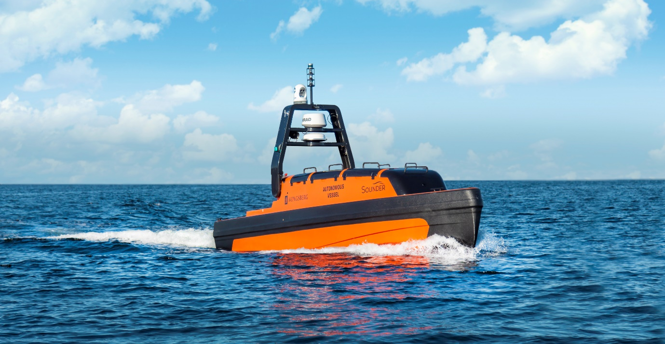
Aker BioMarine’s new Sounder USV will collect data on krill biomass to facilitate sustainable harvesting
Kongsberg, Norway, 17th June 2021 – Aker BioMarine has ordered a new Sounder USV (Unmanned Surface Vehicle) from Kongsberg Maritime, to further reduce their carbon footprint and optimise krill harvesting in Antarctica. The USV is also equipped to collect valuable scientific data.
Sustainable use of the ocean and marine resources is a key part of Aker BioMarine’s strategy. To achieve this, the company has invested heavily in technology that contributes to more sustainable fishery and fishery management. In order to collect detailed data on the krill biomass, Aker BioMarine launched an unmanned solar-powered ocean data drone (Sailbuoy) early in 2020. Now the company has made another important investment, buying a specially designed USV from Kongsberg Maritime.
Unmanned maritime systems are evolving rapidly, and Kongsberg Maritime has a history of making world-leading products for the hydrographic and subsea positioning industries. The company supplies more multibeam sonars, positioning and fishery systems to the offshore market than any other manufacturer. The new agreement with Aker BioMarine will give the biotech and krill harvesting company an even greater scientific edge for their operations in Antarctica.
“With this USV we will further reduce our fuel consumption when looking for krill. Data from the USV will help our vessels navigate more efficiently, and thereby help minimise our CO₂ footprint. We chose Kongsberg Maritime because of their experience and technical expertise, and this USV represents a versatile and reliable platform to help us reach net-zero carbon emissions by 2050,” says Frank Grebstad, SVP Vessel Operations at Aker BioMarine.
As part of the agreement between Kongsberg Maritime and Aker BioMarine, the companies will co-operate to further develop the USV, together with scientific advice from REV Ocean, a not-for-profit company with a mission to make the ocean healthy again. REV Ocean will give scientific and technical advice to the project and look for novel ways to better utilise the data from the USV in large international science programs and projects.
“This new agreement with Aker BioMarine is very exciting. The ability to collect precise data effectively from the ocean is important to make fisheries more sustainable. Further developing and advancing this technology will be invaluable in making the job of scientists easier,” says Nina Jensen, CEO of REV Ocean.
“We´re proud to announce this contract and believe that our co-operation with Aker BioMarine has the potential to help the company substantially in their hunt to further reduce their carbon footprint,” says Atle Gran, Area Sales Manager, Marine Robotics at Kongsberg Maritime. “KONGSBERG is committed to sustainability and firmly believes that autonomous solutions such as our USVs and AUVs are key to greener maritime operations, and in helping us to learn more about the marine environment and how to interact with it in the least invasive way possible.”
About the Sounder USV:
- The Sounder USV is designed for optimal performance of hydroacoustic sensors and systems.
- It is built around a robust 8-metre vessel hull, developed in cooperation with Viking Norsafe AS.
- The USV can be remotely controlled from a shore station or mothership through Kongsberg Maritime Broadband Radio (MBR), or from further afield via satellite communications. Additionally, situation awareness sensors – such as RADAR and various camera systems – facilitate advanced mission autonomy.
- Systems from Kongsberg Maritime’s range of sensors for hydroacoustic mapping, positioning, communication, fish finding, and oceanographic research are integrated into the USV.
- The system configuration for this USV will help Aker BioMarine collect data for their fishery needs, but it can also collect data for scientific purposes.
Ends

For further information, please contact:
Gunvor Hatling Midtbø, VP Communication
Kongsberg Maritime
Tel: +47 9921 4209
gunvor.hatling.midtbo@km.kongsberg.com

David Pugh
Saltwater Stone
Tel: +44 (0)1202 669244
d.pugh@saltwater-stone.com
Katrin Berntsen,
Director Communications
Aker BioMarine
katrin.berntsen@akerbiomarine.com

About Kongsberg Maritime
Kongsberg Maritime is a global marine technology company providing innovative and reliable ‘Full Picture’ technology solutions for all marine industry sectors including merchant, offshore, cruise, subsea and naval. Headquartered in Kongsberg, Norway, Kongsberg Maritime has manufacturing, sales and service facilities in 34 countries.
Kongsberg Maritime solutions cover all aspects of marine automation, safety, manoeuvring, navigation, and dynamic positioning as well as energy management, deck handling and propulsion systems, and ship design services. Subsea solutions include single and multibeam echo sounders, sonars, AUV and USV, underwater navigation and communication systems.
Training courses at locations globally, LNG solutions, information management, position reference systems and technology for seismic and drilling operations are also part of the company’s diverse technology portfolio. Additionally, Kongsberg Maritime provides services within EIT (Electro, Instrument & Telecom) engineering and system integration, on an EPC (Engineering, Procurement & Construction) basis.
Kongsberg Maritime is part of Kongsberg Gruppen (KONGSBERG), an international, knowledge-based group that celebrated 200 years in business during 2014. KONGSBERG supplies high-technology systems and solutions to customers in the oil and gas industry, the merchant marine, and the defence and aerospace industries.
Web: Kongsberg Gruppen | Kongsberg Maritime
Social media: LinkedIn | Twitter | Facebook

About Aker BioMarine
Aker BioMarine is a biotech innovator and Antarctic krill-harvesting company, dedicated to improving human and planetary health. Listed on Oslo Stock Exchange, the company develops krill-based ingredients for pharmaceutical, nutraceutical, aquaculture, and animal feed applications, including INVI, a highly concentrated protein isolate, and LYSOVETA, a targeted transporter of EPA and DHA from krill. Aker BioMarine’s fully transparent value chain stretches from sustainable krill harvesting in pristine Antarctic waters through its Montevideo logistics hub, Houston production plant, and to customers around the world. The company’s strong focus on sustainability inspired the launch of AION by Aker BioMarine, a circularity company dedicated to helping companies to recycle and reuse waste.
Web: Aker BioMarine

