GRAMMY AWARD-WINNER & ELECTRONIC DANCE MUSIC ICON
FRED RISTER
UNVEILS FINAL SINGLE
“I WANT A MIRACLE (FEAT. SAM MARTIN & CHRIS WILLIS)”

ALL PROCEEDS TO BENEFIT THE KIDNEY CANCER ASSOCIATION

DOCUMENTARY FILM CURRENTLY IN PRODUCTION FEATURING EXCLUSIVE INTERVIEWS WITH DAVID GUETTA, will.i.am, AND MORE

WATCH/POST: LINK
BUY/STREAM: https://ParametricRecs.lnk.to/IWAMPR

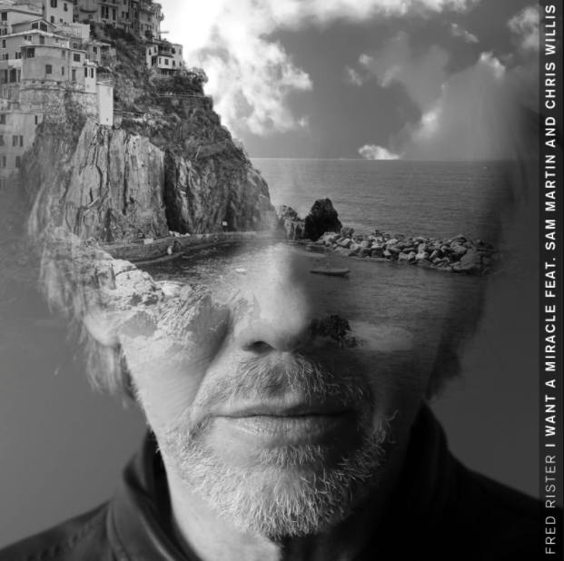

GRAMMY Award-winning producer Fred Rister has announced the release of his final single, “I Want A Miracle (ft. Sam Martin & Chris Willis),” out today via Parametic Records and accompanied by an official music video (WATCH HERE). All proceeds from the single will benefit the Kidney Cancer Association – donate HERE.

Perhaps best known for his landmark collaborations with dance music superstar David Guetta, Rister is currently battling a variety of cancers while still making extraordinary music, both on his own and alongside Guetta. A 5x ASCAP Award-winner, Rister has co-produced and co-written a remarkable canon of pop and dance classics with Guetta, including the worldwide multi-platinum hits, “Memories (ft. Kid Cudi),” “Without You (ft. Usher),” “Getting’ Over You (ft. Fergie & LMFAO),” “Little Bad Girl (ft. Taio Cruz & Ludacris),” Flo Rida’s “Club Can’t Handle Me (ft. David Guetta),” and of course the GRAMMY Award-winning “When Love Takes Over (ft. Kelly Rowland),” named by Billboard as the #1 dance-pop collaboration of all time. Rister also teamed with Guetta to co-produce The Black Eyed Peas’ 2009 blockbuster, “I Gotta Feeling,” a GRAMMY Award-winner, record-shattering global #1 single, and still iTunes’s most downloaded track of all time.

Born Frédéric Riesterer in Malo-Les Bains near Dunkirk, in the North of France, Rister will soon be the subject of a landmark documentary detailing his remarkable contributions to electronic dance music. Produced by Lucien Television, the film will chronicle Rister’s accomplished career, from beloved Paris DJ to world-conquering producer and composer, with exclusive interviews from such longtime collaborators as Guetta and The Black Eyed Peas’ will.i.am.

http://www.fredrister.com
https://twitter.com/fred_rister
https://www.facebook.com/FredRisterOfficiel
https://www.instagram.com/fredristerofficiel
https://secure.kidneycancer.org/IWAM

Press Materials: http://press.atlanticrecords.com/fred-rister/
Contact: Jordan Danielle Frazes | Jordan.Frazes@AtlanticRecords.com

ABOUT KIDNEY CANCER ASSOCIATION
The Kidney Cancer Association (KCA) is a charitable organization made up of patients, family members, physicians, researchers, and other health professionals from around the world. It is the world’s first international charity dedicated specifically to the eradication of death and suffering from renal cancers. It is also by far the largest kidney cancer charity, with members in more than 100 countries. KCA funds, promotes, and collaborates with the National Cancer Institute (NCI), American Society for Clinical Oncology (ASCO), American Urological Association (AUA), and other institutions on research projects. KCA also educates families and physicians, and serves as an advocate on behalf of patients at the state and federal levels in the United States and globally. For more information or to make a donation, please visit www.kidneycancer.org.

