Kongsberg Maritime to deliver integrated propulsion and manoeuvring systems for two 230m RoPax vessels
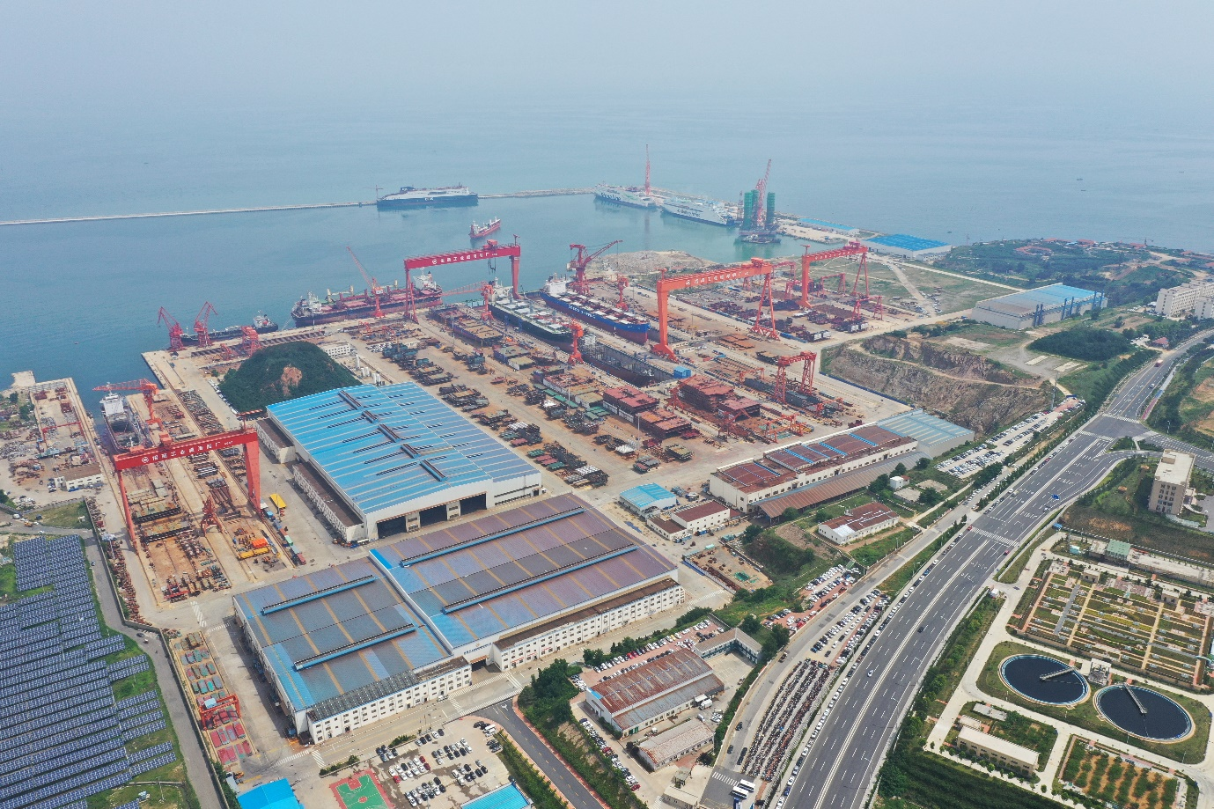
Kongsberg Maritime is to supply China Merchants Jinling Shipyard (Weihai) with systems for two RoPax vessels
Kongsberg, Norway, 8th October 2020 – Kongsberg Maritime is pleased to reveal that it has signed a contract with China Merchants Jinling Shipyard (Weihai) to deliver a propulsion and manoeuvring system for two 230m roll-on, roll-off passenger (RoPax) vessels for Finnlines. Currently under construction at Weihai and expected to be delivered for deployment in the Baltic Sea by 2023, the ships will each have capacity for 1,212 passengers and are specified with a focus on sustainable technologies and green operation.
Worth in excess of EUR 12 million, the contract will see the system fitted to Finnlines’ flagship Superstar RoPax vessels. The ships will be built to the highest Swedish/Finnish ice class (1A Super), with a twin shaft line propulsion system powered by four main engines. Kongsberg Maritime have proposed a system whereby the ships will be able to run two efficiency/speed profiles: 16 knots with two engines running, or 19 knots with four engines running. This capability is enabled via an innovative two-speed gearbox solution, delivering a propulsion efficiency increase of about 3% compared with a single-speed gearbox.
This sophisticated system is underpinned by Kongsberg Maritime’s world-class automation technologies. Yaling Liu, VP Sales and Marketing for Kongsberg Maritime in Greater China, said: “We understand the conditions in which the customer’s vessels will operate and have developed strategies to improve energy efficiency, thereby saving fuel and reducing emissions. Our well-proven Ice Class 1A propulsion package will allow the vessels to work effectively in Arctic conditions, dealing with floating ice and extreme cold.”
Efficiency is further boosted through the use of KONGSBERG’s Controllable Pitch Propellers (CPPs). With the propeller and rudder integrated into a single system, hydrodynamic performance is optimised, thrust is increased and drag is reduced, with a consequent reduction in emissions. Combined with a ‘twisted’ rudder design that further
improves manoeuvrability, twin-screw vessels can be expected to achieve efficiency
gains of up to 6%.
Weisong Ni, Vice GM for China Merchants Jinling Shipyard (Weihai) Co. Ltd, said: “These vessels are being built to the highest standards for use in the sensitive environment of the Baltic Sea, so it is vital that we make every effort to choose technologies that ensure they will operate as sustainably as possible. KONGSBERG’s propulsion and manoeuvring system will help ensure that the vessels minimise fuel usage and emissions, whilst at the same time assisting manoeuvrability – often a crucial consideration for passenger ferries which may dock several times every day.”
Egil Haugsdal, President Kongsberg Maritime, said: “This is a major contract and a key endorsement of our propulsion, manoeuvring and automation systems, of which we are justly proud. We have developed strategies to improve energy efficiency, thereby saving fuel and reducing emissions. Kongsberg Maritime is committed to sustainability across our industry, and this contract is an example of how our technologies can fundamentally benefit both the environment and the enactment of onboard operations.”
Ends

For further information, please contact:
Gunvor Hatling Midtbø, VP Communication
Kongsberg Maritime
Tel: +47 9921 4209
gunvor.hatling.midtbo@km.kongsberg.com
David Pugh
Saltwater Stone
Tel: +44 (0)1202 669244
d.pugh@saltwater-stone.com

About Kongsberg Maritime
Kongsberg Maritime is a global marine technology company providing innovative and reliable ‘Full Picture’ technology solutions for all marine industry sectors including merchant, offshore, cruise, subsea and naval. Headquartered in Kongsberg, Norway, Kongsberg Maritime has manufacturing, sales and service facilities in 34 countries.
Kongsberg Maritime solutions cover all aspects of marine automation, safety, manoeuvring, navigation, and dynamic positioning as well as energy management, deck handling and propulsion systems, and ship design services. Subsea solutions include single and multibeam echo sounders, sonars, AUV and USV, underwater navigation and communication systems.
Training courses at locations globally, LNG solutions, information management, position reference systems and technology for seismic and drilling operations are also part of the company’s diverse technology portfolio. Additionally, Kongsberg Maritime provides services within EIT (Electro, Instrument & Telecom) engineering and system integration, on an EPC (Engineering, Procurement & Construction) basis.
Kongsberg Maritime is part of Kongsberg Gruppen (KONGSBERG), an international, knowledge-based group that celebrated 200 years in business during 2014. KONGSBERG supplies high-technology systems and solutions to customers in the oil and gas industry, the merchant marine, and the defence and aerospace industries.
Web: Kongsberg Gruppen | Kongsberg Maritime
Social media: LinkedIn | Twitter | Facebook

