Allison Transmission Europe B.V.
Communications
Sliedrecht, The Netherlands

A safe decision: Munich fire brigade is very satisfied with new Atego fire-fighting vehicles with Allison transmissions
The first 22 of 58 vehicles are in service; Allison’s 3000 Series fully automatic transmission is providing the propulsion for each truck.
Munich, Germany – The new Mercedes-Benz Atego 1429F fire-fighting vehicle with Allison’s 3000PR transmission and Iveco Magirus fire protection engineering bodywork has been in service to the great satisfaction of the Munich fire brigade since December 2009. No wonder, because by the time they were delivered, two test trucks had already endured – and passed – a gruelling three-week test as fully-fledged fire fighting vehicles. Designed to highlight any potential areas for improvement, the review involved the team providing its judgement on the vehicles via a questionnaire after every operation. All in all the fire-fighters were very positive about the vehicles and only minor adjustments to cabin interior were undertaken. The 3000 Series Allison transmission convinced the team from the beginning and no changes were required.
The drivetrain of the new generation fire-fighting vehicle met expectations completely. It was important to the fire brigade that the new vehicles provide superior acceleration without jolting. Allison transmissions are able to offer that, thanks to the torque converter, planetary gearing and advanced electronic controls which enable continuous power transfer to the wheels without interruption. Keeping the vehicles driving together as a group is also made easier with a fully automatic transmission. An integrated retarder provides additional vehicle braking while extending service brake life.
Munich fire brigade’s decision to opt for fully automatic transmissions was based on extensive tests. First, they compared two demonstration fire vehicles with automated manual transmissions (AMT) with their own existing vehicles with fully automatic transmissions. The behaviour of the AMT-equipped vehicles during shifting and acceleration was unfavourable and this drove a new policy in the summer of 2008 to specify only fully automatic transmissions. The combination of Mercedes-Benz Atego 1429F, Allison fully automatic 3000 transmission with retarder and Iveco Magirus bodywork met all the brigade’s challenging demands while providing the most attractive value for money proposition.
“Munich fire brigade will benefit from the many advantages of an Allison transmission. The outstanding reliability and durability result in less downtime, only minor maintenance requirements and thus reduced cost of operation,” says Claus-Peter Geier, Allison Transmission Market Development Account Manager in Germany. “There are also a lot of advantages for the drivers. They can have both hands on the wheel the whole time and can completely concentrate on the traffic without getting distracted by gear shifting. Drivers require the briefest of instructions to operate the new vehicles because fully automatic transmissions are almost self-explanatory.”
Later this summer, the fire brigade will receive the next part-delivery of 23 vehicles. In spring 2011 the final shipment of 13 vehicles will arrive. In total, 32 of the 58 new vehicles will belong to the municipal fire brigade and 26 to the auxiliary fire brigade. The vehicles replace the older generation of fire-fighting vehicles that had reached a certain condition and age.
Munich fire brigade’s fleet has more than 400 emergency vehicles, trailer, swap bodies and setting tanks. Approximately 1,400 people work at the ten fire stations and nine emergency doctor stations. In 2009 the vehicles went out 61,881 times of which 4,248 were fire-fighting runs and 18,227 were rescue operations.
Technical vehicle data:
Type: HLF 20/16
Chassis: Mercedes-Benz Atego 1429F
Engine performance: 210 kW (286 HP)
Vehicle dimensions: 7,900 x 2,440 x 3,200 mm
Gross vehicle weight: 14,000 kg
Wheelbase: 3610 mm
Rated power of the pump: 2000 l/min at 10 bar
Water supply tank: 1.600 l
Foam compound tank: 200 l
Transmission: Allison Transmission 3000 with retarder

About Allison Transmission, Inc.
Allison Transmission, Inc. (Allison) is the premier global provider of commercial duty automatic transmissions and hybrid propulsion systems. Allison products are specified by over 250 of the world’s leading vehicle manufacturers and are used in many market sectors including bus, refuse, fire, construction, distribution, military and specialty applications. Founded in 1915, the Allison business is headquartered in Indianapolis, Indiana, U.S.A. and employs 2,900 people. Regional headquarters with dedicated support staff are located in China, The Netherlands, Brazil, India and Japan. With a global presence in 80 countries, Allison has over 1550 distributor and dealer locations. More information about Allison is available at www.allisontransmission.com.
###

Press Contacts
Propel Technology Allison Transmission Europe B.V.
Contact : Claire Dumbreck Contact : Miranda Jansen
Bloxham Mill, Barford Road Baanhoek 188
Bloxham, OX15 4FF 3361GN Sliedrecht - Netherlands
Tél. : +44 1295 724130 Tél. : +31 (0)78-6422 174
claire@propel-technology.com miranda.jansen@allisontransmission.com

Photographs
Available upon request from claire@propel-technology.com
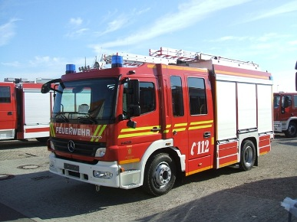  ©Florian Hobmeier, Iveco Magirus  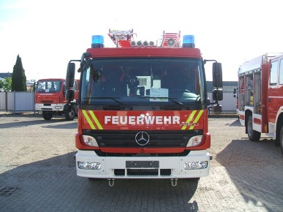  ©Florian Hobmeier, Iveco Magirus  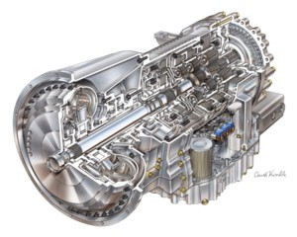  © Allison Transmission | The first 22 fire fighting vehicles – Mercedes-Benz Atego 1429F with the 3000PR Allison fully automatic transmission – of 58 are now in service with the Munich fire brigade.  The Mereces-Benz Atego 1429F equipped with an Allison fully automatic transmission met the expectations of the Munich fire brigade completely.  The 3000 Series is the most popular Allison transmission in the fire-fighting sector. It can be installed in fire-fighting vehicles with engine power up to 336 kW and 1695 Nm.

