LG G3 vandt prisen som årets bedste smartphone på mwc 2015, mens LG Watch urbane fik adskillige priser
– Den innovative LG G3 blev kåret til Best Smartphone of the Year af GSMA, da Global Mobile Awards i går løb af stablen i Barcelona.
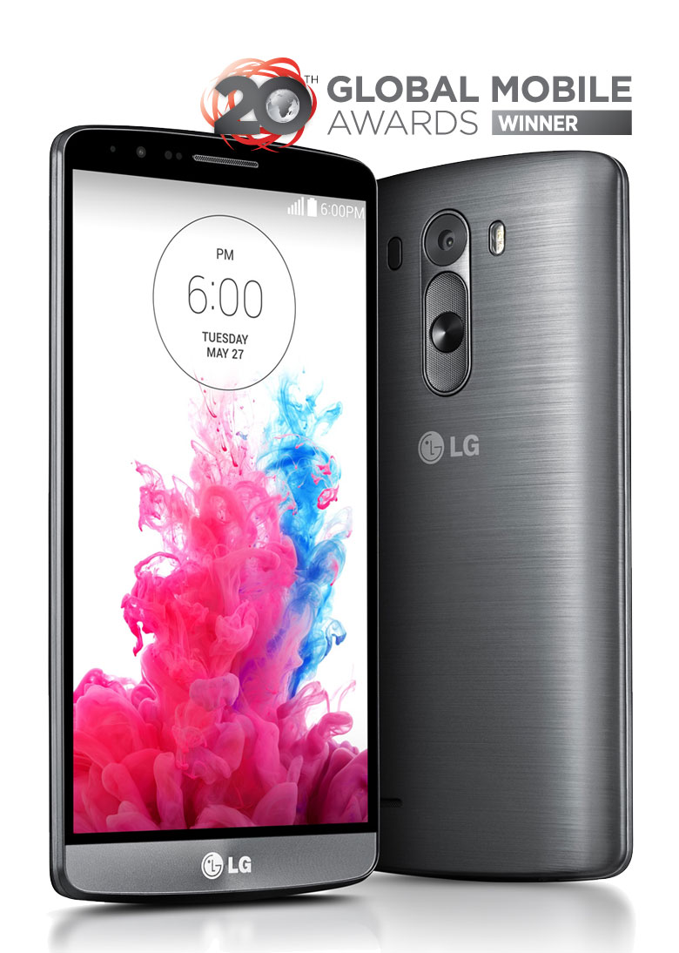
KØBENHAVN, 6. marts, 2015 – LG G3 løb med prisen som Best Smartphone of the Year ved Global Mobile Awards, som fandt sted under årets Mobile World Congress i Barcelona. G3-modellen vandt den prestigefyldte pris for sit høje kvalitetsniveau, sine unikke funktioner og ikke mindst brugeroplevelsen. For mere information om prisen, se www.globalmobileawards.com/winners-2015.

Derudover indhentede LGs to smartwatches i Watch Urbane-serien tilsammen hele ni priser fra globale medier i løbet af mobil-messen. Det elegant designede Android Wear-ur LG Watch Urbane, som udkommer i danske butikker i april, blev udvalgt til bedste smartwatch på MWC 2015 af både Android Authority, Android Central, PC Pro og Ubergizmo. For mere information om LG Watch Urbane-serien, se den danske pressemeddelelse.

Billeder i høj opløsning
For billeder af de prisbelønnede produkter i høj opløsning, kan du besøge LGs billedarkiv og skrive ”mwcawards” i søgefeltet i venstre side.

Du kan finde mere information i den engelske pressemeddelelse nedenfor:
LG G3 NAMED BEST SMARTPHONE, LG URBANE
SMARTWATCHES TAKE HOME 9 AWARDS AT MWC 2015

Company Recognized as Mobile Industry Leader at 20th Annual Global Mobile Awards

BARCELONA, Mar. 5, 2015 — The LG G3 smartphone from LG Electronics (LG) was named Best Smartphone of the Year by the GSMA at the Global Mobile Awards during Mobile World Congress 2015 for its quality, variety of useful features and ease of use. Additionally, the LG Watch Urbane and LG Watch Urbane LTE won nine awards at the show from various top-tier media outlets.

“Since launch, the LG G3 has been critically acclaimed, carried by over 170 partners across the globe and its success has largely contributed to the 16 percent increase in annual global revenue,” said the GSMA in its award announcement. “It delivers an easy-to-use, intuitive user experience with its 5.5-inch Quad HD Display and 13-megapixel OIS+ camera with Laser Auto Focus. It is also packed with innovations such as Smart Keyboard, Gesture for Selfie, Flash for Selfie and Knock Code™ to offer a simply convenient, simply clever and simply safer user experience.”

On the smartwatch front, the LG Watch Urbane and the LG Watch Urbane LTE were both named the best smartwatch of this year’s show by a number of prominent technology media outlets. The LG Watch Urbane was chosen by Android Authority, Android Central, PC Pro and Ubergizmo for its classical and cosmopolitan design with analogue flavor. The world’s first LTE smartwatch, LG Watch Urbane LTE, received best-of-show recognition from Android Central, AndroidPIT, Digital Trends, Expert Reviews and TechnoBuffalo. It was recognized by a number of the awardees for being the first smartwatch to include an NFC-based payment feature and the most powerful battery in the industry.

“We are honored that so many organizations recognized the effort that went into developing the LG G3 and Urbane smartwatches,” said Juno Cho, president and CEO of LG Electronics Mobile Communications Company. “We will continue to innovate and perfect our premium smartphones and wearable devices to improve the lives of our customers.”

For more information on LG’s products at MWC 2015, visit www.LGnewsroom.com/MWC2015.

# # #

Om LG Electronics
LG Electronics, Inc. (KSE: 066570.KS) er en af verdens største leverandører og en innovator inden for forbrugerelektronik, husholdningsapparater og mobilkommunikation med 87 000 ansatte fordelt på 113 kontorer i verden. LG opnåede en global omsætning på 53,10 milliarder USD i 2013. LG består af fem hovedområder – Home Entertainment, Mobile Communications, Home Appliance, Air Conditioning & Energy Solution og køretøjer – og en af verdens største producent af fladskærms tv, mobiltelefoner, luftvarmepumper, vaskemaskiner og køleskabe. Siden oktober 1999 er LG Electronics kommet til Norden. Den nordiske omsætning var i 2013 omkring 1,56 milliarder DKK. For mer e information, besøg www.lg.com

Om LG Electronics Mobile Communications
LG Electronics Mobile Communications Company er et globalt ledende foretagende inden for mobil kommunikation. Gennem avanceret teknik og innovativ design, skaber virksomheden produkter, der skaber en bedre livsstil for forbrugere over hele verden gennem en komplet smartphone oplevelse. Som et ledende foretagende inden for 4G Long Term Evolution (LTE), fortsætter LG forpligtelsen for, at skabe banebrydende LTE-teknologi og opfylde forbrugerens behov gennem differentierede LTE-produkter af højeste kvalitet, baseret på selskabets store beholdninger af LTE patenter og tekniske viden.

For mere information, kontakt venligst:
Susanne Persson  PR Manager  LG Electronics Nordic AB  Box 83, 164 94 Kista  Mobil: +46 (0)70 969 46 06  E-post: susanne.persson@lge.com | Kristoffer Ejebro  Product Specialist MC  LG Electronics Nordic AB  Box 83, 164 94 Kista  Mobil: +46 (0)70 239 3009  E-post: kristoffer.ejebro@lge.com  Konrad Paul Hahn  Channel Manager (Denmark, IS)  LG Electronics Nordic AB  Mobile Communication  Mobile: 004528298837  E-mail:konrad.hahn@lge.com

