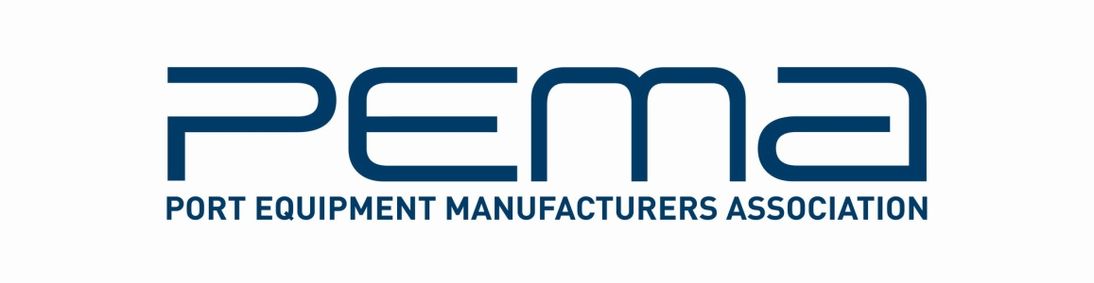

Media Release
PEMA welcomes new Head of Administration

June 1, 2016 – The Port Equipment Manufacturers’ Association, (PEMA), will welcome a new Head of Administration, Cassandra Kelly, on June 1, 2016. Following a two-month handover period, Ms Kelly and the new role of Head of Administration will replace the PEMA Secretariat. This is the first time PEMA has had a full-time employee in London and this change has been made to accommodate the significant growth in PEMA’s membership and level of activity. The existing secretariat organisation will continue to lead projects such as the association’s information papers and presence at industry events such as TOC Europe until July 31, 2016.

“With extensive experience of administrative and project management, executive support, business operations, compliance and stakeholder engagement – specifically in the global maritime segment – Cassandra is the ideal person to ensure the continued smooth running of PEMA. We welcome her warmly to the association,” says PEMA President, Ottonel Popesco.

“We would also like to thank the outgoing PEMA Secretariat supplier NLI for the outstanding work done with PEMA since its establishment in 2004. As the association continues its growth, the PEMA Board and NLI are assessing options for future cooperation,” adds Popesco.

Before joining PEMA, Ms Kelly was on secondment from Lloyd’s Register as Executive Secretary to the EU Recognised Organisations Mutual Recognition, (EU RO MR), Group for a period of three years.

This wide-ranging position involved the establishment and running of the Group's Secretariat service to co-ordinate the implementation of the mutual recognition of marine type approval certification across 11 competing class societies, and liaising with stakeholders such as industry associations and the European Commission.

Previously, Ms Kelly held various positions at Lloyd’s Register including Business Support Specialist & Improvement Consultant at its Fuel Oil Bunker Analysis Service; Business Support Specialist for Marine Consultancy Services; and Technical Support Supervisor for the organisation’s Ship Emergency Response Service.

“I feel that I bring to PEMA the professional experience, and strong operations support acumen that the association will need as its membership and scope of activities continues to grow,” explains Ms Kelly.

Ms Kelly will be attending the upcoming TOC Europe industry event that runs from June 14 to 16 in Hamburg, during which she hopes to meet PEMA members, event visitors and speakers, and colleagues from the industry as a whole.

The new contact details for PEMA’s Head of Administration are:

Ms Cassandra Kelly
10 Eagle Court - Britton Street
Farringdon - London
EC1M 5QD, United Kingdom

Phone: +44 7766228958
Email: cassandra.kelly@pema.org

Separately, PEMA is preparing for another active TOC Europe, which will include the announcement of the winner of the PEMA Student Challenge, as well as a fresh round of TECH TOC seminars, during which leading industry figures discuss key challenges and issues facing the shipping sector. PEMA will also be exhibiting at the event, at stand D124.

For details of PEMA events at TOC Europe 2016, visit: pema.org/pema-events, and to register to attend, go to: tocevents-europe.com.

ENDS

About PEMA
Founded in 2004, PEMA provides a forum and public voice for the global port equipment and technology sectors. The Association has seen strong growth in recent years, and now has over 100 member companies representing all facets of the industry, including crane, equipment and component manufacturers; automation, software and technology providers; consultants and other experts. www.pema.org

For more information on this media release, please contact Cassandra Kelly, PEMA Head of Administration at cassandra.kelly@pema.org.

