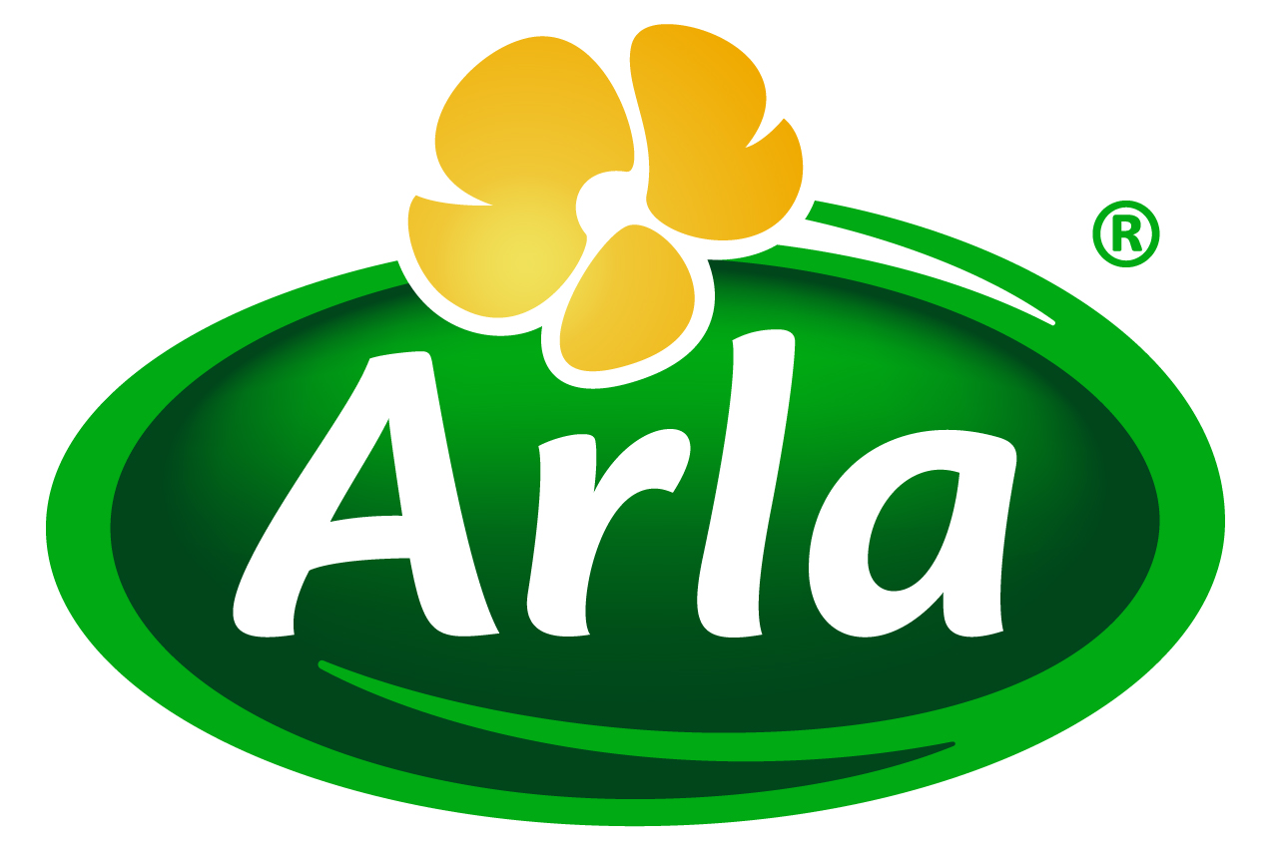
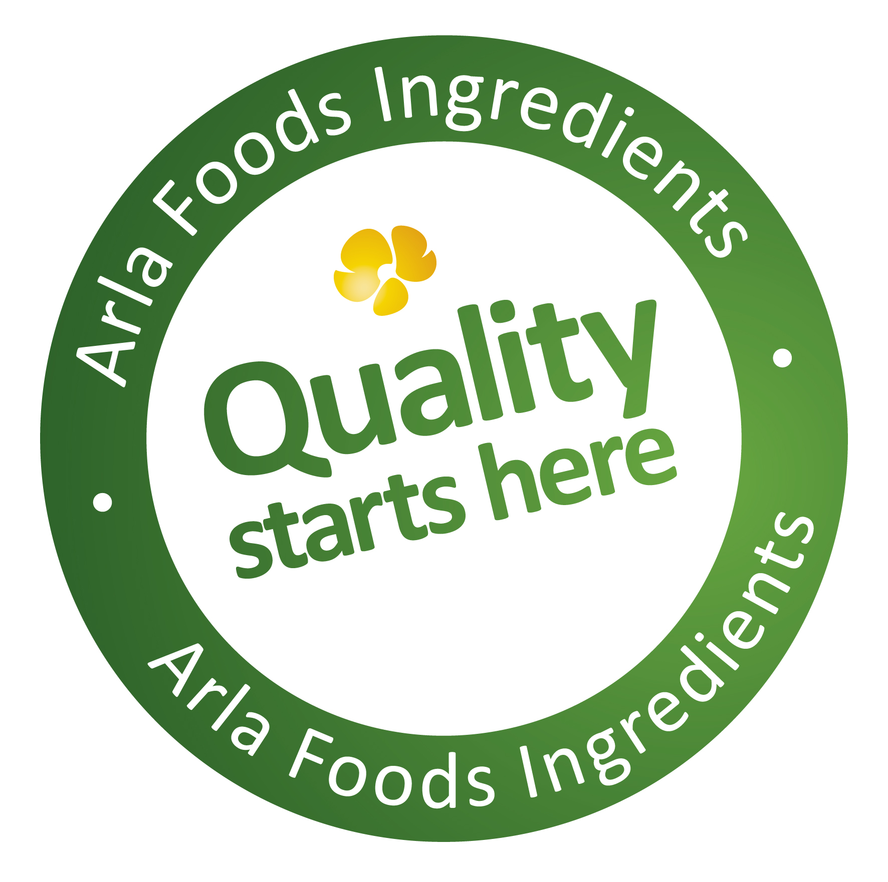

1 May 2014

Arla Foods Ingredients targets lifestyle nutrition
opportunity with Lacprodan® DI-7017

Arla Foods Ingredients has launched its advanced whey protein Lacprodan® DI-7017 into the lifestyle nutrition market for the first time.

Lacprodan® DI-7017 is a 100% whey protein concentrate rich in the essential and branched chain amino acids that are scientifically proven to optimise the body’s muscle-building and satiety response mechanisms. The ingredient offers quicker digestion time than casein, and is suitable for use in a range of great-tasting food and beverage applications, including long-life UHT drinks.

Initially launched in 2012 into the clinical nutrition market, Lacprodan® DI-7017 is now available to companies looking to tap into the surge in popularity of high-protein products among mainstream consumers. According to Euromonitor, protein supplements represent the fastest growing category in consumer health, with global sales rising by 59% to $5.4 billion between 2006 and 2011.

Peter Schouw Andersen, Business Development Manager for Health & Performance at Arla Foods ingredients, said: “Whey protein has long been popular with body-builders and elite athletes for its superb muscle-building and satiety benefits. In recent years, however, it has emerged from this niche to go mainstream. Increasing numbers of ‘ordinary’ health-conscious consumers are now demanding food and beverage products that help them stay fit, toned and looking and feeling good but which are convenient to integrate into their everyday lives.”

He continued: “The key to tapping into this growth opportunity is to offer consumers lifestyle protein-based products that are delicious and easy to consume, since these shoppers are not willing to make the taste and convenience sacrifices accepted by niche protein consumers such as body-builders. Lacprodan® DI-7017 enables food and beverage companies to do this. It offers all the proven nutrition characteristics of whey proteins, but is also easy to use in mainstream products that consumers will love and be willing to pay a premium for.”

Lacprodan® DI-7017 is ideal for use in a comprehensive range of functional foods and drinks, including milk and water-based beverages and soups. It contains 100% whey protein, is UHT-stable, offers neutral pH and tastes good. These attributes make it especially attractive to manufacturers wishing to develop long shelf life products designed for weight management and the increase of muscle mass simultaneously.

Peter Schouw Andersen commented: “Whey protein is already the gold-standard in proteins, thanks to its excellent amino acids profile. Health-conscious consumers are always on the lookout for products that will help them stay fit and toned by regulating their weight and preserving muscle mass. A nutritional ingredient that promises to help them achieve this in an easy and enjoyable way is a compelling offer.”

He added: “Formulating functional food and beverage products with Lacprodan® DI-7017, a high quality whey protein, enables companies to offer great-tasting and highly nutritional products that will appeal to consumers and help them to stay fit and toned as part of an active life.”

ENDS

For more information, please contact:

Miranda Mills, Ingredient Communications
Tel: +44 207 193 4167
Email: Miranda.mills@ingredientcommunications.com

About Arla Foods Ingredients
Quality starts here: Arla Foods Ingredients is a global leader in natural whey ingredients for products in a range of categories – from bakery, beverages, dairy and ice cream to clinical, infant and sports nutrition.
The cornerstones of our business are innovative ingredients, world-class facilities and a staff of dedicated experts. Drawing on our portfolio of functional and nutritional whey proteins, milk minerals, lactose and permeate, our expert team delivers solutions that bring new food products quickly and efficiently to market. Our application centres run hundreds of customer product trials every week. All ingredients are produced using state-of-the-art processing technology at our plant in Denmark, or by one of our joint ventures in Argentina, Germany and the UK.
Arla Foods Ingredients Group P/S is a 100% owned subsidiary of Arla Foods, a global dairy company and cooperative owned by dairy farmers in Denmark, Sweden, the UK, Germany, Belgium and Luxemburg.

RSS Feed
Visit our website at www.arlafoodsingredients.com/news and sign up to our News RSS feed for all the latest developments – updated regularly.

Twitter
Follow us on twitter for all the latest updates @ArlaIngredients

