PRESS INFORMATION 2017

Kasthall’s design classic
is renewed with a radiant finish

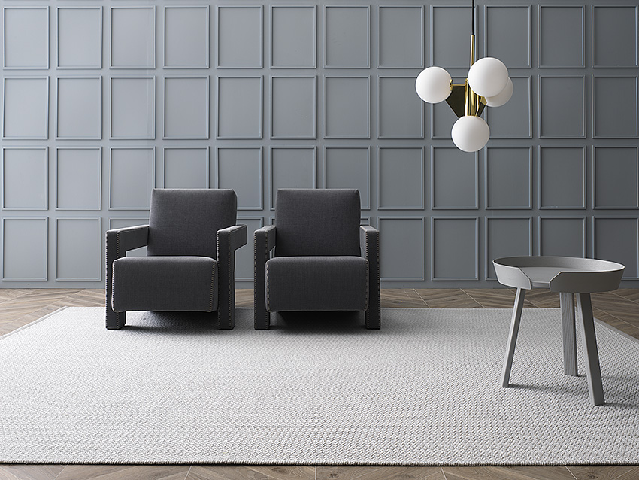
Kasthall is now launching the new Chenille family, renewing six of the brand’s most popular patterns and weaving them in luxurious wool and linen chenille yarn. Like the sense of dimension in an oil painting, an exciting contrast is generated by the meeting of shimmering linen and matte wool yarn. The unique yarn is hand-made at the factory in Kinna and then woven into the desired design.

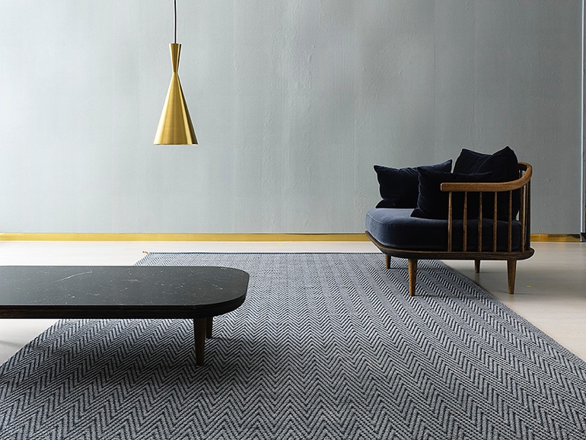
CHENILLE FAMILY

Chenille is a new family, created by Kasthall’s design studio, in which six of Kasthall’s most popular patterns are woven with a wool and linen chenille yarn. The unique yarn is hand-made to order at the factory in Kinna and then woven into the desired design. The rugs have a luxurious feel with a gorgeous, radiant finish.

Product information
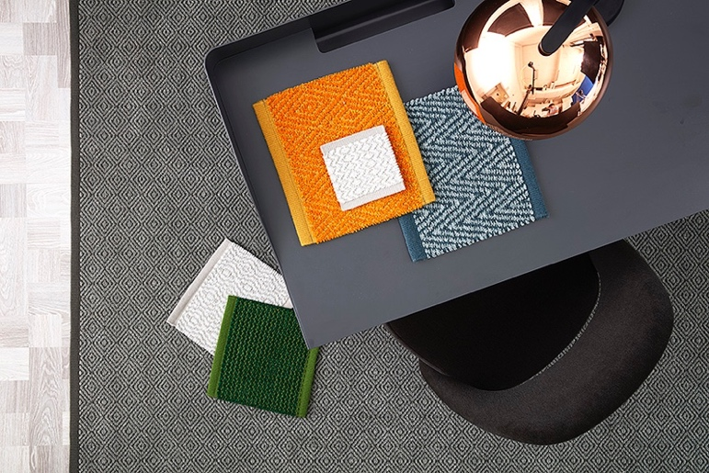
Product type: Woven chenille rug in exquisite wool and linen
Pattern: Goose Eye, Goose Eye XL, Charles, Bloom, Ingrid and Corduroy
Colors: Glacier, Verona, Saffron, Dove, Clay and Emerald

Rec./approx. price standard width: SEK 5,613/ m²
Rec./approx. price carpet: SEK 6,263/ m²

Retailers: Kasthall’s flagship store and & showroom in Stockholm, Kasthall’s showroom in Gothenburg and more.
For high-resolution images, see the Grand Relations press room, www.grandrelations.com/press

For interview questions, contact Hans Hjelmqvist, Senior PR Advisor, Grand Relations
hans@grandrelations.com | +46 708 295 661

For more information, contact Sanna Fehrman, PR Consultant, Grand Relations
sanna@grandrelations.com | +46 762 332 158

For product loans, contact Alvin Nyström, Showroom Manager, Grand Relations alvin@grandrelations.com | +46 769 471 900

ABOUT KASTHALL
The historic company Kasthall designs and manufactures exclusive rugs for private and public environments. Since it was founded in 1889, the company has had its own manufacturing facility in Kinna, western Sweden. Over the years, Kasthall has become one of the leading international design companies in textile flooring and today, most of its sales are outside of Sweden. Kasthall continues to develop its products with an extraordinary understanding of design and innovation, invaluable craftsmanship, a focus on sustainability, and by always delivering unique rugs of the highest quality to the global interior design world.
For more information, visit www.kasthall.com

