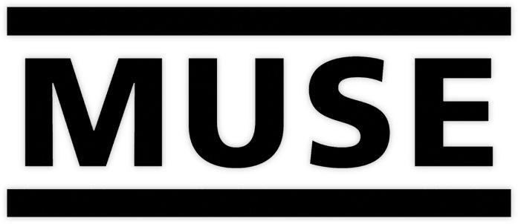

CELEBRATE THE 20TH ANNIVERSARY OF ‘ORIGIN OF SYMMETRY’
WITH THE NEW ‘XX ANNIVERSARY REMIXX’ EDITION

RELEASED ON DIGITAL FORMATS ON JUNE 18TH AND FEATURES
REMIXED AND REMASTERED AUDIO PLUS RE-IMAGINED ARTWORK

‘CITIZEN ERASED’ PROVIDED AS AN INSTANT DOWNLOAD – LISTEN HERE

VINYL FOLLOWS ON JULY 9TH

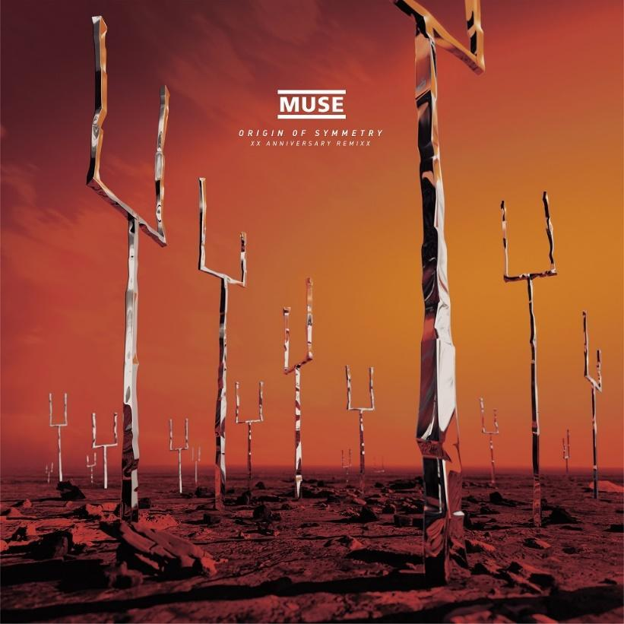

Muse celebrate the twentieth anniversary of ‘Origin Of Symmetry’ by releasing ‘Origin Of Symmetry: XX Anniversary RemiXX’ on Warner Records. The new edition features remixed and remastered audio plus re-imagined artwork and will be released on digital formats on June 18th before two vinyl packages follow on July 9th.

As the album’s anniversary approached, Muse asked the Grammy-winning producer Rich Costey, who has produced or mixed material on almost every subsequent record, to revisit the original recordings. Whereas most remix albums aim to radically rework the material, or to switch to an entirely different genre, the band and Costey wanted to provide a renewed clarity with a more open, dynamic and less crushed sound. This highlights parts and ideas previously buried or muted on the original mixes, like a harpsichord on ‘Micro Cuts’ and Abbey Road recorded strings on ‘Citizen Erased’, ‘Megalomania’ and ’Space Dementia’.

And that’s precisely what has been achieved. From the visceral opening riff of ‘New Born’ to the cinematic melancholy of the closing ‘Megalomania’ via the staggering scope of fan favourite ‘Citizen Erased’, the remix unveils every facet of the album’s intricate production alongside a new-found warmth. It further benefits from mastering courtesy of Alex Wharton at Abbey Road Studios.

Matt Bellamy said:

"In revisiting the album what we found was the original mixes on the singles, like ‘Plug In Baby’ and ‘Bliss’, were pretty good so they were the hardest ones to improve. It was the deeper album tracks like ‘Micro Cuts’ where we were able to make massive breakthroughs."

The ‘XX Anniversary RemiXX’ also adds ‘Futurism’ to the tracklist. Originally a bonus track on the album’s Japanese edition and subsequently tagged to the end of the album on streaming services, ‘Futurism’ now adds a burst of energy to bridge the gap between ‘Feeling Good’ and ‘Megalomania’. This reflects its placing on the 2019 box set ‘Origin of Muse’.

‘Origin of Symmetry: XX Anniversary RemiXX’ is completed with a modernised reimagination of the album’s cover art courtesy of Sujin Kim. The visual artist has created a hyper-realistic 3D rendering of William Eager’s original cover image.

‘Origin of Symmetry: XX Anniversary RemiXX’ is now available to pre-order / pre-save on digital formats here, with ‘Citizen Erased’ provided as an instant download. A limited edition exclusive 140 gram coloured double-vinyl set is available here. A striking package and a must-have item for collectors, it features LP1 on translucent sun yellow vinyl and LP2 on translucent orange vinyl. It will also be released on double black vinyl, which can be pre-ordered here. Both versions of the vinyl feature an unorthodox detail: the sides are marked M, U, S and E rather than the standard format.

‘Origin of Symmetry: XX Anniversary RemiXX’ tracklist:

Side M
1. ‘New Born’
2. ‘Bliss’

Side U
3. ‘Space Dementia’
4. ‘Hyper Music’
5. ‘Plug In Baby’

Side S
6. ‘Citizen Erased’
7. ‘Micro Cuts’
8. ‘Screenager’
9. ‘Darkshines’

Side E
10. ‘Feeling Good’
11. ‘Futurism’
12. ‘Megalomania’

ABOUT ‘ORIGIN OF SYMMETRY’:

‘Origin of Symmetry’ is the album that changed everything for Muse. Somehow both more spontaneous and experimental than their debut record ‘Showbiz’, its ambition, sprawling influences and grandiosity was a world apart from the garage-rock revivalists and chest-beating nu-metal that ruled the roost at the time. Powered by the band’s first two mainstream European hits, ‘Plug In Baby’ and ‘New Born’, the album provided their first Top 10 UK hit when it debuted at #3. It has since established a reputation as a fan favourite while also generating huge commercial success.

Original praise for the album:

“It’s amazing for such a young band to load up with a heritage that includes the darker visions of Cobain and Kafka, Mahler and The Tiger Lillies, Cronenberg and Schoenberg, and make a sexy, populist album. But Muse have carried it off.” 9/10 – NME

“This is Muse at their best, at their most accessible and ironically most threatening to the status quo.” 10/10 – Drowned in Sound

ABOUT MUSE:

Muse is Matt Bellamy, Dominic Howard and Chris Wolstenholme. Their last album, ‘Simulation Theory’, debuted at #1 and marked the band’s sixth straight album to debut in the U.K top spot. Their previous studio album, ‘Drones’, went on to win a Grammy Award for Best Rock Album, the band’s second, in February 2016. Since forming in 1994, Muse have released eight studio albums, selling over 20 million copies worldwide. Widely recognized as one of the best live bands in the world, Muse have won numerous music awards including two Grammy Awards, an American Music Award, five MTV Europe Music Awards, two Brit Awards, eleven NME Awards and seven Q Awards, amongst others. The band is currently in the studio working on their next record.

Website
Spotify
Apple Music
YouTube
Facebook
Twitter
Instagram

