SteelSeries Brings its Award-Winning Signature Sound to the Arctis 1 Headset
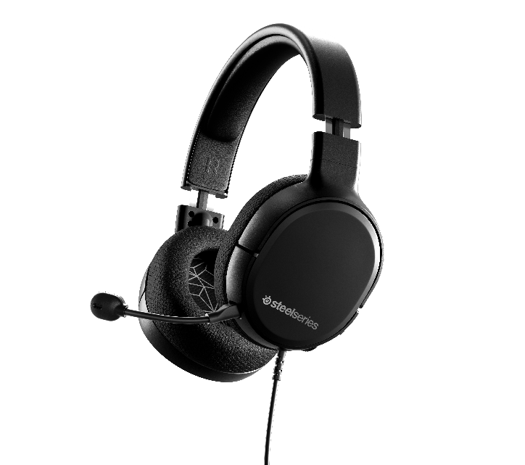

MEDIA ALERT – June 11, 2019 – SteelSeries, the global leader in gaming peripherals and makers of the most award-winning headset line in history, today announces the Arctis 1 gaming headset. The headset features the same powerful Arctis drivers and sleek design as the Arctis 3, 5, 7 and 9X, but at a more affordable $49.99 price point.

The Arctis 1 is an all-platform gaming headset that easily doubles as a stylish pair of on-the-go headphones. With a detachable microphone and sleek low-profile design, gamers can enjoy the award-winning performance of Arctis no matter where they are.

The Arctis 1 universal 3.5mm connection is made for gaming on all platforms, including PC, PS4, Xbox One and Nintendo Switch. It features the same speaker drivers and signature soundscape of the award-winning Arctis line, so that gamers don’t need to sacrifice audio quality, even at a lower price point. The Arctis 1 also uses the same ClearCast microphone for natural-sounding clarity and noise cancellation, but instead of being retractable like the Arctis 3, 5, 7, and 9X, the microphone is detachable so it can easily transition between a headset and headphones. The Arctis 1 forgoes the iconic ski goggle suspension headband in favor of a lower profile solution that is optimized for use on the go, while still boasting excellent comfort with Airweave fabric ear cushions and a steel-reinforced headband for a perfect fit and lasting durability.

“Arctis was the first brand of headsets that offered best-in-class audio performance in a beautifully designed package that users could use while gaming or on-the-go,” said SteelSeries CEO, Ehtisham Rabbani. “We’re excited to bring the full Arctis experience to even more gamers at an incredibly affordable price point.”

The Arctis 1 is available now for $49.99 at SteelSeries.com.

For more information about the Arctis 1 and the complete line of SteelSeries’ Arctis headsets, visit www.SteelSeries.com for more information.

For high-resolution images, click here.

