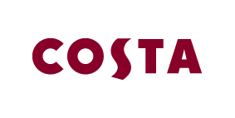
Tuesday 1st September

SOLIHULL COSTA CUSTOMER VISITS LOCAL STORE 364 DAYS A YEAR
KNOWN BY ALL AS ‘MR COSTA’

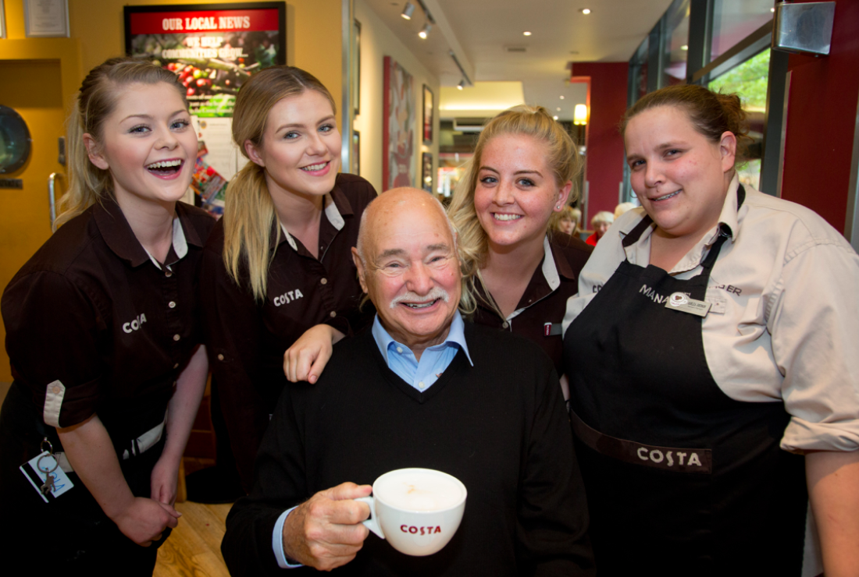

A man in Solihull has been announced one of Costa’s most loyal customers, visiting his local store for the past 15 years.
Don, 81 from Solihull visited the Mell Square store weekly before the death of his wife in 2005, and now finds comfort in visiting the welcoming staff at his local Costa everyday, who have become his close friends.
Don said, "I think Costa is second to none. I have been going there for 364 days a year for 15 years. Seeing the staff at Costa each day keeps me young.”
The UK continues to become a country of coffee connoisseurs, which is why it is vital for Costa to use their 40 plus years of experience to consistently provide irresistible coffee, paired with quality food, in a welcoming environment.
Jim Slater, Managing Director at Costa said, “Our customers keep coming back because our specialist baristas are highly skilled, and are trusted to create a beautiful hand-crafted coffee every time. It takes time, training and dedication to be a Costa barista. We want all of our teams to enjoy their time with Costa, and hopefully create the occasional little moment of happiness for our customers too.”
Costa is celebrating its customers and employees throughout September and October, for more stories on Costa people please visit www.costa.co.uk
ENDS

For further information please contact the Costa Press Office at Costateam@onegreenbean.com
or call 0207 017 1014

About Costa
Costa is the UK’s favourite coffee shop, having been awarded “Best Branded Coffee Shop Chain in the UK and Ireland" by Allegra Strategies for five years running (2010, 2011, 2012, 2013 & November 2014).

Winner of “Best Branded Coffee Chain in Europe” Allegra Strategies 2010, 2011, 2012, 2013 and 2014.

With over 1,800 coffee shops in the UK and more than 1,100 overseas, Costa is the fastest growing coffee shop business in the UK and the second largest coffee shop operator in the world. Founded in London by Italian brothers Sergio and Bruno Costa in 1971, Costa has become the UK’s favourite coffee shop chain and diversified into both the at-home and gourmet self-serve markets.

Costa employs over 12,000 people and is creating around 1,500 jobs this year and over 4,500 jobs in the next three years in the UK. We continue to be part of the Sunday Times Best Companies To Work For list.

Costa is committed to looking after coffee-growers. That's why we've established The Costa Foundation, a registered charity. The Costa Foundation's aims are to relieve poverty, advance education and the health and environment of coffee-

